TRƯỜNG ĐẠI HỌC VĂN LANG
KHOA CÔNG NGHỆ THÔNG TIN


NGÀNH: CÔNG NGHỆ THÔNG TIN

MÔN: LẬP TRÌNH WEB NÂNG CAO
Lớp: 242_71ITSE41403_0401

Giảng viên hướng dẫn: Trần Vũ Đại
Thành viên:
Đặng Ngọc Hồng Yến
Phạm Quốc Bảo

STT | Họ và Tên | MSSV
1 | Đặng Ngọc Hồng Yến | 2274802011043
2 | Phạm Quốc Bảo | 2274802010049

- Backend
- Chạy dự án: npm start
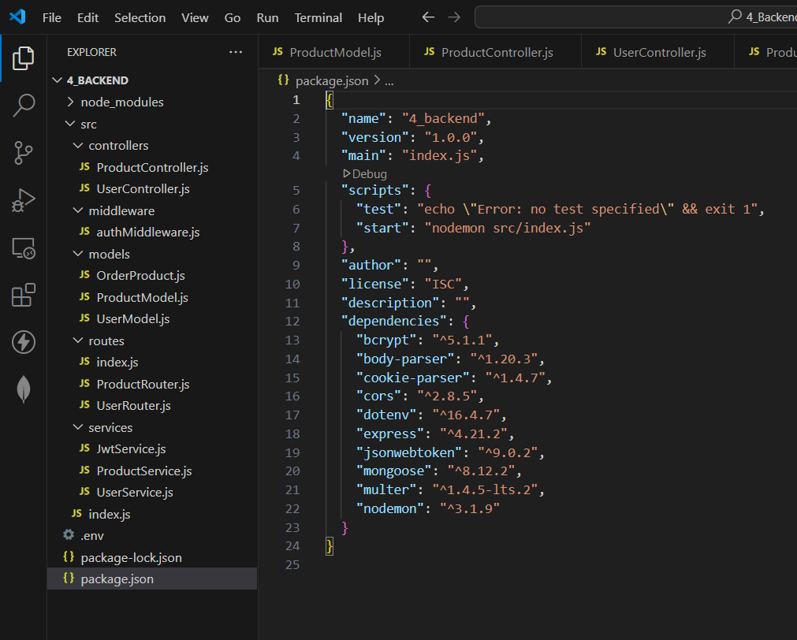
  - Cấu hình dữ liệu
    - Cấu hình dữ liệu Người dùng
const mongoose = require('mongoose')
const userSchema = new mongoose.Schema(
{
name: {type: String, require: true},
email: {type:String, require: true, unique: true},
password: {type: String, require: true},
isAdmin: {type: Boolean, default: false, require: true},
phone: {type: Number, require: true},
address: {type: String, require:true},
//avatar:{type: String},
avatar: {
data: Buffer,
contentType: String
}

},
{
timestamps: true
}

);
const User = mongoose.model("User", userSchema);
module.exports = User;
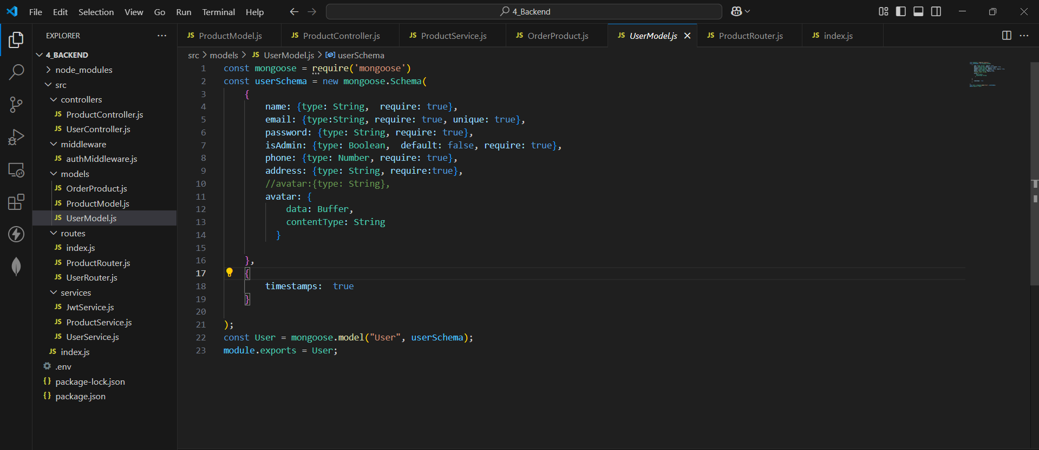
    - Cấu hình dữ liệu Sản phẩm
const mongoose = require('mongoose')
const productSchema = new mongoose.Schema(
{
name: {type: String, require: true, unique: true},
image: {type:String, require: true},
type: {type: String, require: true},
price: {type: Number, require: true},
countInStock: {type: Number, require: true},
rating: {type: Number, require: true},
description: {type: String},
discount:{type: String}

},
{
timestamps: true
}

);
const Product = mongoose.model('Product', productSchema);
module.exports = Product;
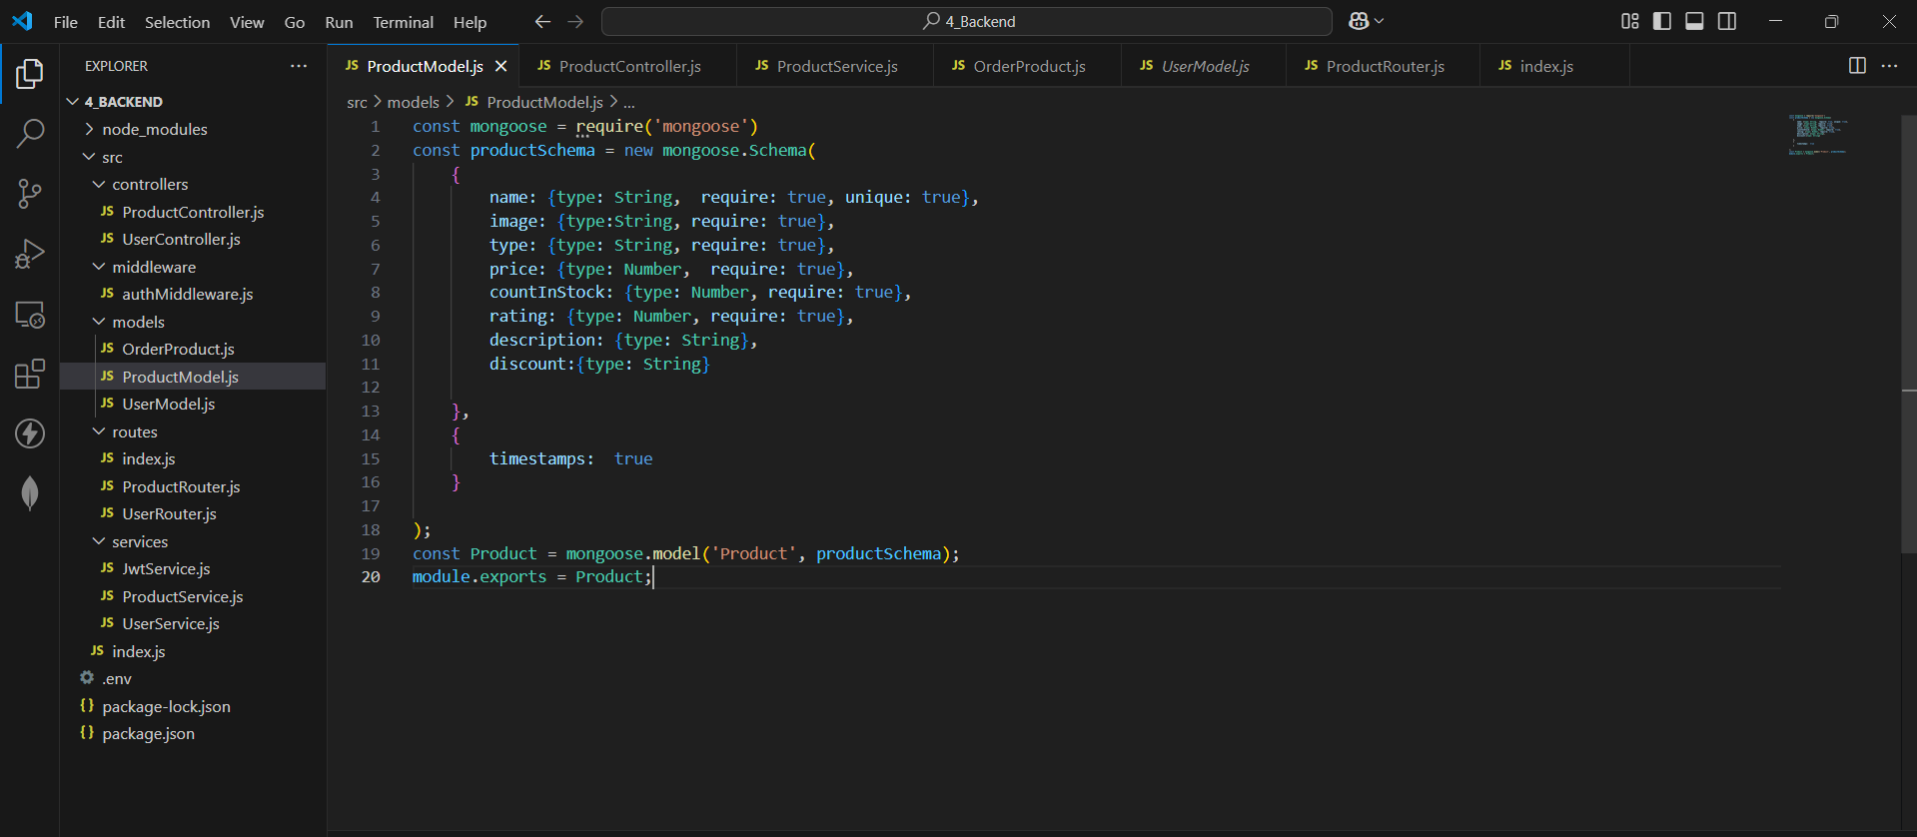
    - Cấu hình dữ liệu Đặt hàng
const mongoose = require('mongoose')
const orderSchema = new mongoose.Schema({
orderItems: [
{
name: {type: String, require: true},
amount: {type: Number, require: true},
image:{typeL: String, require: true},
price: {type: Number, require: true},
product:{
type: mongoose.Schema.Types.ObjectId,
ref: 'Product',
require: true,
},

},
],
ShippingAddress:{
fullName: {type: String, require: true},
address: {type: Stting, require: true},
city: {type: String, require: true},
country:{type: String, require: true},
phone: {type: Number, require: true},

},
paymentMethod:{type: String, require: true},
itemsPrice:{type: Number, require: true},
shippingPrice:{type: Number, require: true},
taxPrice:{type:Number, require: true},
totalPrice: {type: Number, require: true},
user:{type:mongoose.Schema.Types.ObjectId, ref:'User', require: true},
isPaid:{type: Boolean, default: false},
paiAt:{type: Date},
isDelivered:{type: Boolean, default: false},
deliveredAt:{type: Date},

},
{
timestamps: true
}

);
const Order = mongoose.model("Order", orderSchema);
module.exports = Order;
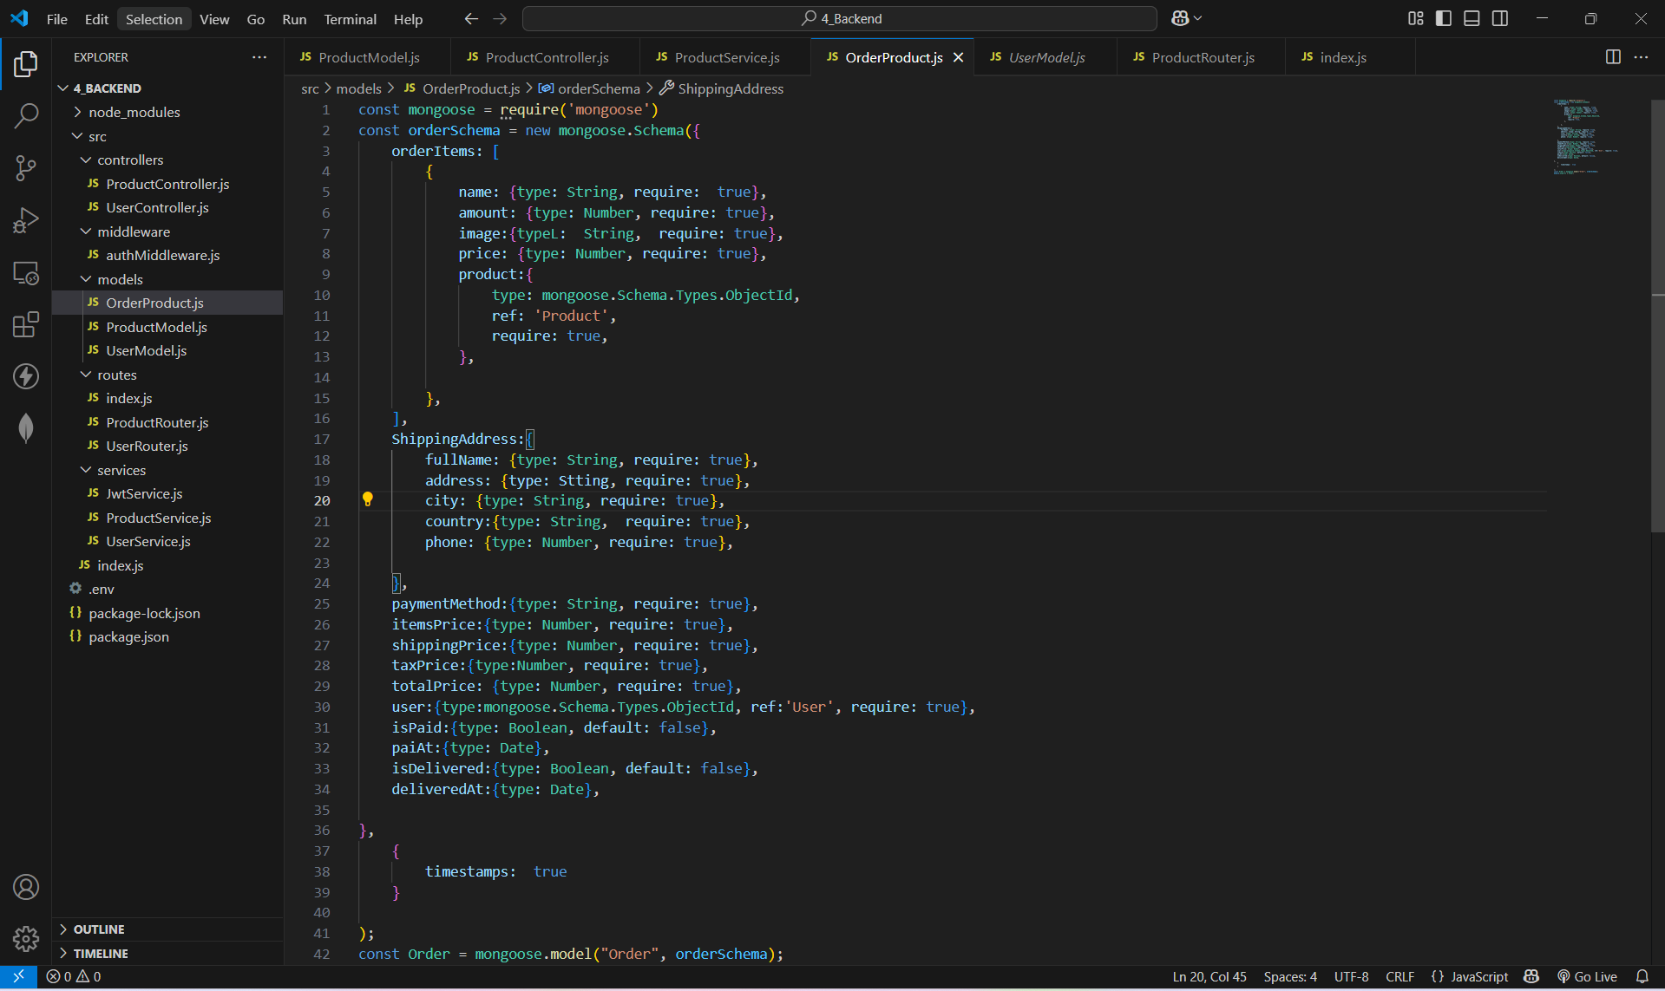
  - Các Controller
    - Module Điều Khiển Người Dùng (User Controller) – Bao gồm các chức năng tạo, xóa, cập nhật, xem tất cả user, tạo token, refresh token và đăng xuất
const UserService = require('../services/UserService');
const JwtService = require('../services/JwtService');
const { response } = require('express');
const multer = require('multer');
const path = require('path');
const emailRegex = /^\w+([-.]?\w+)*@\w+([-.]?\w+)*(\.\w{2,3})+$/;

const createUser = async (req, res) => {
try {
const { name, email, password, confirmPassword} = req.body;

if (!name || !email || !password || !confirmPassword) {
return res.status(400).json({ status: "ERROR", message: "All fields are required" });
}

if (!emailRegex.test(email)) {
return res.status(400).json({ status: "ERROR", message: "Invalid email format" });
}

if (password.length < 6) {
return res.status(400).json({ status: "ERROR", message: "Password must be at least 6 characters" });
}

if (password !== confirmPassword) {
return res.status(400).json({ status: "ERROR", message: "Passwords do not match" });
}

const existingUser = await UserService.findUserByEmail(email);
if (existingUser) {
return res.status(400).json({ status: "ERROR", message: "Email already exists" });
}

const response = await UserService.createUser({ name, email, password});

return res.status(201).json(response);
} catch (error) {
return res.status(500).json({ status: "ERROR", message: "Internal Server Error" });
}
};

const loginUser = async (req, res) => {
try {
const { email, password } = req.body;

if (!email || !password) {
return res.status(400).json({ status: "ERROR", message: "Email and password are required" });
}

if (!emailRegex.test(email)) {
return res.status(400).json({ status: "ERROR", message: "Invalid email format" });
}

const response = await UserService.loginUser(req.body); // Gọi đến UserService
const { refresh_token } = response;

res.cookie('refresh_token', refresh_token, {
httpOnly: true,
//secure: false,
secure: process.env.NODE_ENV === 'production',
samesite: 'strict'
});

return res.status(200).json(response); // Trả lại thông tin thành công
} catch (error) {
return res.status(500).json({ status: "ERROR", message: "Internal Server Error" });
}
};

const storage = multer.memoryStorage();
const upload = multer({
storage: storage,
limits: { fileSize: 10 * 1024 * 1024 }, // Giới hạn kích thước file (10MB)
fileFilter: (req, file, cb) => {
// Chỉ cho phép các file ảnh
if (!file.mimetype.startsWith('image/')) {
return cb(new Error('Only image files are allowed'), false);
}
cb(null, true);
}
});

const updateUser = async (req, res) => {
try {
const userId = req.params.id;

if (!userId) {
return res.status(400).json({ status: "ERROR", message: "User ID is required" });
}

upload.single('avatar')(req, res, async (err) => {
if (err) {
return res.status(400).json({ status: "ERROR", message: "File upload failed: " + err.message });
}

const updateData = req.body;

if (req.file) {
updateData.avatar = {
data: req.file.buffer,
contentType: req.file.mimetype
};
}

const response = await UserService.updateUser(userId, updateData);

return res.status(200).json(response);
});
} catch (error) {
return res.status(500).json({ status: "ERROR", message: "Internal Server Error" });
}
};

const deleteUser = async (req, res) => {
try {
const userId = req.params.id;

if (!userId) {
return res.status(400).json({ status: "ERROR", message: "User ID is required" });
}

const response = await UserService.deleteUser(userId);

return res.status(200).json(response);
} catch (error) {
return res.status(500).json({ status: "ERROR", message: "Internal Server Error" });
}
};

const getAllUser = async (req, res) => {
try {
const response = await UserService.getAllUser();

return res.status(200).json(response);
} catch (error) {
return res.status(500).json({ status: "ERROR", message: "Internal Server Error" });
}
};

const getDetailsUser = async (req, res) => {
try {
const userId = req.params.id;

if (!userId) {
return res.status(400).json({ status: "ERROR", message: "User ID is required" });
}

const response = await UserService.getDetailsUser(userId);

return res.status(200).json(response);
} catch (error) {
return res.status(500).json({ status: "ERROR", message: "Internal Server Error" });
}
};

const refreshToken = async (req, res) => {
try {
const refreshToken = req.cookies.refresh_token;
if (!refreshToken) {
return res.status(401).json({ status: "ERROR", message: "No refresh token found" });
}

const response = await JwtService.refreshTokenJwtService(refreshToken);
if (response.status === "OK") {
return res.status(200).json(response);
} else {
return res.status(401).json({ status: "ERROR", message: "Invalid refresh token" });
}
} catch (error) {
return res.status(500).json({ status: "ERROR", message: "Internal Server Error" });
}
};

const logoutUser = async (req, res) => {
try {
res.clearCookie('refresh-token')
return res.status(200).json({
status: 'OK',
message: 'Logout successfully'
})

} catch (e) {
return res.status(404).json({
message:e
});
}
};

module.exports = {
createUser,
loginUser,
updateUser,
deleteUser,
getAllUser,
getDetailsUser,
refreshToken,
logoutUser
};

    - Module Điều Khiển Sản Phẩm (Product Controller) - Bao gồm các chức năng tạo, xóa, cập nhật, xem tất cả, xem chi tiết sản phẩm
const ProductService = require('../services/ProductService');

const createProduct = async (req, res) => {
try {

const { name, image, type, countInStock, price, rating, description } = req.body;

if (!name || !image || !type || !countInStock || !price || !rating) {
return res.status(200).json({
status: "ERROR",
message: "The input is required"
});
}

const response = await ProductService.createProduct(req.body);

return res.status(200).json(response);
} catch (e) {
return res.status(500).json({
status: "ERROR",
message: "Internal Server Error"
});
}
};

const updateProduct = async (req, res) => {
try {
const productId = req.params.id
const data = req.body

if (!productId) {
return res.status(200).json({ status: "ERROR", message: "The productId is required" });
}

const response = await ProductService.updateProduct(productId, data);

return res.status(200).json(response);
} catch (e) {
return res.status(404).json({
message: e
});
}
};

const deleteProduct = async (req, res) => {
try {
const productId = req.params.id
const token = req.headers
console.log('token')
if(!productId){
return res.status(200).json({
status: 'ERR',
message:"The product ID is require"
})
}
const response=await ProductService.deleteProduct(productId)
return res.status(200).json(response)
} catch (e) {
return res.status(404).json({
message: e
})
}
};

const getAllProduct = async (req, res) => {
try {
const { limit, page, sort, filter } = req.query;

// Kiểm tra filter có đúng định dạng không (phải có ":")
if (filter && !filter.includes(":")) {
return res.status(400).json({ status: "ERROR", message: "Invalid filter format. Use field:value" });
}

const response = await ProductService.getAllProduct(
Number(limit) || 6,
Number(page) || 0,
sort,
filter
);

return res.status(200).json(response);
} catch (e) {
return res.status(500).json({
status: "ERROR",
message: "Internal Server Error",
error: e.message
});
}
};

const getDetailsProduct = async (req, res) => {
try {
const productId = req.params.id

if(!productId){
return res.status(200).json({
status: 'ERR',
message:"The product Id is require"
})
}
const response=await ProductService.getDetailsProduct(productId)
return res.status(200).json(response)
} catch (e) {
return res.status(404).json({
message: e
})
}
};

module.exports = {
createProduct,
updateProduct,
getDetailsProduct,
deleteProduct,
getAllProduct

};

1.3. Các Service
1.3.1 ProductService
const Product = require("../models/ProductModel");

const createProduct = (newProduct) => {
return new Promise(async (resolve, reject) => {
const { name, image, type, countInStock, price, rating, description } = newProduct;

try {
const checkProduct = await Product.findOne({
name: name
});

if (checkProduct !== null) {
return resolve({
status: 'OK',
message: 'The name of product is already in use',
});
}

const createProduct = await Product.create({
name, image, type, countInStock, price, rating, description
});

if (createProduct) {
return resolve({
status: 'OK',
message: 'PRODUCT CREATED SUCCESSFULLY',
data: createProduct
});
}

} catch (e) {
return reject(e);
}
});
};

const updateProduct = async (id, data) => {
return new Promise(async (resolve, reject) => {
try {
const checkProduct = await Product.findOne({
_id: id
})

if (checkProduct === null) {
return resolve({
status: "OK",
message: "The product is not defined"
});
}
const updateProduct = await Product.findByIdAndUpdate(id, data, {new: true})
return resolve({
status: "OK",
message: "Product updated successfully",
data: updateProduct
});

} catch (e) {
return reject(e);
}
});
};

const deleteProduct = (id) => {
return new Promise(async (resolve, reject) => {
try {
const checkProduct = await Product.findOne({
_id: id
});

if (checkProduct === null) {
resolve({
status: "OK",
message: "The product is not defined"
});
}

await Product.findByIdAndDelete(id);

resolve({
status: "OK",
message: "Product deleted successfully"
});

} catch (e) {
return reject(e);
}
});
};

const getAllProduct = (limit, page, sort, filter) => {
return new Promise(async (resolve, reject) => {
try {
const totalProduct = await Product.countDocuments();

// Xử lý sắp xếp (sort)
let sortObj = {};
if (sort) {
const sortFields = sort.split(",");
sortFields.forEach(field => {
sortObj[field] = 1;
});
}

// Xử lý bộ lọc (filter)
let objectFilter = {};
if (filter) {
const filterArr = filter.split(","); // Mảng chứa các bộ lọc, ví dụ: ["name:iphone", "type:electronics"]
filterArr.forEach(f => {
const [field, value] = f.split(":"); // Phân tách theo dấu ":"
if (field && value) {
objectFilter[field] = { $regex: value, $options: "i" }; // Tìm kiếm không phân biệt hoa thường
}
});
}

console.log("Filter applied:", objectFilter); // Kiểm tra filter trước khi query

// Truy vấn MongoDB
const allProducts = await Product.find(objectFilter)
.limit(limit)
.skip(page * limit)
.sort(sortObj);

resolve({
status: "OK",
message: "SUCCESS",
data: allProducts,
total: totalProduct,
pageCurrent: Number(page + 1),
totalPage: Math.ceil(totalProduct / limit),
});

} catch (e) {
return reject(e);
}
});
};

const getDetailsProduct = (id) => {
return new Promise(async (resolve, reject) => {
try {
const product = await Product.findOne({
_id: id
});

if (product === null) {
resolve({
status: "OK",
message: "The product is not defined"
});
}

resolve({
status: "OK",
message: "SUCCESS",
data: product
});

} catch (e) {
reject(e);
}
});
};

module.exports = {
createProduct,
updateProduct,
getDetailsProduct,
deleteProduct,
getAllProduct
}

1.3.2 User Service
const User = require("../models/UserModel");
const bcrypt = require("bcrypt");
const { genneralAccessToken, genneralRefreshToken } = require("./JwtService");

const findUserByEmail = async (email) => {
try {
return await User.findOne({ email });
} catch (error) {
console.error("Error in findUserByEmail:", error);
throw error;
}
};

const createUser = (newUser) => {
return new Promise(async (resolve, reject) => {
const { name, email, password, confirmPassword, phone } = newUser;
try {
const checkUser = await findUserByEmail(email);

if (checkUser) {
return resolve({
status: 'ERROR',
message: 'The email is already in use',
});
}

const hash = bcrypt.hashSync(password, 10);
console.log('hash', hash);

const createdUser = await User.create({
name,
email,
password: hash,
phone
});

if (createdUser) {
return resolve({
status: 'OK',
message: 'ACCOUNT CREATED SUCCESSFULLY',
data: createdUser
});
}

return resolve({
status: 'ERROR',
message: 'User creation failed',
});

} catch (e) {
return reject(e);
}
});
};

const loginUser = (userLogin) => {
return new Promise(async (resolve, reject) => {
const { email, password } = userLogin;
try {
//const checkUser = await findUserByEmail(email);
const checkUser = await User.findOne({
email: email
})
if (checkUser === null) {
return resolve({
status: 'ERROR',
message: 'User not found',
});
}

const comparePassword = await bcrypt.compare(password, checkUser.password);
console.log('comparePassword', comparePassword);

if (!comparePassword) {
return resolve({
status: 'ERROR',
message: 'Incorrect email or password',
});
}

const access_token = await genneralAccessToken({
id: checkUser.id,
isAdmin: checkUser.isAdmin
});

const refresh_token = await genneralRefreshToken({
id: checkUser.id,
isAdmin: checkUser.isAdmin
});

return resolve({
status: 'OK',
message: 'SUCCESS',
access_token,
refresh_token,
user:{
id: checkUser.id,
name: checkUser.name,
email: checkUser.email
}
});

} catch (e) {
return reject(e);
}
});
};

// const updateUser = async (userId, userData) => {
// return new Promise(async (resolve, reject) => {
// try {
// const user = await User.findByIdAndUpdate(userId, userData, { new: true });

// if (!user) {
// return resolve({
// status: "ERROR",
// message: "User not found"
// });
// }

// return resolve({
// status: "OK",
// message: "User updated successfully",
// data: user
// });

// } catch (e) {
// return reject(e);
// }
// });
// };
const updateUser = async (userId, userData) => {
return new Promise(async (resolve, reject) => {
try {
// Cập nhật người dùng trong cơ sở dữ liệu
const user = await User.findByIdAndUpdate(userId, userData, { new: true });

if (!user) {
return resolve({
status: "ERROR",
message: "User not found"
});
}

return resolve({
status: "OK",
message: "User updated successfully",
data: user
});

} catch (e) {
return reject(e);
}
});
};

const deleteUser = (id) => {
return new Promise(async (resolve, reject) => {
try {
const checkUser = await User.findOne({
_id: id
})

if (checkUser === null) {
resolve({
status: "OK",
message: "User not found"
});
}

await User.findByIdAndDelete(id);

resolve({
status: "OK",
message: "User deleted successfully"
});

} catch (e) {
return reject(e);
}
});
};

const getAllUser = () => {
return new Promise(async (resolve, reject) => {
try {
const allUser = await User.find();

resolve({
status: "OK",
message: "SUCCESS",
data: allUser
});

} catch (e) {
return reject(e);
}
});
};

const getDetailsUser = (id) => {
return new Promise(async (resolve, reject) => {
try {
const user = await User.findById(id);

if (!user) {
return resolve({
status: "ERROR",
message: "User not found"
});
}

resolve({
status: "OK",
message: "SUCCESS",
data: user
});

} catch (e) {
reject(e);
}
});
};

module.exports = {
findUserByEmail,
createUser,
loginUser,
updateUser,
deleteUser,
getAllUser,
getDetailsUser,
};
1.3.3 JWT Service

const jwt = require('jsonwebtoken')
const dotenv = require('dotenv');
dotenv.config()

const genneralAccessToken =async (payload)=>{
console.log('payload', payload)
const access_token = jwt.sign({
...payload
}, process.env.ACCESS_TOKEN ,{expiresIn:'1d'})

return access_token
}
const genneralRefreshToken =async (payload)=>{

const refresh_token = jwt.sign({
...payload
}, process.env.REFRESH_TOKEN,{expiresIn:'365d'})

return refresh_token
}

const refreshTokenJwtService =(token)=>{
return new Promise((resolve, reject) => {
try {

jwt.verify(token, process.env.REFRESH_TOKEN, async (err, user)=>{
if(err){
console.log('err',err)
resolve({
status: "ERROR",
message:"The authemitication"
})
}
const access_token = await genneralAccessToken({
id: user?.id,
isAdmin: user?.isAdmin
})
console.log('access_token', access_token)
resolve({
status: "OK",
message: "SUCCESS",
access_token
});
})

} catch (e) {
reject(e);
}
});

}
module.exports={
genneralAccessToken,
genneralRefreshToken,
refreshTokenJwtService
}

  - MiddleWare
const jwt = require('jsonwebtoken');
const dotenv = require('dotenv');
dotenv.config();

const authMiddleWare = (req, res, next) => {
// Lấy token từ header Authorization (Bearer token)
const token = req.headers.authorization && req.headers.authorization.split(' ')[1];

if (!token) {
return res.status(401).json({
message: "Authentication token is missing",
status: "ERROR"
});
}

// Giải mã token và kiểm tra
jwt.verify(token, process.env.ACCESS_TOKEN, function (err, decoded) {
if (err) {
return res.status(401).json({
message: "Authentication failed: Invalid or expired token",
status: "ERROR"
});
}

// Kiểm tra nếu payload không có thông tin cần thiết
if (!decoded || typeof decoded.isAdmin === 'undefined') {
return res.status(401).json({
message: "Invalid token: Missing user information",
status: "ERROR"
});
}

// Kiểm tra quyền admin
if (decoded.isAdmin) {
next(); // Cho phép tiếp tục nếu là admin
} else {
return res.status(403).json({
message: "Forbidden: You do not have permission to access this resource",
status: "ERROR"
});
}
});

};

const authUserMiddleWare = (req, res, next) => {
const token = req.headers.authorization && req.headers.authorization.split(' ')[1];

if (!token) {
return res.status(401).json({
message: "Authentication token is missing",
status: "ERROR"
});
}

// Giải mã token và kiểm tra
jwt.verify(token, process.env.ACCESS_TOKEN, function (err, decoded) {
if (err) {
return res.status(401).json({
message: "Authentication failed: Invalid or expired token",
status: "ERROR"
});
}

// Kiểm tra nếu payload không có thông tin người dùng
if (!decoded) {
return res.status(401).json({
message: "Invalid token: Missing user information",
status: "ERROR"
});
}

req.user = decoded; // Lưu thông tin người dùng vào req.user
next(); // Cho phép tiếp tục nếu là người dùng hợp lệ
});
};
module.exports = {
authMiddleWare,
authUserMiddleWare
};

  - Route
const UserRouter = require("./UserRouter");
const ProductRouter = require("./ProductRouter");
const routes = (app) => {
app.use("/api/user", UserRouter);
app.use("/api/product", ProductRouter)

};

module.exports = routes;

const express = require("express");
const router = express.Router();
const userController = require("../controllers/UserController");
const {authMiddleWare, authUserMiddleWare} = require("../middleware/authMiddleware");

router.post("/sign-up", userController.createUser);
router.post("/sign-in", userController.loginUser);
router.post("/log-out", userController.logoutUser);
router.put('/update-user/:id', authUserMiddleWare, userController.updateUser);
router.delete('/delete-user/:id', authMiddleWare, userController.deleteUser);
router.get('/getAll', authMiddleWare, userController.getAllUser);
router.get('/get-details/:id',authUserMiddleWare, userController.getDetailsUser);
router.post('/refresh-token', userController.refreshToken);

module.exports = router;

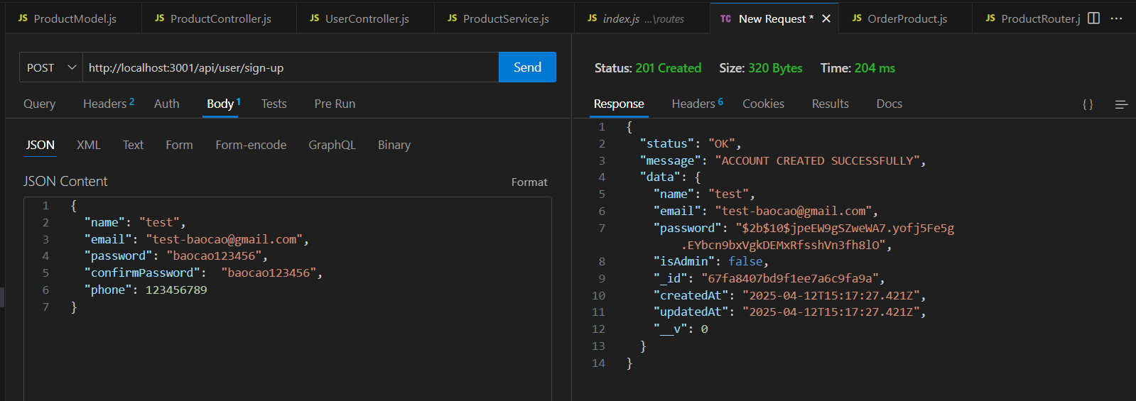
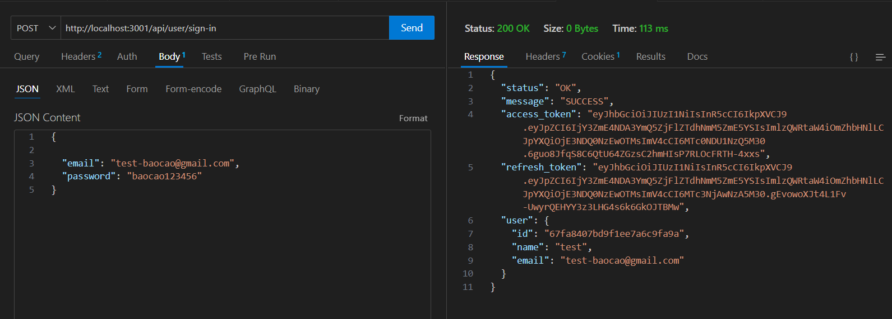

Lưu ý: cần thêm access-token vào Header để cập nhật được user
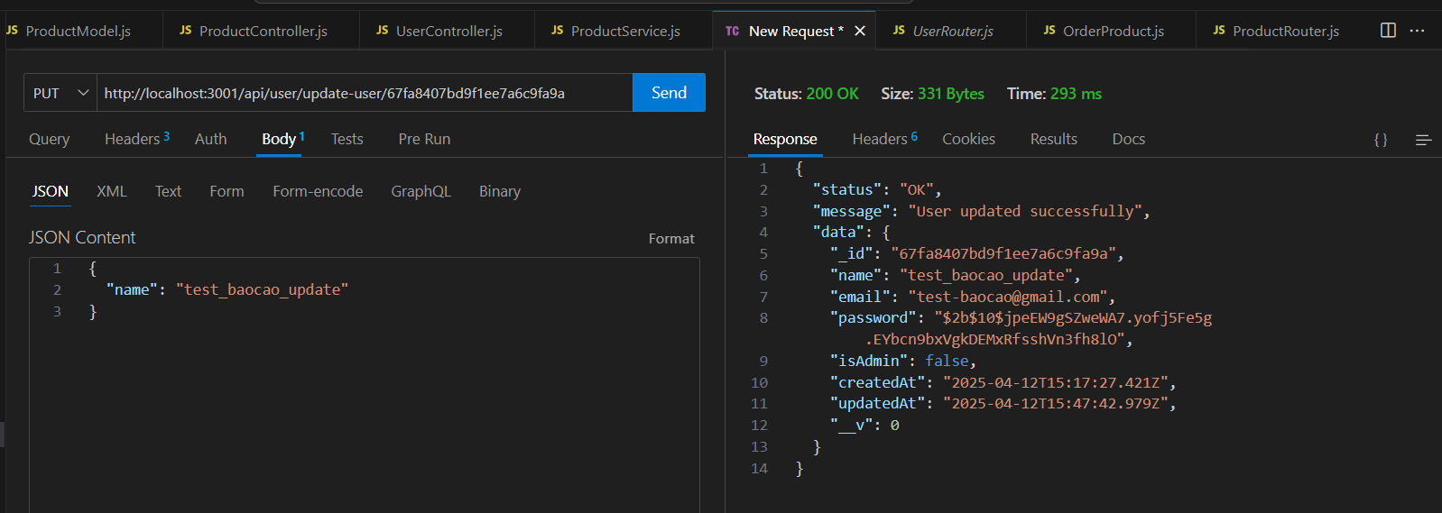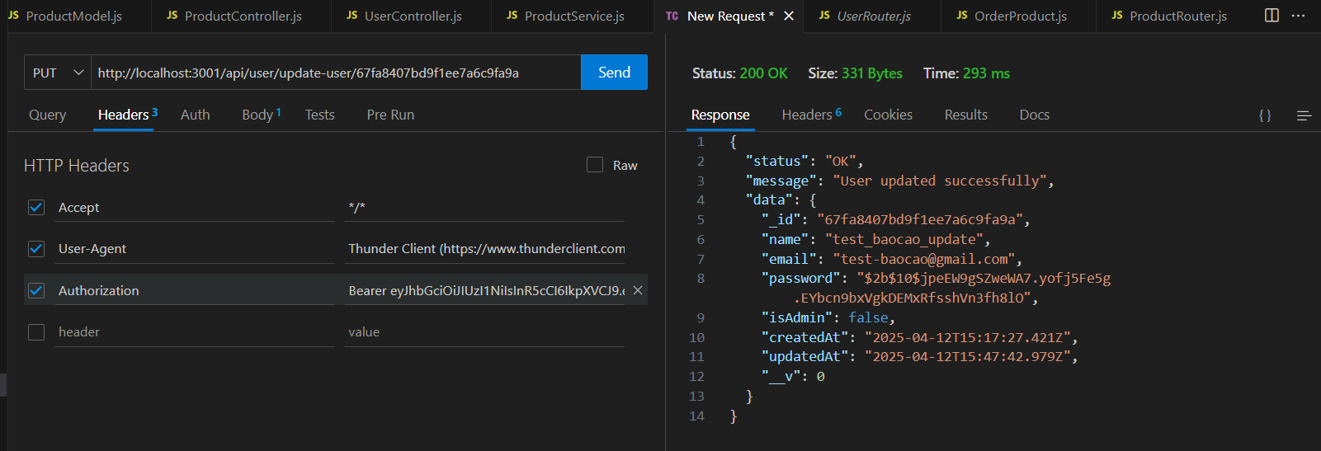
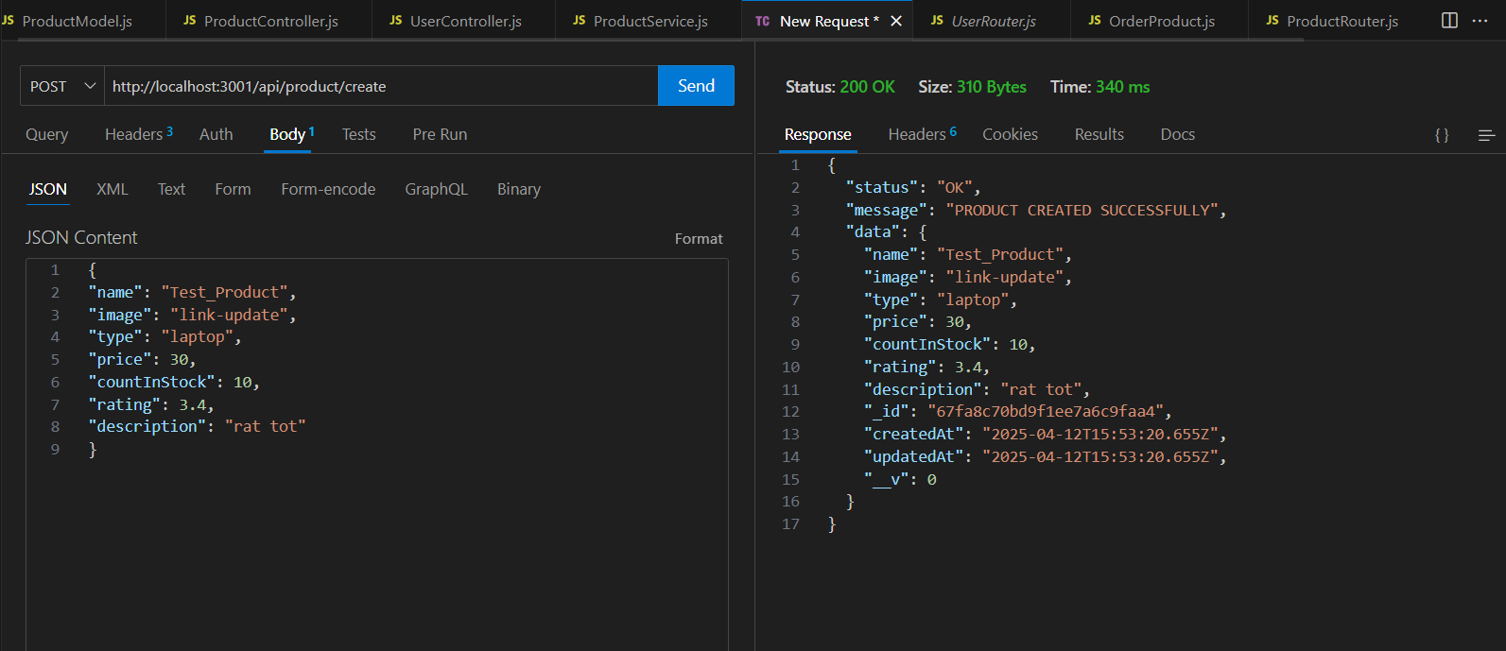
const express = require("express");
const router = express.Router();
const ProductController = require('../controllers/ProductController');
const {authMiddleWare} = require("../middleware/authMiddleware")

router.post("/create", ProductController.createProduct);
router.put("/update/:id", authMiddleWare, ProductController.updateProduct);
router.get('/get-details/:id', ProductController.getDetailsProduct);
router.delete('/delete-product/:id', authMiddleWare, ProductController.deleteProduct);
router.get('/getAll-product', ProductController.getAllProduct);

module.exports = router;

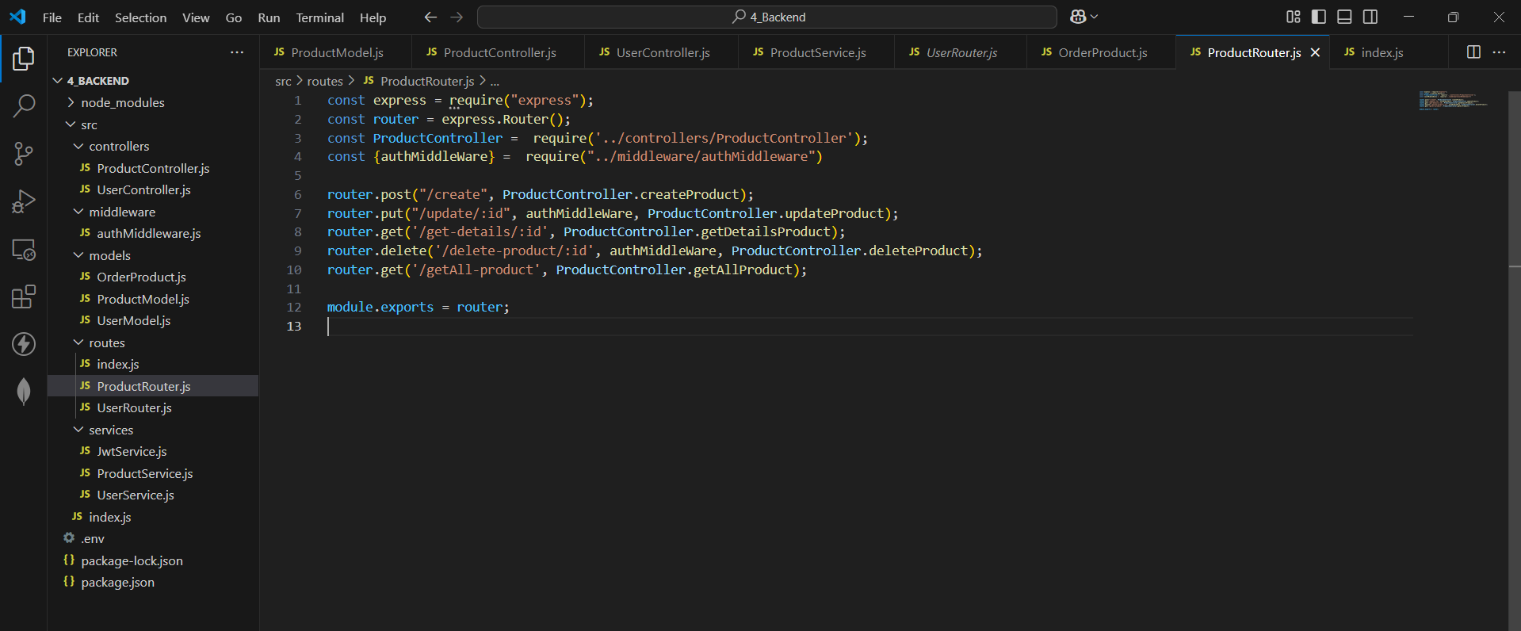

- Bổ sung xử lý order
const mongoose = require('mongoose');

const orderSchema = new mongoose.Schema({
orderItems: [
{
name: { type: String, required: true },
amount: { type: Number, required: true },
image: { type: String, required: true }, // sửa typeL thành type
price: { type: Number, required: true },
product: {
type: mongoose.Schema.Types.ObjectId,
ref: 'Product',
required: true,
},
},
],
shippingAddress: { // sửa Stting thành String
fullName: { type: String, required: true },
address: { type: String, required: true },
city: { type: String, required: true },
phone: { type: Number, required: true },
},
paymentMethod: { type: String, required: true },
itemsPrice: { type: Number, required: true },
shippingPrice: { type: Number, required: true },
totalPrice: { type: Number, required: true },
user: { type: mongoose.Schema.Types.ObjectId, ref: 'User', required: true },
isPaid: { type: Boolean, default: false },
paidAt: { type: Date }, // sửa paiAt thành paidAt
isDelivered: { type: Boolean, default: false },
deliveredAt: { type: Date },
}, {
timestamps: true,
});

const Order = mongoose.model("Order", orderSchema);
module.exports = Order;

- Controller
const OrderService = require('../services/OrderService');

const createOrder = async (req, res) => {
try {
console.log('req.body', req.body);

const {
paymentMethod,
itemsPrice,
shippingPrice,
totalPrice,
fullName,
address,
city,
phone,
orderItems
} = req.body;

// Ưu tiên kiểm tra orderItems trước
if (!orderItems || !Array.isArray(orderItems) || orderItems.length === 0) {
return res.status(400).json({
status: "ERROR",
message: "orderItems is required and must be a non-empty array"
});
}

// Sau đó kiểm tra các trường còn lại
if (!paymentMethod || !itemsPrice || !shippingPrice || !totalPrice || !fullName || !address || !city || !phone) {
return res.status(400).json({
status: "ERROR",
message: "The input is required"
});
}

const response = await OrderService.createOrder(req.body);

return res.status(200).json(response);
} catch (e) {
console.error("Create Order Error:", e);
return res.status(500).json({
status: "ERROR",
message: "Internal Server Error"
});
}
};

module.exports = {
createOrder

};

- Service
const Order = require("../models/OrderProduct");
const bcrypt = require("bcrypt");

const createOrder = (newOrder) => {
return new Promise(async (resolve, reject) => {
console.log("newOrder", newOrder)
const { orderItems, paymentMethod, itemsPrice, shippingPrice, totalPrice, fullName, address, city, phone, user } = newOrder;
try {

const createdOrder = await Order.create({
orderItems,
shippingAddress:{
fullName,
address,
city,
phone
},
paymentMethod,
itemsPrice,
shippingPrice,
totalPrice,
user: user,
});

if (createdOrder) {
return resolve({
status: 'OK',
message: 'ORDER CREATED SUCCESSFULLY',
data: createdOrder
});
}
console.log('createdOrder', createdOrder)

return resolve({
status: 'ERROR',
message: 'Order creation failed',
});

} catch (e) {
console.log("e", e)
return reject(e);
}
});
};

module.exports = {
createOrder
};

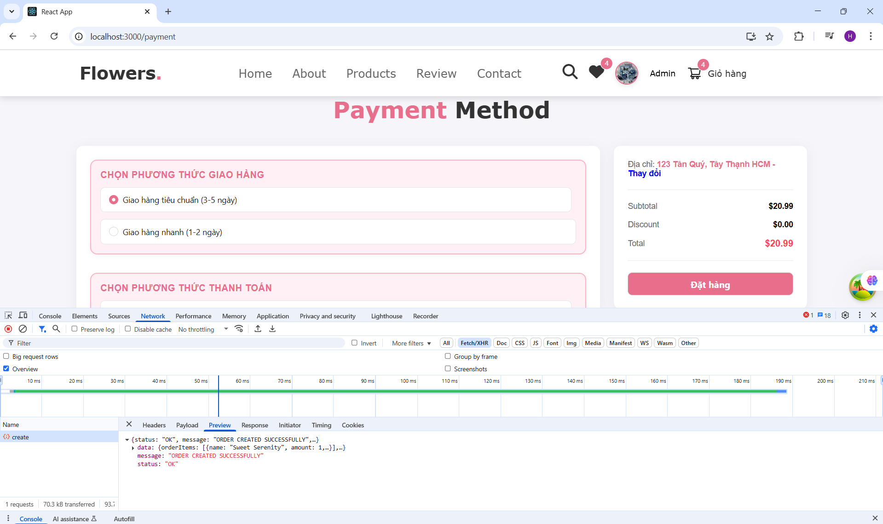
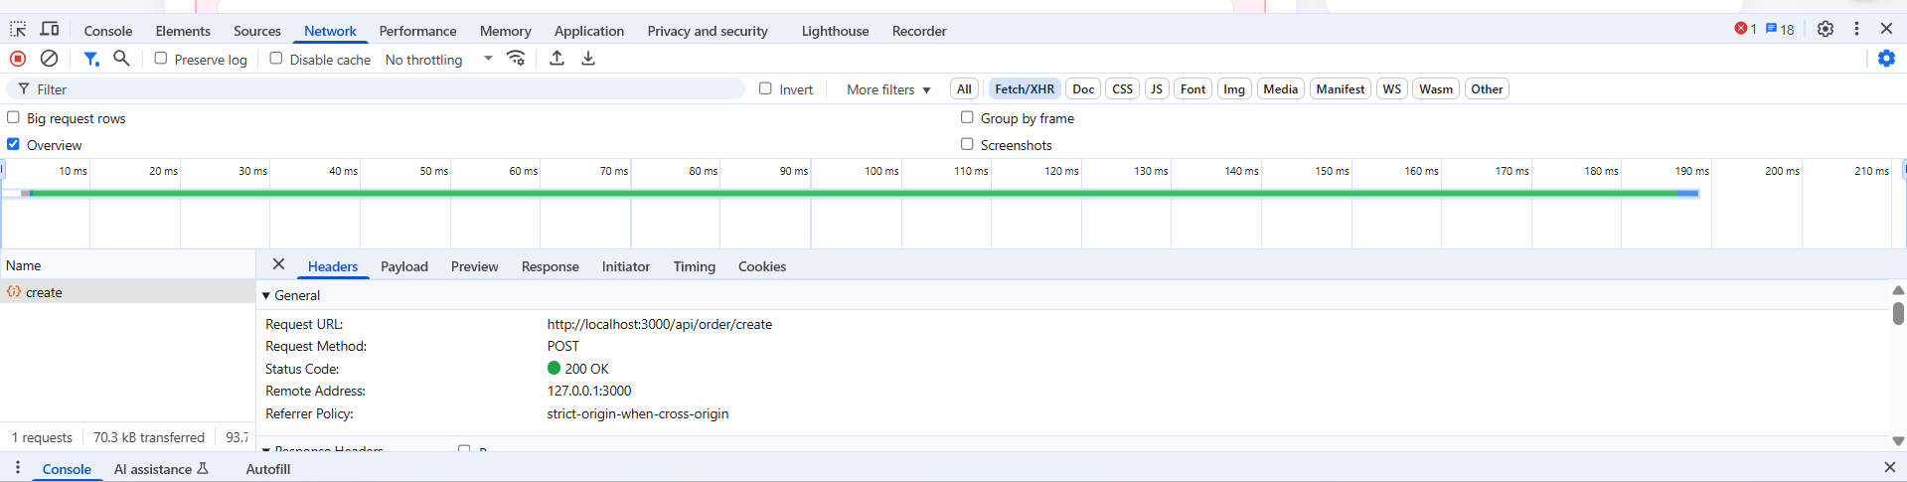

- Front-end
  - Component
    - AboutComponent: CSS inline
import React from "react";
import styled from "styled-components";
import video from '../../assets/images/video.mp4';

const AboutSection = styled.section`
width: 100%;
max-width: 12000px;
margin: 10px auto;
background: #f8f8f8;
padding: 30px 20px;
border-radius: 10px;
box-shadow: 0px 5px 15px rgba(0, 0, 0, 0.1);
font-family: Verdana, Geneva, Tahoma, serif, sans-serif;
`;

const Heading = styled.h1`
font-size: 3rem;
color: #333;
text-align: center;
margin-bottom: 30px;
font-weight: bolder;
span {
color: #e84393;
}
`;

const Row = styled.div`
display: flex;
align-items: center;
flex-wrap: wrap;
gap: 5rem;
justify-content: center;
`;

const VideoContainer = styled.div`
flex: 1 1 48%;
max-width: 700px;
position: relative; /* Để h3 nằm chồng lên video */

video {
width: 100%;
border: 1.5rem solid #fff;
border-radius: 10px;
box-shadow: 0 5px 15px rgba(0, 0, 0, 0.2);
}

h3 {
position: absolute;
font-family: Verdana, Geneva, Tahoma, serif, sans-serif;
font-weight: bolder;
top: 50%;
left: 50%;
transform: translate(-50%, -50%);
font-size: 3.55rem;
background: #fff;
width: 100%;
padding: 1rem 2rem;
text-align: center;
mix-blend-mode: screen;
}
`;

const Content = styled.div`
flex: 1 1 48%;
max-width: 500px;

h3 {
font-size: 30px;
color: #333;
margin-bottom: 15px;
font-weight: bolder;

}

p {
font-size: 30px;
color: #666;
line-height: 1.6;
margin-bottom: 10px;
}
`;

const LearnMoreButton = styled.a`
display: inline-block;
margin-top: 10px;
padding: 12px 24px;
background: #333;
color: white;
text-decoration: none;
border-radius: 40px;
transition: 0.01s ease-in-out;
font-size: 1.8rem;
font-family: Verdana, Geneva, Tahoma, serif, sans-serif;
text-align: center;

&:hover {
background:rgb(236, 119, 176);
}
`;

const AboutComponent = () => {
return (
<AboutSection>
<Heading>
<span>About</span> Us
</Heading>
<Row>
<VideoContainer>
<video src={video} loop autoPlay muted></video>
<h3>From Best Flowers Gardens</h3>
</VideoContainer>
<Content>
<h3>Why Choose Us?</h3>
<p>Lorem ipsum dolor sit amet, consectetur adipiscing elit, sed do eiusmod tempor incididunt ut labore et dolore magna aliqua.</p>
<p>Eu facilisis sed odio morbi quis commodo odio aenean sed adipiscing diam donec adipiscing tristique risus nec feugiat in fermentum</p>
<LearnMoreButton href="#">Learn More</LearnMoreButton>
</Content>
</Row>
</AboutSection>
);
};

export default AboutComponent;

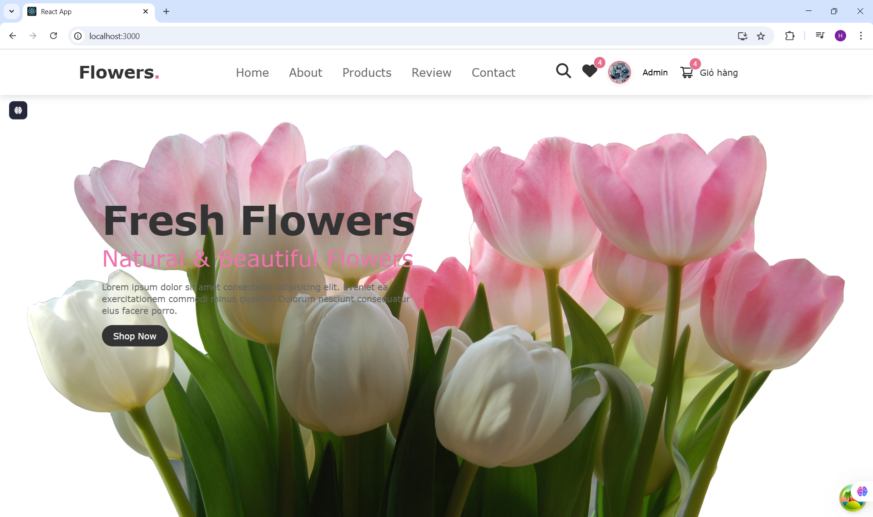
    - HeaderComponent
import React, { useEffect, useState } from "react";
import { Col, Badge, Popover, Spin } from "antd"; // Import Spin để hiển thị loading
import "bootstrap-icons/font/bootstrap-icons.css";
import "@fortawesome/fontawesome-free/css/all.min.css";
import { useNavigate } from "react-router-dom";
import { resetUser } from "../../redux/slides/userSlide";
import {
WrapperHeader,
WrapperLogoHeader,
WrapperCham,
WrapperNavbar,
WrapperIcons,
WrapperToggleInput,
WrapperToggleLabel,
WrapperHeaderAccount,
WrapperTextHeaderSmall,
WrapperContentPopup
} from "./style";
import { CaretDownOutlined, UserOutlined, ShoppingCartOutlined } from '@ant-design/icons';
import { useDispatch, useSelector } from "react-redux";
import * as UserService from '../../services/UserService';

const HeaderComponent = ({ isHiddenCart = false, isHiddenSearch = false, isHiddenHeart = false }) => {
const navigate = useNavigate();
const user = useSelector((state) => state.user);
const dispatch = useDispatch();
const [userName, setUserName] = useState('');
const [userAvatar, setUserAvatar] = useState('');

const [loading, setLoading] = useState(false);
const handleNavigateLogin = () => {
navigate('/sign-in');
};

const handleLogout = async () => {
setLoading(true);
await UserService.logoutUser();
dispatch(resetUser());
setLoading(false);
navigate('/');
};

useEffect(() => {
setLoading(true)
setUserName(user?.name)
setUserAvatar(user?.avatar)
setLoading(false)

}, [user?.name, user?.avatar])
const order = useSelector((state)=> state.order)
const content = (
<div>
{/* Hiển thị spinner khi loading là true */}
<WrapperContentPopup onClick={() => navigate('/profile-user')}>Thông tin người dùng</WrapperContentPopup>
{user?.isAdmin && (
<WrapperContentPopup onClick={() => navigate('/system/admin')}>Quản lý hệ thống</WrapperContentPopup>
)}
<WrapperContentPopup onClick={handleLogout}>
{loading ? <Spin size="small" /> : 'Đăng xuất'}
</WrapperContentPopup>

</div>
);

return (
<WrapperHeader >
{/* Toggle Menu */}
<WrapperToggleInput type="checkbox" id="toggler" />
<WrapperToggleLabel htmlFor="toggler" className="fas fa-bars" />

{/* Logo */}
<Col span={6}>
<WrapperLogoHeader style={{ cursor: 'pointer' }} onClick={() => navigate('/')}>
Flowers<WrapperCham>.</WrapperCham>
</WrapperLogoHeader>
</Col>

{/* Navbar */}
<WrapperNavbar>
<div role="link" onClick={() => navigate('/')}>Home</div>
<div href="#about">About</div>
<div onClick={() => navigate('/products')}>Products</div>
<div href="#review">Review</div>
<div href="#contact">Contact</div>
</WrapperNavbar>

{/* Icons */}
<Col span={8} style={{ display: 'flex', gap: '20px' }}>
<WrapperIcons>
<div className="icon1">
{!isHiddenSearch &&(
<a onClick={() => navigate('/search')} className="fas fa-search"></a>
)}

{!isHiddenHeart && (
<Badge count={4} size="medium" style={{ transform: 'translate(15px, -7px)' }} color="#e76f8b">
<a href="#" className="fas fa-heart"></a>
</Badge>
)}

<WrapperHeaderAccount>

{userAvatar ? (<img src={userAvatar} alt='avatar' style={{
height: '40px',
width: '40px',
borderRadius: '50%',
objectFit: 'cover',
border: '2px solid #e76f8b',
boxShadow: '0 2px 8px rgba(0, 0, 0, 0.1)',
transition: 'transform 0.3s ease-in-out',
}} />) : (<UserOutlined style={{ fontSize: '26px' }} />)}

{user?.name ? (
<>
<Popover content={content} trigger="click">
<span style={{ cursor: 'pointer' }}>{user.name}</span>
</Popover>
</>
) : (
<div onClick={handleNavigateLogin} style={{ cursor: 'pointer' }}>
<WrapperTextHeaderSmall >Đăng ký/Đăng nhập</WrapperTextHeaderSmall>
<div>
<WrapperTextHeaderSmall>Tài khoản</WrapperTextHeaderSmall>
<CaretDownOutlined />
</div>
</div>
)}
</WrapperHeaderAccount>
<WrapperHeaderAccount onClick={() => navigate('/order')} style={{ cursor: 'pointer' }}>
{!isHiddenCart && (
<div style={{ display: 'flex', gap: '10px' }}>
<Badge count={order?.orderItems?.length} size="medium" style={{ transform: 'translate(12px, -12px)' }} color="#e76f8b">
<ShoppingCartOutlined style={{ fontSize: '26px' }} />
</Badge>
<WrapperTextHeaderSmall style={{ marginTop: '5px' }}>Giỏ hàng</WrapperTextHeaderSmall>
</div>
)}

</WrapperHeaderAccount>
</div>
</WrapperIcons>
</Col>
</WrapperHeader>
);
};

export default HeaderComponent;

- CSS: style.js
import { Row } from "antd";
import styled from "styled-components";

export const WrapperHeader = styled(Row)`
position: fixed;
top: 0;
left: 0;
right: 0;
background: #fff;
padding: 2rem 9%;
display: flex;
align-items: center;
//justify-content: space-between;
justify-content: ${(props) => (props.isHiddenCart && props.isHiddenSearch && props.isHiddenHeart ? 'center' : 'space-between')};
z-index: 1000;
box-shadow: 0 0.5rem 1rem rgba(0, 0, 0, 0.1);
font-family: Verdana, Geneva, Tahoma, serif, sans-serif;

`;

export const WrapperLogoHeader = styled.span`
font-size: 3rem;
color: #333;
font-weight: bolder;
display: flex;
align-items: center;
font-family: Verdana, Geneva, Tahoma, serif, sans-serif;
`;

export const WrapperCham = styled.span`
font-size: 3rem;
color: #e76f8b;
font-weight: bold;
margin-left: 0px;
font-family: Verdana, Geneva, Tahoma, serif, sans-serif;
`;

export const WrapperNavbar = styled.div`
display: flex;
gap: 3.5rem;
margin-left: -110px;

div {
font-size: 2rem;
color: #666;
text-decoration: none;
transition: 0.001s linear;
cursor: pointer;

&:hover {
color: #e76f8b;
}
}

/* Ẩn menu mặc định trên màn hình nhỏ */
@media (max-width: 768px) {
display: none;
flex-direction: column;
position: absolute;
top: 100%;
left: 0;
width: 100%;
background: #fff;
box-shadow: 0 .5rem 1rem rgba(0, 0, 0, .1);
padding: 1rem 0;
text-align: center;
}
`;

export const WrapperIcons = styled.div`
display: flex;
align-items: center;
gap: 10px;
.icon1 {
display: flex;
gap: 2rem;

a {
margin-top: 5px;
font-size: 26px;
color: #333;
transition: 0.2s linear;

&:hover {
color: #e76f8b;
}
}
}
`;

export const WrapperCartButton = styled.button`
padding: 5px 8px;
background: none;
border: none;
color: #333;
position: relative;
cursor: pointer;

.bi {
font-size: 23px;
}
`;

export const WrapperToggleInput = styled.input`
display: none;

/* Khi checkbox được checked, hiển thị menu */
&:checked ~ ${WrapperNavbar} {
display: flex;
}
`;

export const WrapperToggleLabel = styled.label`
font-size: 3rem;
color: #333;
border-radius: .5rem;
padding: .5rem 1.5rem;
cursor: pointer;
border: .1rem solid rgba(0, 0, 0, .3);
display: none;

@media (max-width: 768px) {
display: block;
}
`;

export const WrapperHeaderAccount = styled.div`
display: flex;
align-items: center;
gap: 20px;
font-family: Verdana, Geneva, Tahoma, serif, sans-serif;

&:hover {
color: #e76f8b;
}
`
export const WrapperTextHeaderSmall = styled.span`
font-size: 15px;
font-family: Verdana, Geneva, Tahoma, serif, sans-serif;
color: #333;
&:hover {
color: #e76f8b;
}
`
export const WrapperIconHeader = styled.span`
font-size: 11px;
color: #fff;

`

export const WrapperContentPopup = styled.p`
cursor: pointer;
&:hover{
color: #e76f8b;
}
`
Trạng thái chưa đăng nhập
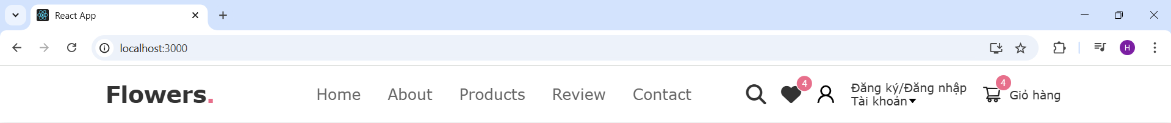
Có isAdmin = true
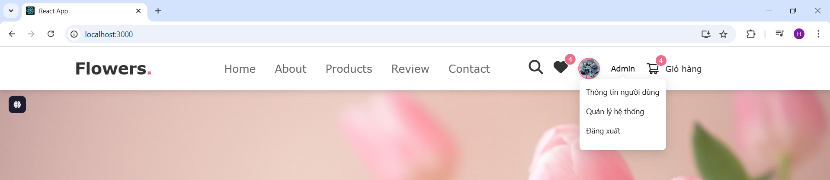
Có isAdmin = False
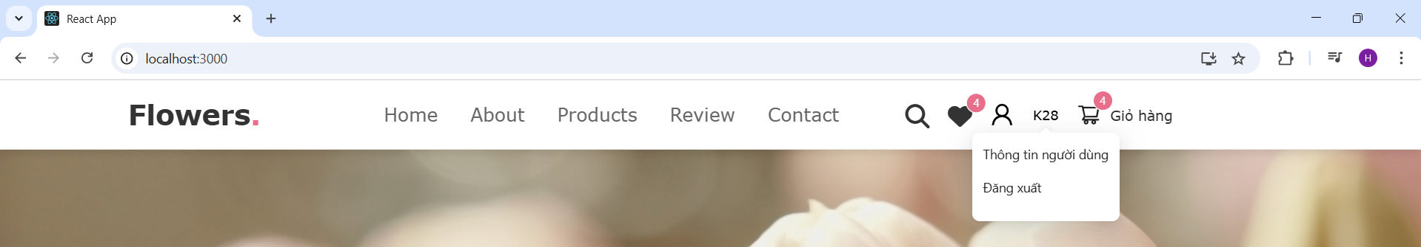
    - FooterComponent
import React from "react";
import { FooterContainer, BoxContainer, Box, Credit, StyledLink, ContactImage } from "./style";
import c from "../../assets/images/c.png"

const Footer = () => {
return (
<FooterContainer>
<BoxContainer>
<Box>
<h3>Quick links</h3>
<StyledLink href="#home">Home</StyledLink>
<StyledLink href="#about">About</StyledLink>
<StyledLink href="#products">Products</StyledLink>
<StyledLink href="#review">Review</StyledLink>
<StyledLink href="#contact">Contact</StyledLink>
</Box>

<Box>
<h3>Extra Links</h3>
<StyledLink href="#home">My Account</StyledLink>
<StyledLink href="#about">My Order</StyledLink>
<StyledLink href="#products">My Favorite</StyledLink>
</Box>

<Box>
<h3>Locations</h3>
<StyledLink href="#home">USA</StyledLink>
<StyledLink href="#about">Vietnam</StyledLink>
<StyledLink href="#products">France</StyledLink>
<StyledLink href="#review">England</StyledLink>
</Box>

<Box>
<h3>Contact Info</h3>
<StyledLink href="#home">+84-942-432-8492</StyledLink>
<StyledLink href="#about" className="e1">yourflowersgarden@gmail.com</StyledLink>
<StyledLink href="#products">Ho Chi Minh City, Vietnam</StyledLink>
<ContactImage src={c} alt="Contact" />
</Box>
</BoxContainer>

<Credit> Created By <span style={{color:"#e76f8b"}}> DangNgocHongYen - 2274802011043</span> || All Rights Reserved </Credit>
</FooterContainer>
);
};

export default Footer;

- Css: style.js
import styled from "styled-components";

export const FooterContainer = styled.footer`
background-color: var(--white);
padding: 2rem 0;
margin-top: auto; /* Đẩy Footer xuống dưới cùng */
width: 100%;
font-family: Verdana, Geneva, Tahoma, serif, sans-serif;
`;

export const BoxContainer = styled.div`
max-width: 1200px;
margin: 0 auto;
display: grid;
grid-template-columns: repeat(auto-fit, minmax(27rem, 1fr));
gap: 1.5rem;
align-items: flex-start;
`;

export const Box = styled.div`
h3 {
font-size: 2.5rem;
color: black;
font-weight: bolder;
margin-bottom: 1.5rem;
text-transform: uppercase;
}
`;

export const StyledLink = styled.a`
font-size: 1.7rem;
color: var(--light-color);
padding: 1rem 0;
display: block;
text-decoration: none;

&:hover {
text-decoration: underline;
color: #e76f8b;
}
`;

export const ContactImage = styled.img`
width: 300px;
margin-top: 1rem;
`;

export const Credit = styled.div`
text-align: center;
padding: 1.5rem;
margin-top: 1.5rem;
padding-top: 2.5rem;
font-size: 2rem;
color: #333;
border-top: 0.1rem solid rgba(0, 0, 0, 0.1);

span {
color: var(--pink);
}
`;

export const EmailText = styled.p`
text-transform: lowercase;
`;

    - ButtonComponent: tạo các Button trong website bằng cách import và truyền tham số mà ko cần viết lại code
import React, { useState } from 'react';
import { Button } from 'antd';
import { SearchOutlined } from '@ant-design/icons'; // Import icon

const ButtonComponent = ({
size,
disabled,
styleButton = {},
styleTextButton,
textButton,
showIcon = false,
colorButton = '#fff',
...rests
}) => {
const [isClicked, setIsClicked] = useState(false);

return (
<Button
size={size}
disabled={disabled}
onMouseDown={() => setIsClicked(true)}
onMouseUp={() => setIsClicked(false)}
onMouseLeave={() => setIsClicked(false)}
style={{
...styleButton,
background: disabled ? "#ccc" : styleButton?.background,
boxShadow: isClicked
? '0px 2px 5px rgba(231, 111, 139, 0.8)'
: 'none',
transition: 'all 0.2s ease-in-out'
}}
{...rests}
>
{showIcon && <SearchOutlined style={{ color: colorButton, marginRight: 8 }} />}
<span style={styleTextButton}>{textButton}</span>
</Button>
);
};

export default ButtonComponent;

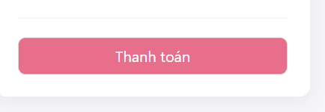
    - CardComponent
import React, { useState } from "react";
import {
Box,
ImageContainer,
Discount,
Icons,
IconButton,
Content,
ProductTitle,
Price
} from "./style";
import { useNavigate } from "react-router-dom";
import { useDispatch, useSelector } from 'react-redux';
import { addOrderProduct, addToWishlist, toggleWishlist, removeFromWishlist } from '../../redux/slides/orderSlide';
import { useLocation } from 'react-router-dom';

const CardComponent = (props) => {
const { countInSttock, description, image, name, price, rating, type, discount, id } = props;
const navigate = useNavigate();
const dispatch = useDispatch();
const location = useLocation();

const [cartAnimate, setCartAnimate] = useState(false);
const [heartAnimate, setHeartAnimate] = useState(false);

const handleDetailsProduct = (id) => {
navigate(`/product-details/${id}`);
};
const user = useSelector((state) => state.user);

const handleAddToCart = (e) => {
e.stopPropagation();
const newProduct = {
product: id,
name,
image,
price,
amount: 1
};
dispatch(addOrderProduct({ orderItems: newProduct }));

setCartAnimate(true);
setTimeout(() => setCartAnimate(false), 300);
};

// const handleHeartClick = (e) => {
// e.stopPropagation();
// setHeartAnimate(true);
// setTimeout(() => setHeartAnimate(false), 300);
// };

const wishlist = useSelector((state) => state.order.wishlistItems);

const handleHeartClick = (e) => {
e.stopPropagation();

if (!user?.id) {
navigate('/sign-in', { state: location.pathname });
} else {
const isWished = wishlist.find(item => item.product === id);
if (isWished) {
dispatch(removeFromWishlist(id));
} else {
const newItem = {
product: id,
name,
image,
price
};
dispatch(addToWishlist(newItem));
}
}

setHeartAnimate(true);
setTimeout(() => setHeartAnimate(false), 300);
};

return (
<Box style={{ cursor: "pointer" }} onClick={() => handleDetailsProduct(id)}>
<Discount>- {discount || 10}%</Discount>
<ImageContainer>
<img src={image} alt={name} />
<Icons>
<IconButton
className={`fas fa-heart ${heartAnimate ? "animate-pop" : ""}`}
onClick={handleHeartClick}
/>
<IconButton
className={`cart-btn ${cartAnimate ? "animate-pop" : ""}`}
onClick={handleAddToCart}
>
Add to Cart
</IconButton>

<IconButton className="fas fa-share" />
</Icons>
</ImageContainer>
<Content>
<ProductTitle>{name}</ProductTitle>
<Price>${price} <span>$21.99</span></Price>
</Content>
</Box>
);
};

export default CardComponent;

import styled from "styled-components";

export const ProductsContainer = styled.section`
padding: 4rem 10%;
`;

export const Heading = styled.h1`
text-align: center;
font-size: 4rem;
font-weight: bold;
margin-bottom: 3rem;

span {
color: var(--pink);
}
`;

export const BoxContainer = styled.div`
display: grid;
grid-template-columns: repeat(3, 1fr);
gap: 1rem;
justify-content: center;
align-items: start;

@media (max-width: 1024px) {
grid-template-columns: repeat(2, 1fr);
}

@media (max-width: 768px) {
grid-template-columns: repeat(1, 1fr);
justify-content: center;
}
`;

export const Box = styled.div`
width: 420px;
height: 630px;
box-shadow: 0 1rem 2rem rgba(0,0,0,0.1);
border-radius: 1rem;
border: 0.15rem solid rgba(0, 0, 0, 0.1);
position: relative;
background: #fff;
display: flex;
flex-direction: column;
align-items: center;
justify-content: space-between;
padding: 10px;
`;

export const Discount = styled.span`
position: absolute;
top: 1rem;
left: 1rem;
padding: 0.9rem 1.4rem;
font-size: 2rem;
color: #e76f8b;
font-weight: bold;
background: rgba(255, 52, 153, 0.05);
z-index: 1;
border-radius: 0.5rem;
`;

export const ImageContainer = styled.div`
position: relative;
text-align: center;
width: 100%;
height: 500px;
overflow: hidden;

img {
width: 100%;
height: 100%;
object-fit: cover;
transition: 0.3s ease-in-out;

&:hover {
transform: scale(1.1);
}
}
`;

export const Icons = styled.div`
position: absolute;
bottom: -6rem;
left: 0;
right: 0;
display: flex;
justify-content: space-between;
transition: 0.3s ease-in-out;

${Box}:hover & {
bottom: 0;
}
`;

export const IconButton = styled.a`
height: 5rem;
line-height: 5rem;
font-size: 2rem;
width: 33.3%;
background: #e76f8b;
color: #fff;
text-align: center;
cursor: pointer;
transition: 0.3s ease-in-out;

&:hover {
background: grey;
}

&.cart-btn {
border-left: 1px solid #fff7;
border-right: 1px solid #fff7;
width: 100%;
}
`;

export const Content = styled.div`
padding: 0.8rem;
text-align: center;
`;

export const ProductTitle = styled.h3`
font-size: 3rem; /* Tăng kích thước chữ */
color: #333;
`;

export const Price = styled.div`
font-size: 3rem; /* Tăng kích thước giá */
color: #e76f8b;
font-weight: bold;
padding-top: 0.5rem; /* Giảm khoảng cách giữa tiêu đề và giá */

span {
font-size: 2rem;
color: #999;
text-decoration: line-through;
margin-left: 0.5rem;
}
`;

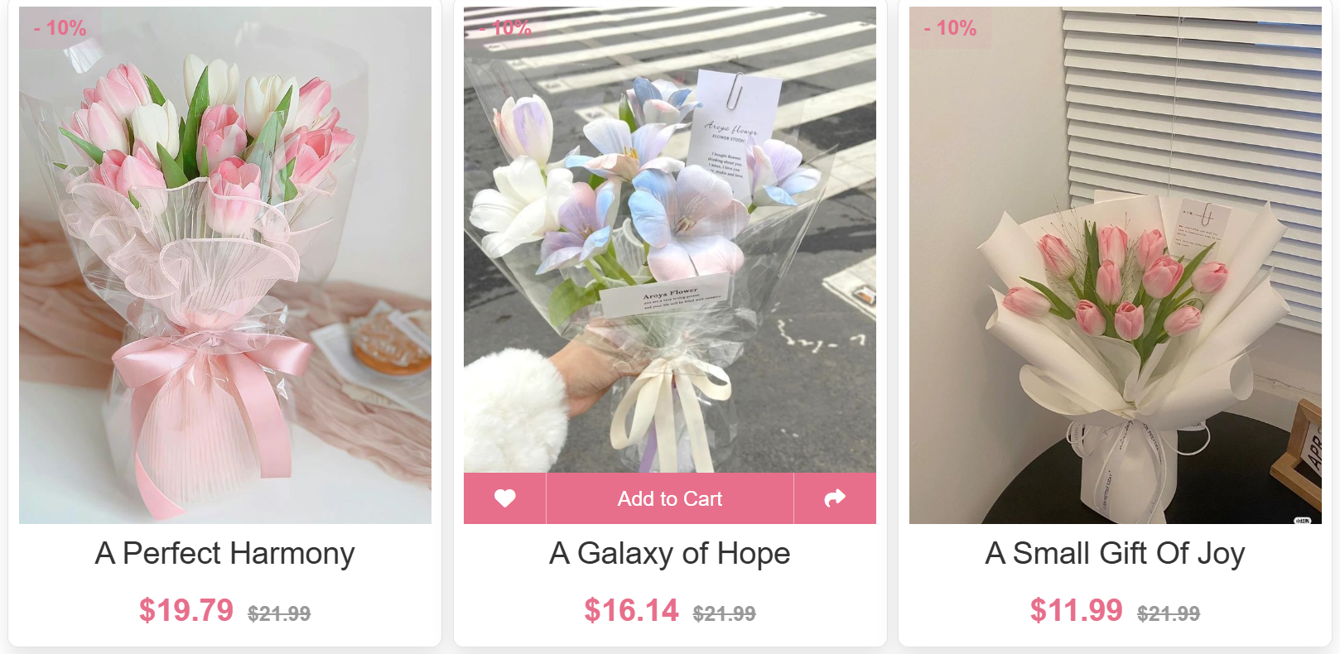
    - AdminProduct
import React, { useEffect, useRef } from "react";
import { WrapperHeader } from "./style";
import { Button, Form, Space } from 'antd';
import { PlusOutlined, EditOutlined, DeleteOutlined, SearchOutlined } from '@ant-design/icons';
import TableComponent from "../TableComponent/TableComponent";
import { useState } from "react";
import InputComponent from '../../components/InputComponent/InputComponent';
import { getBase64 } from "../../untils";
import { WrapperUploadFile } from './style';
import * as ProductService from '../../services/ProductService';
import { useMutationHook } from '../../hooks/useMutationHook';
import * as message from '../../components/Message/Message';
import { useQuery } from "@tanstack/react-query";
import DrawerComponent from "../DrawerComponent/DrawerComponent";
import Loading from "../LoadingComponent/Loading";
import { useSelector } from "react-redux";
import ModalComponent from "../ModalComponent/ModalComponent";
import FooterComponent from "../../components/FooterComponent/FooterComponent"

const AdminProduct = () => {
const [isModalOpen, setIsModalOpen] = useState(false);
const [rowSelected, setRowSelected] = useState('');
const [isOpenDrawer, setIsOpenDrawer] = useState(false);
const [stateProduct, setStateProduct] = useState({
name: '',
price: '',
descriptions: '',
rating: '',
image: '',
type: '',
countInStock: ''

});

const [searchText, setSearchText] = useState('');
const [searchedColumn, setSearchedColumn] = useState('');
const searchInput = useRef(null);

const [isModalOpenDelete, setIsModalOpenDelete] = useState(false)
const [isLoadingUpdate, setISLoadingUpdate] = useState(false);
const user = useSelector((state) => state?.user)
const [stateProductDetails, setStateProductDetails] = useState({
name: '',
price: '',
descriptions: '',
rating: '',
image: '',
type: '',
countInStock: ''
});

const [form] = Form.useForm();

const mutation = useMutationHook(
(data) => {
const { name,
price,
descriptions,
rating,
image,
type,
countInStock } = data;
const res = ProductService.createProduct({
name, price, descriptions, rating, image, type, countInStock
});
return res;
}
);

console.log('rowSelected', rowSelected)
const mutationUpdate = useMutationHook( //Đã check
(data) => {
console.log('data', data)
const { id, token, ...rests } = data;
const res = ProductService.updateProduct(
id,
{ ...rests },
token,
);
return res
}
);

const mutationDeleted = useMutationHook(
(data) => {
console.log('data', data)
const { id, token } = data;
const res = ProductService.deleteProduct(
id,
token
);
return res
}
);

const [page, setPage] = useState(1);
const [limit, setLimit] = useState(6);

const getAllProducts_2 = async () => {
const res = await ProductService.getAllProducts_2({
limit,
page: page - 1,
search: searchText
});
return res;
};

const fetchGetDetailsProducts = async (rowSelected) => { //Đã check

const res = await ProductService.getDetailsProduct(rowSelected)
if (res?.data) {
setStateProductDetails({
name: res?.data?.name,
price: res?.data?.price,
descriptions: res?.data?.descriptions,
rating: res?.data?.rating,
image: res?.data?.image,
type: res?.data?.type,
countInStock: res?.data?.countInStock
})
}

}
useEffect(() => {
form.setFieldsValue(stateProductDetails)
}, [form, stateProductDetails]) //Đã check
useEffect(() => {//Đã check
if (rowSelected) {
setISLoadingUpdate(true)
fetchGetDetailsProducts(rowSelected)
}
}, [rowSelected])

const handleDetailsProduct = () => { //Đã check
// if (rowSelected) {
// setISLoadingUpdate(true)
// fetchGetDetailsProducts()
// }
setIsOpenDrawer(true)
}
const { data, isLoading, isSuccess, isError } = mutation //Đã checkcheck
const { data: dataUpdated, isLoading: isLoadingUpdated, isSuccess: isSuccessUpdated, isError: isErrorUpdated } = mutationUpdate //Đã check
const { data: dataDeleted, isLoading: isLoadingDelete, isSuccess: isSuccessDeleted, isError: isErrorDeleted } = mutationDeleted
const queryProduct = useQuery({ //Dã check
queryKey: ['products', page],
queryFn: getAllProducts_2
});
const { isLoading: isLoadingProducts, data: products } = queryProduct
const renderAction = () => {
return (
<div>
<DeleteOutlined style={{ fontSize: "25px", color: "red", cursor: 'pointer' }} onClick={() => setIsModalOpenDelete(true)} />
<EditOutlined style={{ fontSize: "25px", color: "green", cursor: 'pointer' }} onClick={handleDetailsProduct} />
</div>
)
}
const handleSearch = (selectedKeys, confirm, dataIndex) => {
confirm();
// setSearchText(selectedKeys[0]);
// setSearchedColumn(dataIndex);
};
const handleReset = clearFilters => {
clearFilters();
///setSearchText('');
};
const getColumnSearchProps = dataIndex => ({
filterDropdown: ({ setSelectedKeys, selectedKeys, confirm, clearFilters }) => (
<div style={{ padding: 8 }} onKeyDown={e => e.stopPropagation()}>
<InputComponent
ref={searchInput}
placeholder={`Search ${dataIndex}`}
value={selectedKeys[0]}
onChange={e => setSelectedKeys(e.target.value ? [e.target.value] : [])}
onPressEnter={() => handleSearch(selectedKeys, confirm, dataIndex)}
style={{ marginBottom: 8, display: 'block' }}
/>
<Space>
<Button
type="primary"
onClick={() => handleSearch(selectedKeys, confirm, dataIndex)}
icon={<SearchOutlined />}
size="small"
style={{ width: 90 }}
>
Search
</Button>
<Button
onClick={() => clearFilters && handleReset(clearFilters)}
size="small"
style={{ width: 90 }}
>
Reset
</Button>
</Space>
</div>
),
filterIcon: filtered => <SearchOutlined style={{ color: filtered ? '#1677ff' : undefined }} />,
onFilter: (value, record) =>
record[dataIndex].toString().toLowerCase().includes(value.toLowerCase()),
filterDropdownProps: {
onOpenChange(open) {
if (open) {
setTimeout(() => {
var _a;
return (_a = searchInput.current) === null || _a === void 0 ? void 0 : _a.select();
}, 100);
}
},
},
});

const columns = [
{
title: 'Name',
dataIndex: 'name',
sorter: (a, b) => a.name.length - b.name.length,
...getColumnSearchProps('name')
},
{
title: 'Price',
dataIndex: 'price',
sorter: (a, b) => a.price - b.price,
filters: [
{
text: '>= 50',
value: '>=',
},
{
text: '<= 50',
value: '<=',
},
],
onFilter: (value, record) => {

if (value === '>=') {
return record.price >= 50
}
return record.price <= 50

},
},

{
title: 'Rating',
dataIndex: 'rating',
sorter: (a, b) => a.rating - b.rating,
filters: [
{
text: '>= 3',
value: '>=',
},
{
text: '<= 3',
value: '<=',
},
],
onFilter: (value, record) => {
console.log("checkrating", {value, record})
if (value === '>=') {
return Number(record.rating) >= 3
}
return Number(record.rating) <= 3

},

},
{
title: 'Type',
dataIndex: 'type',
},
{
title: 'Action',
dataIndex: 'action',
render: renderAction
},
];

const dataTable = products?.data?.length && products?.data?.map((product) => {
return { ...product, key: product._id }
})

useEffect(() => {
if (mutation.isSuccess && data?.status === 'OK') {
message.success();
handleCancel();
} else if (mutation.isError) {
message.error();
}
}, [mutation.isSuccess]);

useEffect(() => {
if (mutation.isSuccessDeleted && dataDeleted?.status === 'OK') {
message.success();
handleCancelDelete();
} else if (mutation.isErrorDeleted) {
message.error();
}
}, [mutation.isSuccessDeleted]);

useEffect(() => {
if (isSuccessUpdated && dataUpdated?.status === 'OK') {
message.success();
handleCloseDrawer();
} else if (isErrorUpdated) {
message.error();
}
}, [isSuccessUpdated, isErrorUpdated]);

const handleCancel = () => {
setIsModalOpen(false);
setStateProduct({
name: '',
price: '',
descriptions: '',
rating: '',
image: '',
type: '',
countInStock: ''
});
form.resetFields();
};

const handleCancelDelete = () => {
setIsModalOpenDelete(false)
}
const handleDeleteProduct = () => {
mutationDeleted.mutate({ id: rowSelected, token: user?.access_token }, {
onSettled: () => {
queryProduct.refetch();
setIsModalOpenDelete(false);
}
})
}
const handleCloseDrawer = () => {
setIsOpenDrawer(false)
setStateProductDetails({
name: '',
price: '',
descriptions: '',
rating: '',
image: '',
type: '',
countInStock: ''
});
form.resetFields();
};

const onFinish = () => {

mutation.mutate(stateProduct, {
onSettled: () => {
queryProduct.refetch()
}
})
};

const handleOnChange = (e) => { //Đã check
setStateProduct({
...stateProduct,
[e.target.name]: e.target.value
});
};

const handleOnChangeDetails = (e) => { //Đã check
console.log('check', e.target.name, e.target.value)
setStateProductDetails({
...stateProductDetails,
[e.target.name]: e.target.value
})
}

const handleOnchangeAvatar = async ({ fileList }) => { //Đã check
const file = fileList[0];
if (!file.url && !file.preview) {
file.preview = await getBase64(file.originFileObj);
}
setStateProduct({
...stateProduct,
image: file.preview
});
};

const handleOnchangeAvatarDetails = async ({ fileList }) => { //Đã check
const file = fileList[0];
if (!file.url && !file.preview) {
file.preview = await getBase64(file.originFileObj);
}
setStateProductDetails({
...stateProductDetails,
image: file.preview
});
};
console.log('user', user)
const onUpdateProduct = () => { //Đã check
console.log('Attempting to update product with ID:', rowSelected);
mutationUpdate.mutate({ id: rowSelected, token: user?.access_token, ...stateProductDetails }, {
onSettled: () => {
queryProduct.refetch()
}
})
}

return (
<div>
<WrapperHeader>Quản lý sản phẩm</WrapperHeader>
<div style={{ marginTop: '10px' }}>
<Button style={{ height: '150px', width: '150px', borderRadius: '6px', borderStyle: 'dashed' }} onClick={() => setIsModalOpen(true)}>
<PlusOutlined style={{ fontSize: '60px' }} />
</Button>
</div>
<div style={{ marginTop: '20px' }}>
{/* <TableComponent columns={columns} isLoading={isLoadingProducts} data={dataTable} onRow={(record, rowIndex) => {
return {
onClick: event => {
setRowSelected(record._id)
}
}
}} /> */}
<TableComponent
columns={columns}
isLoading={isLoadingProducts}
data={dataTable}
pagination={{
current: page,
pageSize: limit,
total: products?.total || 0,
onChange: (newPage) => setPage(newPage),
showSizeChanger: false,
}}
onRow={(record) => ({
onClick: () => {
setRowSelected(record._id);
},
})}
/>

</div>
<ModalComponent forceRender title="Tạo sản phẩm" open={isModalOpen} onCancel={handleCancel} footer={null}>
<Form
name="basic"
labelCol={{ span: 6 }}
wrapperCol={{ span: 18 }}
style={{ maxWidth: 600 }}
onFinish={onFinish}
autoComplete="on"
form={form}
>
<Form.Item
label="Name"
name="name"
rules={[{ required: true, message: 'Tên sản phẩm' }]}
>
<InputComponent value={stateProduct.name} onChange={handleOnChange} name="name" />
</Form.Item>
<Form.Item
label="Type"
name="type"
rules={[{ required: true, message: 'Loại sản phẩm' }]}
>
<InputComponent value={stateProduct.type} onChange={handleOnChange} name="type" />
</Form.Item>

<Form.Item
label="CountInStock"
name="countInStock"
rules={[{ required: true, message: 'Số sản phẩm còn lại' }]}
>
<InputComponent value={stateProduct.countInStock} onChange={handleOnChange} name="countInStock" />
</Form.Item>

<Form.Item
label="Price"
name="price"
rules={[{ required: true, message: 'Giá sản phẩmphẩm' }]}
>
<InputComponent value={stateProduct.price} onChange={handleOnChange} name="price" />
</Form.Item>

<Form.Item
label="Rating"
name="rating"
rules={[{ required: true, message: 'Đánh giá sản phẩmphẩm' }]}
>
<InputComponent value={stateProduct.rating} onChange={handleOnChange} name="rating" />
</Form.Item>

<Form.Item
label="Description"
name="description"
rules={[{ required: true, message: 'Mô tả sản phẩmphẩm' }]}
>
<InputComponent value={stateProduct.descriptions} onChange={handleOnChange} name="descriptions" />
</Form.Item>

<Form.Item
label="Image"
name="image"
rules={[{ required: true, message: 'Hình ảnh' }]}
>
<WrapperUploadFile onChange={handleOnchangeAvatar} maxCount={1}>
<Button>Select File</Button>
{stateProduct?.image && (
<img
src={stateProduct?.image}
style={{
height: '80px',
width: '80px',
borderRadius: '50%',
objectFit: 'cover',
border: '2px solid #e76f8b',
boxShadow: '0 2px 8px rgba(0, 0, 0, 0.1)',
transition: 'transform 0.3s ease-in-out',
marginLeft: '10px'
}}
alt="avatar"
onMouseEnter={(e) => e.target.style.transform = 'scale(1.05)'}
onMouseLeave={(e) => e.target.style.transform = 'scale(1)'}
/>
)}
</WrapperUploadFile>
</Form.Item>

<Form.Item wrapperCol={{ offset: 20, span: 16 }}>
<Button type="primary" htmlType="submit">
Submit
</Button>
</Form.Item>
</Form>
</ModalComponent>
<DrawerComponent title="Chi tiết sản phẩm" isOpen={isOpenDrawer} onClose={() => setIsOpenDrawer(false)} width="90%">

<Form
name="basic"
labelCol={{ span: 2 }}
wrapperCol={{ span: 22 }}
onFinish={onUpdateProduct}
autoComplete="on"
form={form}
>
<Form.Item
label="Name"
name="name"
rules={[{ required: true, message: 'Tên sản phẩm' }]}
>
<InputComponent value={stateProductDetails.name} onChange={handleOnChangeDetails} name="name" />
</Form.Item>
<Form.Item
label="Type"
name="type"
rules={[{ required: true, message: 'Loại sản phẩm' }]}
>
<InputComponent value={stateProductDetails.type} onChange={handleOnChangeDetails} name="type" />
</Form.Item>

<Form.Item
label="CountInStock"
name="countInStock"
rules={[{ required: true, message: 'Số sản phẩm còn lại' }]}
>
<InputComponent value={stateProductDetails.countInStock} onChange={handleOnChangeDetails} name="countInStock" />
</Form.Item>

<Form.Item
label="Price"
name="price"
rules={[{ required: true, message: 'Giá sản phẩm' }]}
>
<InputComponent value={stateProductDetails.price} onChange={handleOnChangeDetails} name="price" />
</Form.Item>

<Form.Item
label="Rating"
name="rating"
rules={[{ required: true, message: 'Đánh giá sản phẩm' }]}
>
<InputComponent value={stateProductDetails.rating} onChange={handleOnChangeDetails} name="rating" />
</Form.Item>

<Form.Item
label="Description"
name="description"
rules={[{ required: true, message: 'Mô tả sản phẩm' }]}
>
<InputComponent value={stateProductDetails.descriptions} onChange={handleOnChangeDetails} name="descriptions" />
</Form.Item>

<Form.Item
label="Image"
name="image"
rules={[{ required: true, message: 'Hình ảnh sản phẩm' }]}
>
<WrapperUploadFile onChange={handleOnchangeAvatarDetails} maxCount={1}>
<Button>Select File</Button>
{stateProductDetails?.image && (
<img
src={stateProductDetails?.image}
style={{
height: '80px',
width: '80px',
borderRadius: '50%',
objectFit: 'cover',
border: '2px solid #e76f8b',
boxShadow: '0 2px 8px rgba(0, 0, 0, 0.1)',
transition: 'transform 0.3s ease-in-out',
marginLeft: '10px'
}}
alt="avatar"
onMouseEnter={(e) => e.target.style.transform = 'scale(1.05)'}
onMouseLeave={(e) => e.target.style.transform = 'scale(1)'}
/>
)}
</WrapperUploadFile>
</Form.Item>

<Form.Item wrapperCol={{ offset: 20, span: 16 }}>
<Button type="primary" htmlType="submit">
Apply
</Button>
</Form.Item>
</Form>
</DrawerComponent>
<ModalComponent forceRender title="Xóa sản phẩm" open={isModalOpenDelete} onCancel={handleCancelDelete} onOk={handleDeleteProduct}>
<div>Bạn chắc chắn muốn xóa sản phẩm này chứ?</div>
</ModalComponent>
</div>

);
};

export default AdminProduct;

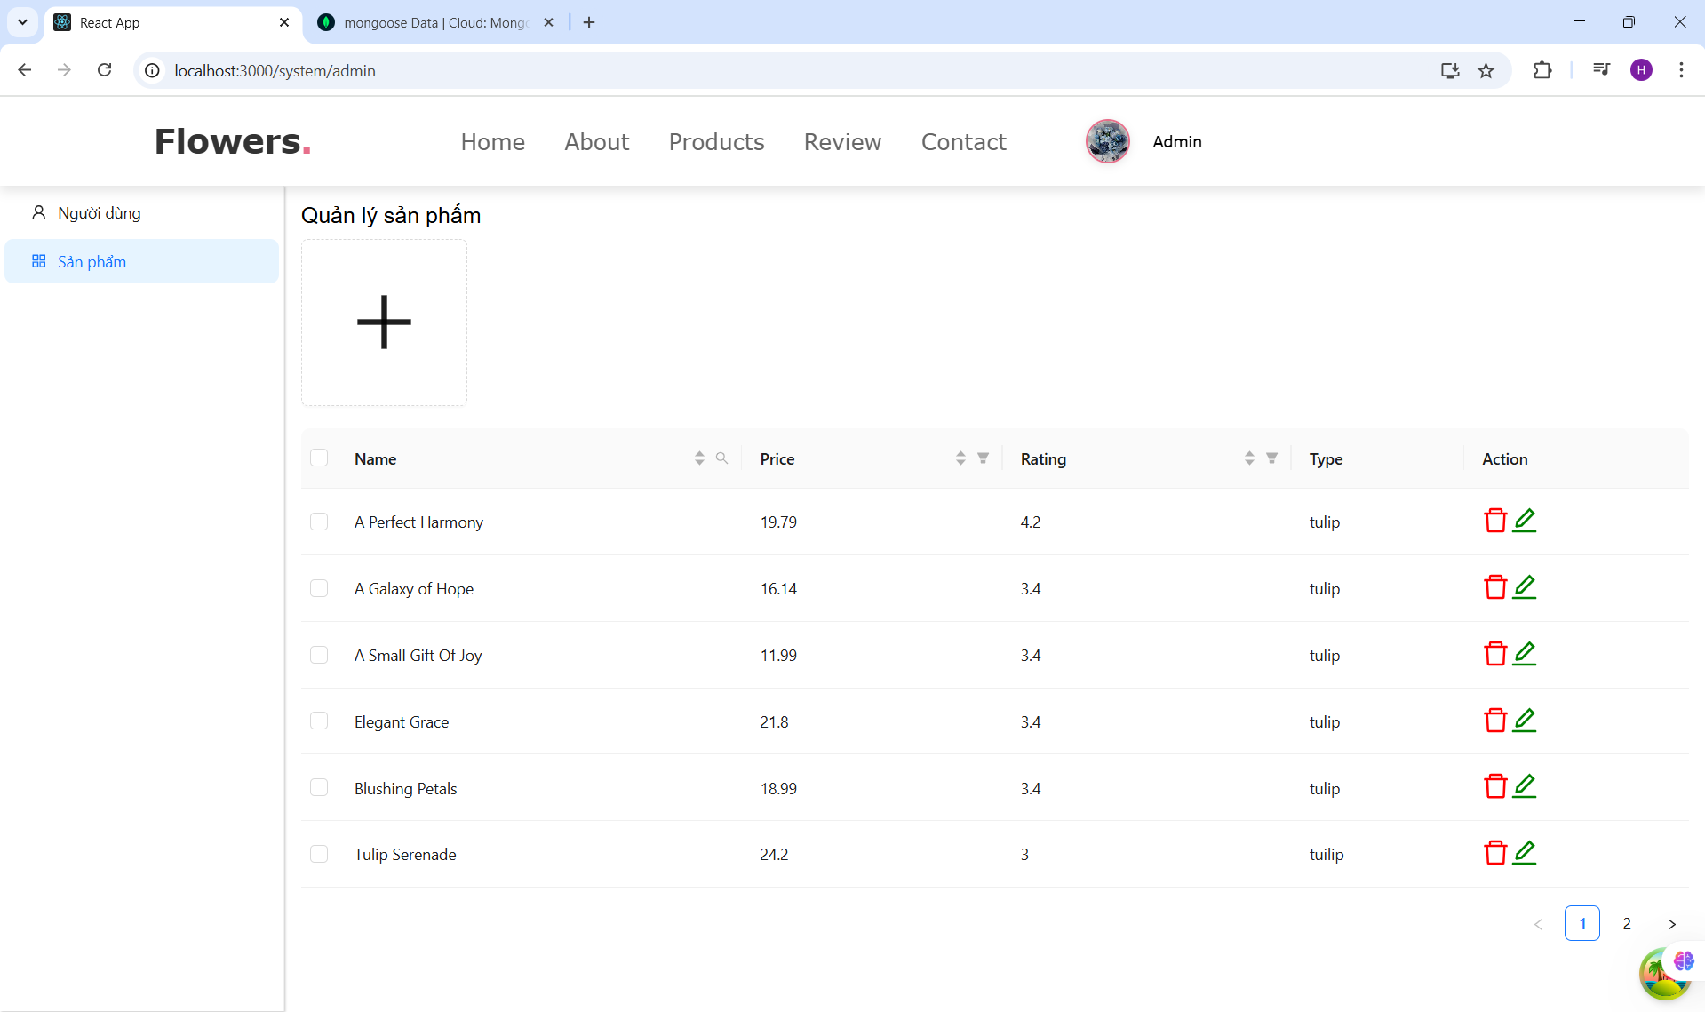
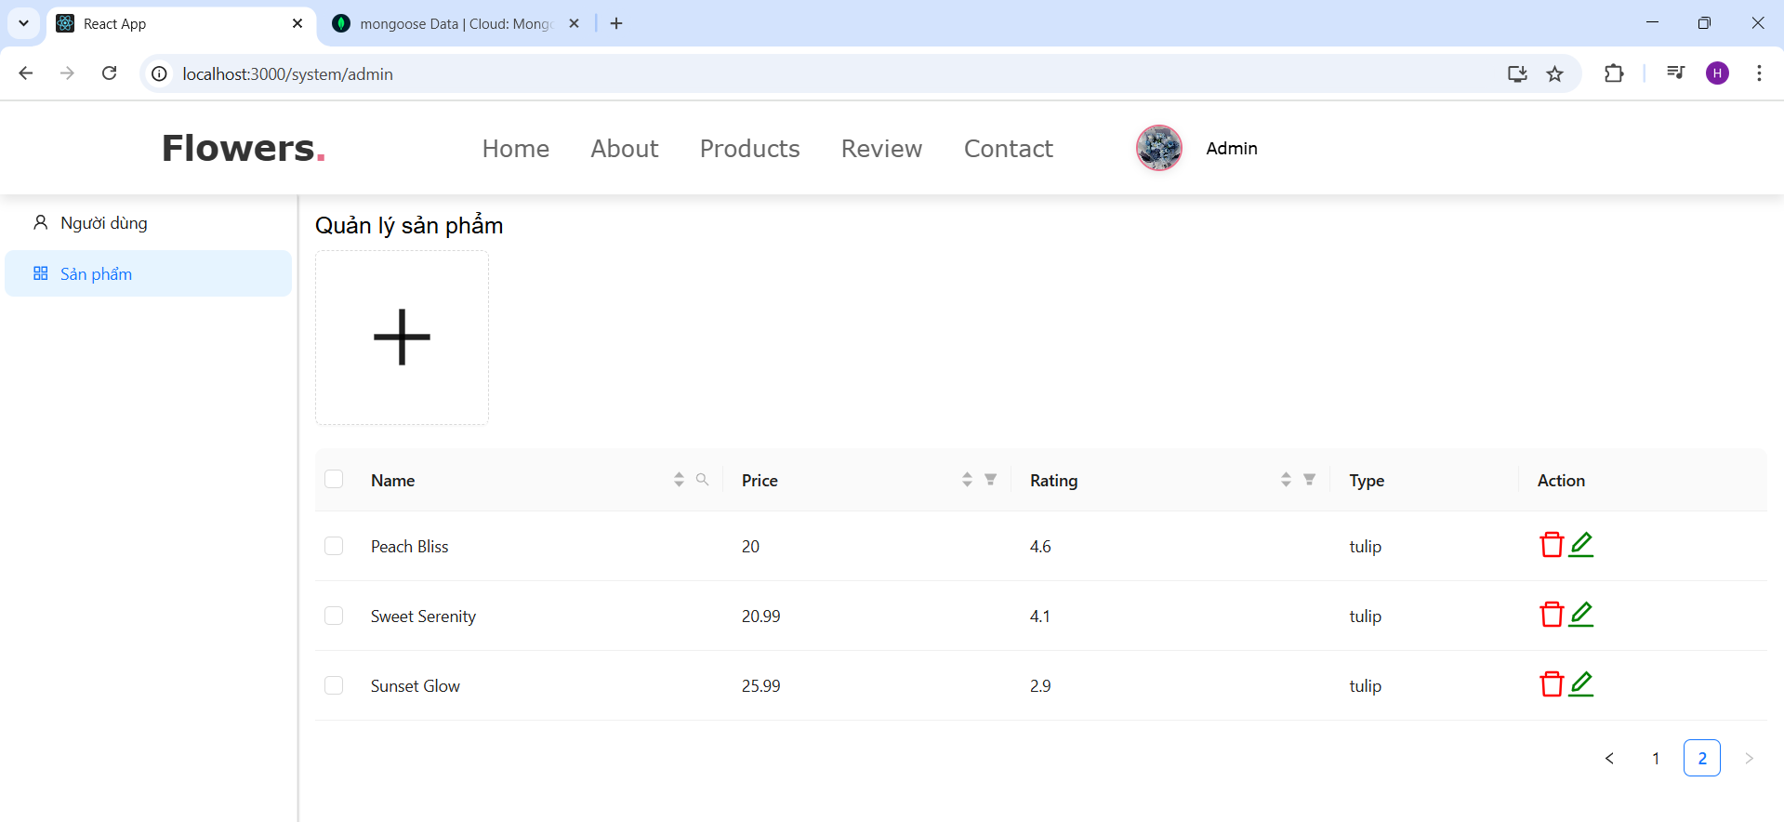
    - AdminUser
import { WrapperHeader } from "./style";
import { PlusOutlined, EditOutlined, DeleteOutlined, SearchOutlined } from '@ant-design/icons';
import TableComponent from "../TableComponent/TableComponent";
import React, { useEffect, useRef, useState } from "react";
import { Button, Form, Space } from 'antd';
import * as UserService from '../../services/UserService';
import InputComponent from '../../components/InputComponent/InputComponent';
import DrawerComponent from "../DrawerComponent/DrawerComponent";
import ModalComponent from "../ModalComponent/ModalComponent";
import { getBase64 } from "../../untils";
import * as message from '../../components/Message/Message';
import { useSelector } from "react-redux";
import { useMutationHook } from "../../hooks/useMutationHook";
import { useQuery } from "@tanstack/react-query";
import { WrapperUploadFile } from './style';
const AdminUser = () => {
const [isModalOpen, setIsModalOpen] = useState(false);
const [rowSelected, setRowSelected] = useState('');
const [isOpenDrawer, setIsOpenDrawer] = useState(false);
const [stateUser, setStateUser] = useState({
name: '',
email: '',
phone: '',
isAdmin: false,

});

const [searchText, setSearchText] = useState('');
const [searchedColumn, setSearchedColumn] = useState('');
const searchInput = useRef(null);

const [isModalOpenDelete, setIsModalOpenDelete] = useState(false)
const [isLoadingUpdate, setISLoadingUpdate] = useState(false);
const user = useSelector((state) => state?.user)
const [stateUserDetails, setStateUserDetails] = useState({
name: '',
email: '',
phone: '',
isAdmin: false,

});

const [form] = Form.useForm();

console.log('rowSelected', rowSelected)
const mutationUpdate = useMutationHook( //Đã check
(data) => {
console.log('data', data)
const { id, token, ...rests } = data;
const res = UserService.updateUser(
id,
{ ...rests }, token,
);
return res
}
);

const mutationDeleted = useMutationHook(
(data) => {
console.log('data', data)
const { id, token } = data;
const res = UserService.deleteUser(
id,
token
);
return res
}
);

const getAllUsers = async () => { //Đã check
const res = await UserService.getAllUsers(user?.access_token);
console.log('rés', res)
return res;
};

const fetchGetDetailsUsers = async (rowSelected) => { //Đã check

const res = await UserService.getDetailsUser(rowSelected)
if (res?.data) {
setStateUserDetails({
name: res?.data?.name,
email: res?.data?.email,
phone: res?.data?.phone,
isAdmin: res?.data?.isAdmin,
})
}

}
useEffect(() => {
form.setFieldsValue(stateUserDetails)
}, [form, stateUserDetails]) //Đã check
useEffect(() => {//Đã check
if (rowSelected) {
setISLoadingUpdate(true)
fetchGetDetailsUsers(rowSelected)
}
}, [rowSelected])

const handleDetailsUser = () => { //Đã check
// if (rowSelected) {
// setISLoadingUpdate(true)
// fetchGetDetailsUsers()
// }
setIsOpenDrawer(true)
}
const {
data: dataUpdated,
isLoading: isLoadingUpdated,
isSuccess,
isError,
isSuccess: isSuccessUpdated,
isError: isErrorUpdated
} = mutationUpdate;

//const { data: dataUpdated, isLoading: isLoadingUpdated, isSuccess: isSuccessUpdated, isError: isErrorUpdated } = mutationUpdate //Đã check
const { data: dataDeleted, isLoading: isLoadingDelete, isSuccess: isSuccessDeleted, isError: isErrorDeleted } = mutationDeleted
const queryUser = useQuery({ //Dã check
queryKey: ['user'],
queryFn: getAllUsers
}); //Đã check
const { isLoading: isLoadingUsers, data: users } = queryUser
const renderAction = () => {
return (
<div>
<DeleteOutlined style={{ fontSize: "25px", color: "red", cursor: 'pointer' }} onClick={() => setIsModalOpenDelete(true)} />
<EditOutlined style={{ fontSize: "25px", color: "green", cursor: 'pointer' }} onClick={handleDetailsUser} />
</div>
)
} //Đã check
const handleSearch = (selectedKeys, confirm, dataIndex) => {
confirm();
};
const handleReset = clearFilters => {
clearFilters();
};
const getColumnSearchProps = dataIndex => ({
filterDropdown: ({ setSelectedKeys, selectedKeys, confirm, clearFilters }) => (
<div style={{ padding: 8 }} onKeyDown={e => e.stopPropagation()}>
<InputComponent
ref={searchInput}
placeholder={`Search ${dataIndex}`}
value={selectedKeys[0]}
onChange={e => setSelectedKeys(e.target.value ? [e.target.value] : [])}
onPressEnter={() => handleSearch(selectedKeys, confirm, dataIndex)}
style={{ marginBottom: 8, display: 'block' }}
/>
<Space>
<Button
type="primary"
onClick={() => handleSearch(selectedKeys, confirm, dataIndex)}
icon={<SearchOutlined />}
size="small"
style={{ width: 90 }}
>
Search
</Button>
<Button
onClick={() => clearFilters && handleReset(clearFilters)}
size="small"
style={{ width: 90 }}
>
Reset
</Button>
</Space>
</div>
),
filterIcon: filtered => <SearchOutlined style={{ color: filtered ? '#1677ff' : undefined }} />,
onFilter: (value, record) =>
record[dataIndex].toString().toLowerCase().includes(value.toLowerCase()),
filterDropdownProps: {
onOpenChange(open) {
if (open) {
setTimeout(() => {
var _a;
return (_a = searchInput.current) === null || _a === void 0 ? void 0 : _a.select();
}, 100);
}
},
},
// render: text =>
// searchedColumn === dataIndex ? (
// <Highlighter
// highlightStyle={{ backgroundColor: '#ffc069', padding: 0 }}
// searchWords={[searchText]}
// autoEscape
// textToHighlight={text ? text.toString() : ''}
// />
// ) : (
// text
// ),
});

const columns = [
{
title: 'Name',
dataIndex: 'name',
sorter: (a, b) => a.name.length - b.name.length,
...getColumnSearchProps('name')
},
{
title: 'Email',
dataIndex: 'email',
sorter: (a, b) => a.email.length - b.email.length,
...getColumnSearchProps('email')
},
{
title: 'Admin',
dataIndex: 'isAdmin',
filters: [
{
text: 'True',
value: true,
},
{
text: 'False',
value: false,
},
],
},
{
title: 'Phone',
dataIndex: 'phone',
sorter: (a, b) => a.phone - b.phone,
...getColumnSearchProps('phone')
},
{
title: 'Action',
dataIndex: 'action',
render: renderAction
},

];

const dataTable = users?.data?.length && users?.data?.map((user) => {
return { ...user, key: user._id, isAdmin: user.isAdmin ? 'True' : 'False' }
})

useEffect(() => {
if (mutationDeleted.isSuccessDeleted && dataDeleted?.status === 'OK') {
message.success();
handleCancelDelete();
} else if (mutationDeleted.isErrorDeleted) {
message.error();
}
}, [mutationDeleted.isSuccessDeleted]);

// useEffect(() => {
// if (mutationUpdate.isSuccessUpdated && dataUpdated?.status === 'OK') {
// message.success();
// handleCloseDrawer();
// } else if (mutationUpdate.isErrorUpdated) {
// message.error();
// }
// }, [mutationUpdate.isSuccessUpdated]);
useEffect(() => {
if (isSuccess && dataUpdated?.status === 'OK') {
message.success();
handleCloseDrawer();
} else if (isError) {
message.error();
}
}, [isSuccess]);

const handleCancel = () => {
setIsModalOpen(false);
setStateUser({
name: '',
email: '',
phone: '',
isAdmin: false,
});
form.resetFields();
};

const handleCancelDelete = () => {
setIsModalOpenDelete(false)
}
const handleDeleteUser = () => {
mutationDeleted.mutate({ id: rowSelected, token: user?.access_token }, {
onSettled: () => {
queryUser.refetch();
setIsModalOpenDelete(false);
}
})
}
const handleCloseDrawer = () => {
setIsOpenDrawer(false)
setStateUserDetails({
name: '',
email: '',
phone: '',
isAdmin: false,
});
form.resetFields();
};

const handleOnChange = (e) => { //Đã check
setStateUser({
...stateUser,
[e.target.name]: e.target.value
});
};

const handleOnChangeDetails = (e) => { //Đã check
console.log('check', e.target.name, e.target.value)
setStateUserDetails({
...stateUserDetails,
[e.target.name]: e.target.value
})
}

const handleOnchangeAvatar = async ({ fileList }) => { //Đã check
const file = fileList[0];
if (!file.url && !file.preview) {
file.preview = await getBase64(file.originFileObj);
}
setStateUser({
...stateUser,
image: file.preview
});
};

const handleOnchangeAvatarDetails = async ({ fileList }) => { //Đã check
const file = fileList[0];
if (!file.url && !file.preview) {
file.preview = await getBase64(file.originFileObj);
}
setStateUserDetails({
...stateUserDetails,
image: file.preview
});
};
console.log('user', user)
const onUpdateUser = () => { //Đã check
mutationUpdate.mutate({ id: rowSelected, token: user?.access_token, ...stateUserDetails }, {
onSettled: () => {
queryUser.refetch()
}
})
}

return (

<div>
<WrapperHeader>Quản lý người dùng</WrapperHeader>
<div style={{ marginTop: '20px' }}>
<TableComponent columns={columns} isLoading={isLoadingUsers} data={dataTable} onRow={(record, rowIndex) => {
return {
onClick: event => {
setRowSelected(record._id)
}
}
}} />
</div>

<DrawerComponent title="Chi tiết Người dùng" isOpen={isOpenDrawer} onClose={() => setIsOpenDrawer(false)} width="90%">

<Form
name="basic"
labelCol={{ span: 2 }}
wrapperCol={{ span: 22 }}
onFinish={onUpdateUser}
autoComplete="on"
form={form}
>
<Form.Item
label="Name"
name="name"
rules={[{ required: true, message: 'Tên người dùng' }]}
>
<InputComponent value={stateUserDetails.name} onChange={handleOnChangeDetails} name="name" />
</Form.Item>
<Form.Item
label="Email"
name="email"
rules={[{ required: true, message: 'Nhập email' }]}
>
<InputComponent value={stateUserDetails.email} onChange={handleOnChangeDetails} name="email" />
</Form.Item>

<Form.Item
label="Phone"
name="phone"
rules={[{ required: true, message: 'Số điện thoại' }]}
>
<InputComponent value={stateUserDetails.phone} onChange={handleOnChangeDetails} name="phone" />
</Form.Item>
<Form.Item wrapperCol={{ offset: 20, span: 16 }}>
<Button type="primary" htmlType="submit">
Apply
</Button>
</Form.Item>
</Form>
</DrawerComponent>
<ModalComponent title="Xóa tài khoản" open={isModalOpenDelete} onCancel={handleCancelDelete} onOk={handleDeleteUser}>
<div>Bạn chắc chắn muốn xóa tài khoản này chứ?</div>
</ModalComponent>

</div>
)

}
export default AdminUser;
- CSS
import styled from "styled-components";
import { Upload } from 'antd';
export const WrapperHeader =styled.h1`
color: #000,
font-size:14px;
`

export const WrapperUploadFile = styled(Upload)`
& .ant-upload.ant-upload-select.ant-upload-select-picture-card {
width: 60px;
height: 60px;
border-radius: 50%;
}
& .ant-upload-list-item ant-upload-list-item-error{
display: none
}
& .ant-upload-list-item-name{
display: none;
}
& .ant-upload-list-item-actions{
display: none;
}
& .anticon anticon-paper-clip{
display: none;
}
& .ant-upload-icon{
display: none;
}
`;
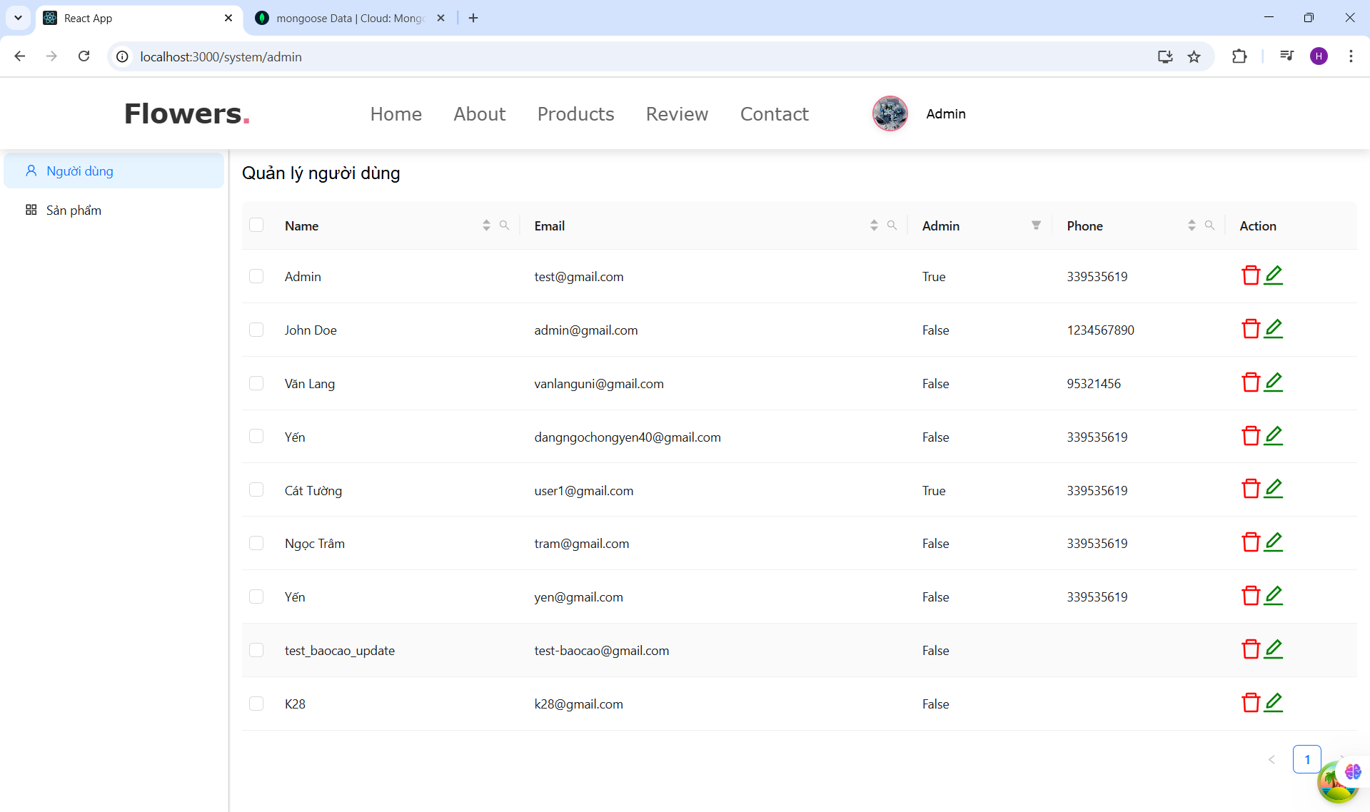
    - ButtonInputSearch
import React from 'react';
import InputComponent from '../InputComponent/InputComponent';
import ButtonComponent from '../ButtonComponent/ButtonComponent';

const ButtonInputSearch = (props) => {
const {
size = 'large',
placeholder = 'Tìm kiếm...',
textButton = 'Tìm kiếm',
bordered = true,
backgroundColorInput = 'white',
backgroundColorButton = '#e76f8b',
colorButton = '#fff',
maxWidth = '1200px'
} = props;

return (
<div className="search-form">
<form style={{
maxWidth: maxWidth,
margin: '0 auto',
display: 'flex',
alignItems: 'center',
gap: '1rem'
}}>
<InputComponent
size={size}
placeholder={placeholder}
bordered={bordered}
style={{
width: '100%',
backgroundColor: backgroundColorInput,
padding: '1.2rem 1.4rem',
fontSize: '1.8rem',
borderRadius: '.5rem',
boxShadow: '0px 4px 8px rgba(0, 0, 0, 0.1)',
border: 'var(--border)'
}}
{...props}
/>
<ButtonComponent
size={size}
styleButton={{
background: backgroundColorButton,
border: !bordered ? 'none' : 'var(--border)',
padding: '1.2rem 2rem',
fontSize: '1.8rem',
borderRadius: '5rem',
boxShadow: '0px 4px 10px rgba(231, 111, 139, 0.5)', // Bóng đổ mặc định
transition: 'all 0.3s ease-in-out',
cursor: 'pointer'
}}
styleTextButton={{
color: colorButton,
fontWeight: 'bold'
}}
textButton={textButton}
showIcon={true}
/>
</form>
</div>
);
};

export default ButtonInputSearch;
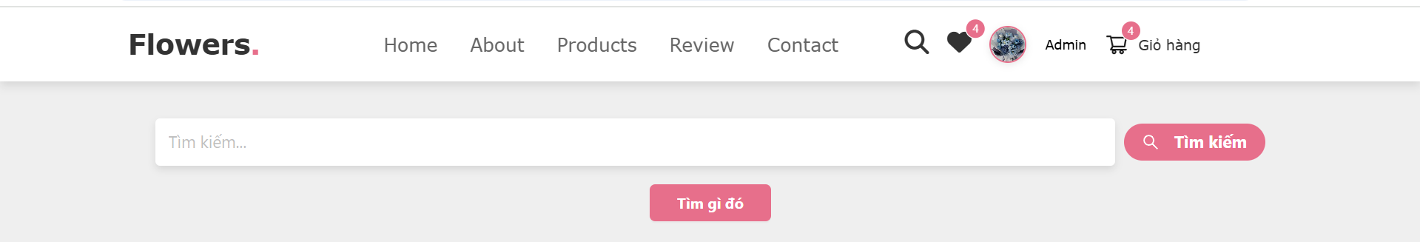
    - DefaultComponent
import React from "react";
import HeaderComponent from "../HeaderComponent/HeaderComponent";
import Footer from "../FooterComponent/FooterComponent";
import { WrapperPageContainer, WrapperContent } from "./style.js";

const DefaultComponent = ({ children }) => {
return (
<WrapperPageContainer>
<HeaderComponent />
<WrapperContent>{children}</WrapperContent>
<Footer />
</WrapperPageContainer>
);
};

export default DefaultComponent;

    - DrawerComponent
import { Drawer } from "antd";
import React from "react";

const DrawerComponent = ({title='Drawer', placement='right', isOpen=false, children, ...rests }) => {

return (
<>
<Drawer title={title} placement={placement} open={isOpen} {...rests}>
{children}
</Drawer>
</>

)

}
export default DrawerComponent
    - IconsComponent
import React from "react";
import styled from "styled-components";
import icon1 from "../../assets/images/icon1.png";
import icon2 from "../../assets/images/icon2.png";
import icon3 from "../../assets/images/icon3.png";
import icon4 from "../../assets/images/icon4.png";

const IconsContainer = styled.section`
background: rgb(220, 220, 220);
display: flex;
flex-wrap: wrap;
gap: 2rem; /* Khoảng cách giữa các icon */
padding: 3rem 5%;
justify-content: center;
margin-top: -3rem;
`;

const IconBox = styled.div`
background: #fff;
border: 0.1rem solid rgba(0, 0, 0, 0.1);
padding: 3rem;
display: flex;
align-items: center;
flex: 1 1 30rem;
max-width: 400px;
box-shadow: 2px 2px 10px rgba(0, 0, 0, 0.1);
transition: transform 0.2s ease-in-out;

&:hover {
transform: translateY(-5px);
}
`;

const IconImage = styled.img`
width: 150px;
height: 140px;
margin-right: 2rem;
`;

const Info = styled.div`
h3 {
color: #333;
font-size: 2rem;
margin-bottom: 0.5rem;
font-weight: bold;
}

span {
color: #555;
font-size: 1.5rem;
font-weight: bold;
}
`;

const IconsComponent = () => {
const iconData = [
{ img: icon1, title: "Free Delivery", desc: "On all orders" },
{ img: icon2, title: "10 Days Returns", desc: "Moneyback guarantee" },
{ img: icon3, title: "Offers & Gifts", desc: "On all orders" },
{ img: icon4, title: "Secure Payments", desc: "Protected by PayPal" }
];

return (
<IconsContainer>
{iconData.map((item, index) => (
<IconBox key={index}>
<IconImage src={item.img} alt={item.title} />
<Info>
<h3>{item.title}</h3>
<span>{item.desc}</span>
</Info>
</IconBox>
))}
</IconsContainer>
);
};

export default IconsComponent;

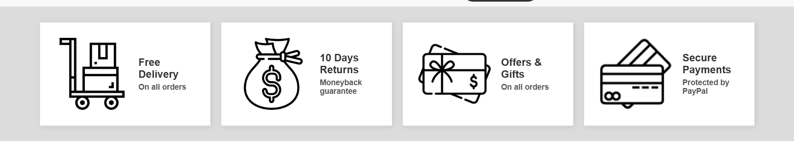
    - InputComponent
import React from 'react';
import { Input } from 'antd';

const InputComponent = ({ size, placeholder, bordered, style, ...rests }) => {
return (
<Input
size={size}
placeholder={placeholder}
bordered={bordered}
style={{
...style,
width: '100%' // Đảm bảo input chiếm toàn bộ chiều rộng
}}
{...rests}
/>
);
};

export default InputComponent;

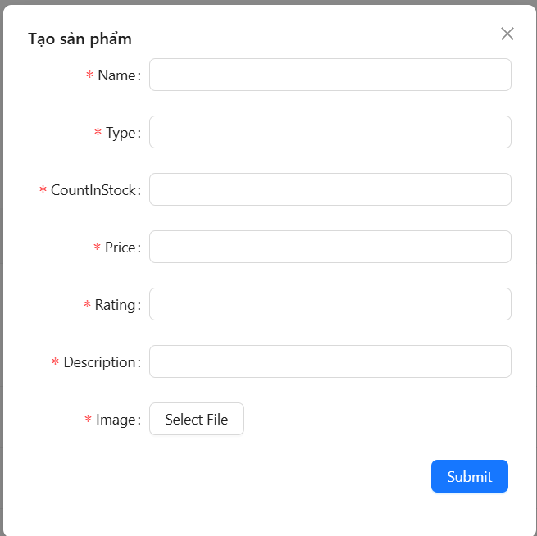
    - InputForm
import React from 'react';
import { WrapperInputStyle } from './style';

const InputForm = (props) => {
const { placeholder = 'Nhập text', ...rests } = props;

return (
<WrapperInputStyle
placeholder={placeholder}
value={props.value}
onChange={props.onChange}
{...rests}
/>
);
};

export default InputForm;

import styled from "styled-components";
import { Input } from 'antd';

export const WrapperInputStyle = styled(Input)`
// Các border mặc định của Ant Design input
border: 1px solid #ccc;
&:hover{
border-color: #ccc;
}
&:focus {
border-color: #e76f8b; // Màu hồng khi focus vào input
box-shadow: 0 0 5px rgba(231, 111, 139, 0.5); // Thêm một chút hiệu ứng shadow cho border
}
`;

    - Message
import {message} from 'antd';

const success =(mes = 'Success') =>{
message.success(mes);
};
const error =(mes = "Error") =>{
message.success(mes);
};
const warning =(mes ='Warning') =>{
message.success(mes);
};

export {success, error, warning}
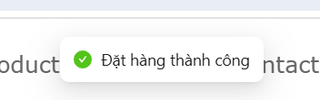
    - ModalComponent

    - ProductDetailsComponent
import React, { useState } from 'react'
import { Row, Col, Image, Spin } from "antd"
import { WrapperStyleImageSmall, WrapperDescription, WrapperStyleColImage, WrapperStyleNameProduct, WrapperQualityProduct, WrapperPriceProduct, WrapperPriceTextProduct, WrapperAddressProduct, WrapperInputNumber } from './style'
import { StarFilled, PlusOutlined, MinusOutlined } from '@ant-design/icons'
import ButtonComponent from '../ButtonComponent/ButtonComponent'
import * as ProductService from '../../services/ProductService'
import { useQuery } from '@tanstack/react-query'
import { useLocation, useNavigate } from 'react-router-dom'
import { useDispatch, useSelector } from 'react-redux'
import { addOrderProduct } from '../../redux/slides/orderSlide'

const ProductDetailsComponent = ({ idProduct }) => {
const [numProduct, setNumProduct] = useState(1)

const user = useSelector((state)=> state.user)
const navigate = useNavigate()
const location = useLocation()
console.log('location', location)
const dispatch = useDispatch()
const onChange = (e) => {
setNumProduct(Number(e.target.value))
}

const fetchGetDetailsProducts = async () => {
if (typeof idProduct !== 'string') {
console.error(' idProduct không hợp lệ:', idProduct)
return null
}

try {
const res = await ProductService.getDetailsProduct(idProduct)
return res?.data
} catch (error) {
console.error('Lỗi khi gọi API lấy chi tiết sản phẩm:', error)
return null
}
}

const { isLoading, data: product } = useQuery({
queryKey: ['product-details', idProduct],
queryFn: fetchGetDetailsProducts,
enabled: !!idProduct,
})

if (isLoading) {
return <div style={{ display: 'flex', justifyContent: 'center', marginTop: 100 }}><Spin size="large" /></div>
}

if (!product) {
return <div style={{ textAlign: 'center', marginTop: 100, color: 'red' }}>Không tìm thấy sản phẩm</div>
}

const handleChangeCount = (type) => {
if (type === 'increase') {
if (numProduct < (product?.countInStock || 10)) {
setNumProduct(prev => prev + 1);
}
} else {
if (numProduct > 1) {
setNumProduct(prev => prev - 1);
}
}
};
const handleAddOrderProduct =()=>{
if(!user?.id){
navigate('/sign-in', {state: location?.pathname})
}else{
dispatch(addOrderProduct({
orderItems:{
name: product?.name,
amount: numProduct,
image: product?.image,
price: product?.price,
product: product?._id
}
}))
}
}
console.log('product details', product, user)
return (
<div style={{ marginTop: '60px', marginLeft: '150px', marginRight: '150px', borderRadius: '4px' }}>
<Row gutter={16} style={{ padding: '20px 20px', justifyContent: 'space-between', backgroundColor: 'white', borderRadius: "20px", marginTop: '100px' }}>
<Col span={10} style={{ borderRight: '1px solid #e5e5e5', paddingRight: '8px' }}>
<div style={{ width: '100%', height: '600px', overflow: 'hidden', borderRadius: '20px' }}>
<Image
src={product?.image}
alt={product?.name}
preview={false}
style={{
width: '100%',
height: '100%',
objectFit: 'cover',
borderRadius: '20px'
}}
/>
</div>
<Row style={{ marginTop: '10px', paddingTop: '10px', display: 'flex', gap: '10px' }}>
<WrapperStyleColImage span={4}>
<WrapperStyleImageSmall src={product?.image} alt="image small" preview={false} width={60} />
</WrapperStyleColImage>
</Row>
</Col>
<Col span={14} style={{ paddingLeft: '10px' }}>
<WrapperStyleNameProduct>{product?.name}</WrapperStyleNameProduct>
<div>
{Array.from({ length: 5 }, (_, i) => (
<StarFilled
key={i}
style={{
fontSize: '12px',
color: i < Math.round(product.rating || 0) ? 'rgb(253,216,54)' : '#ccc'
}}
/>
))}
</div>
<WrapperPriceProduct>
<WrapperPriceTextProduct>{product?.price}$</WrapperPriceTextProduct>
</WrapperPriceProduct>
<WrapperAddressProduct>
<span>Giao đến </span>
<span className='address'>Tân Phú, Thành phố Hồ Chí Minh</span>
<span className='change-address'> - Đổi địa chỉ</span>
</WrapperAddressProduct>
<div style={{ margin: '10px 0', padding: '10px 0', borderTop: '1px solid #e5e5e5', borderBottom: '1px solid #e5e5e5' }}>
<div>Số lượng</div>
<WrapperQualityProduct style={{ margin: '10px 0' }}>
<button style={{ border: 'none', background: 'transparent', cursor:'pointer' }} onClick={() => handleChangeCount('decrease')}>
<MinusOutlined style={{ color: '#000', fontSize: '20px' }} />
</button>
<WrapperInputNumber min={1} max={product?.countInStock || 10} onChange={onChange} value={numProduct} size="small" />
<button style={{ border: 'none', background: 'transparent', cursor:'pointer' }} onClick={() => handleChangeCount('increase')}>
<PlusOutlined style={{ color: '#000', fontSize: '20px' }} />
</button>
</WrapperQualityProduct>
</div>
<WrapperDescription>
<div className="desc-title">Description:</div>
<p>{product?.description || "Hiện tại chưa có mô tả chi tiết cho sản phẩm này."}</p>
</WrapperDescription>
<div style={{ display: 'flex', marginTop: '10px', justifyContent: 'center', alignItems: 'center', gap: '12px' }}>
<ButtonComponent
border={false}
size={40}
styleButton={{
background: '#e76f8b', height: '48px', width: '220px', border: 'none', borderRadius: '4px'
}}
textButton={'Chọn mua'}
onClick={handleAddOrderProduct}
styleTextButton={{ color: '#fff', fontSize: '20px', fontWeight: 'bolder' }}
/>
</div>
</Col>
</Row>

</div>
)
}

export default ProductDetailsComponent

import styled from "styled-components";
import {Image, Col, InputNumber} from 'antd';
export const WrapperStyleImageSmall = styled(Image)`
height: 100px;
width: 100px;
`

export const WrapperStyleColImage = styled(Col)`
flex-basis: unset;
display: flex;
`;

export const WrapperStyleNameProduct = styled.h1`
color:#e76f8b;
font-size: 40px;
font-weight: bolder;
line-height: 32px;
word-break: break-word;

`

export const WrapperStyleTextSell = styled.div`
font-size: 15px;
line-height: 24px;
color: rgb(120,120,120)
`

export const WrapperPriceProduct= styled.div`
color: #e76f8b;
background: rgb(250,250,250);
border-radius: 4px;
`

export const WrapperPriceTextProduct= styled.h1`
font-size: 32px;
line-height: 40px;
margin-right: 8px;
font-weight: 500;
padding: 10px;
margin-top: 10px;
`

export const WrapperAddressProduct= styled.div`
span.address {
text-decoration: underline;
font-size: 15px;
font-weight: bolder;
line-height: 24px;
white-space: nowrap;
overflow: hidden;
text-overflow: ellipsis;
}
span.change-address{
color: rgb(11,116,229);
font-size: 16px;
line-height: 24px;
font-weight: 500;
flex-shrink: 0;
}
`

export const WrapperQualityProduct= styled.div`
display: flex;
gap: 4px;
align-items: center;
width: 100px;
border: 1px solid pink;
border-radius: 4px;

`

export const WrapperInputNumber= styled(InputNumber)`
&.ant-input-number.ant-input-number-sm {
width: 60px;
border-top: none;
border-bottom: none;
&.ant-input-number-handler-wrap{
display: none;
}
}

`
export const WrapperDescription = styled.div`
font-size: 1.5rem;
color: #333;
line-height: 1.6;

.desc-title {
font-weight: bold;
text-decoration: underline;
margin-bottom: 8px;
color: #e76f8b;
}
`;

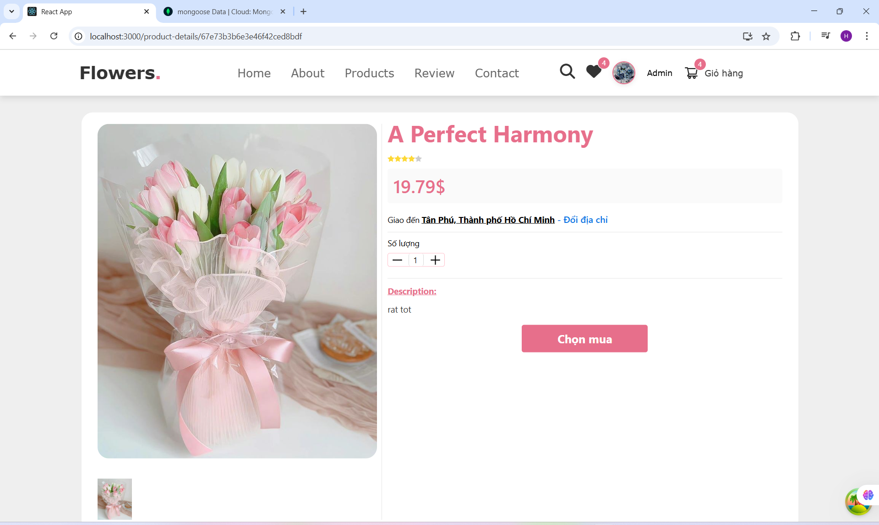
  - Page
    - Home Page
import React, { useState } from "react";
import CardComponent from "../../components/CardComponent/CardComponent";
import SliderComponent from "../../components/SliderComponent/SliderComponent";
import AboutComponent from "../../components/AboutComponent/AboutComponent";
import HomeBannerComponent from "../../components/HomeBannerComponent/HomeBannerComponent";
import IconsComponent from "../../components/IconsComponent/IconsComponent";
import bg1 from '../../assets/images/bg1.jpg';
import bg2 from '../../assets/images/bg2.jpg';
import bg3 from '../../assets/images/bg3.jpg';
import { Heading, WrapperButtonMore } from './style';
import { ProductsContainer, BoxContainer } from "../../components/CardComponent/style";
import { useQuery } from "@tanstack/react-query";
import * as ProductService from '../../services/ProductService';
import { useSelector } from "react-redux";

const HomePage = () => {

const [limit, setLimit] = useState(6)

const fetchProductAll = async (context) => {
console.log('context', context)
const search =''
const limit = context?.queryKey && context?.queryKey[1]
const res = await ProductService.getAllProducts(search, limit);
return res;
}

//const {isLoading, data} = useQuery(['products'],fetchProductAll)
const { isLoading, data: products } = useQuery({
queryKey: ['products', limit], // Đây là key dùng để lưu trữ cache cho query này
queryFn: fetchProductAll, // Hàm gọi API
retry: 3,
retryDelay: 1000

});

console.log('data', products)
return (
<div style={{ marginTop: "75px", position: "relative" }}>
<HomeBannerComponent />
<SliderComponent arrImages={[bg1, bg2, bg3]} />
<div>
<AboutComponent />
</div>
<IconsComponent />
<Heading style={{ margin: "50px", marginBottom: "0px", color: "#333" }}>Latest <span style={{ color: "#e76f8b" }}>Products</span></Heading>
<ProductsContainer>
<BoxContainer>
{products?.data?.map((product) => {
return (
<CardComponent
key={product._id}
countInSttock={product.countInSttock}
description={product.description}
image={product.image}
name={product.name}
price={product.price}
rating={product.rating}
type={product.type}
discount = {product.discount}
id={product._id}
/>

)
})}
</BoxContainer>

</ProductsContainer>
<div style={{ display: "flex", justifyContent: "center", marginTop: "-6px" }}>
<WrapperButtonMore size="large" styleButton={{ background: '#e76f8b', color: '#fff', fontWeight:"bolder"}} textButton="Xem thêm" type="outline" onClick={()=> setLimit(prev=>prev + 6)} />
</div>

</div>
);
};

export default HomePage;

import styled from "styled-components";
import ButtonComponent from "../../components/ButtonComponent/ButtonComponent";

export const Heading = styled.h1`
text-align: center;
font-size: 3rem;
font-weight: bolder;
font-family: Verdana, Geneva, Tahoma, serif, sans-serif;
color: gray;
margin-top: 50px;
margin-bottom: 0;
`;

export const WrapperButtonMore = styled(ButtonComponent)`
border: 1px solid #e76f8b;
color: #e76f8b;
width: 240px;
height: 38px;
border-radius: 5px;
transition: all 0.3s ease-in-out;

&:hover {
background: #e76f8b;
color: white;
}
`;

    - ProductPage
import React, { useEffect, useState } from "react";
import ButtonInputSearch from "../../components/ButtonInputSearch/ButtonInputSearch";
import { Button } from "antd";
import { useDispatch, useSelector } from "react-redux";
import ProductService from '../../services/ProductService';
import { searchProduct as searchProductAction } from "../../redux/slides/productSlide";
import { useQuery } from "@tanstack/react-query";
import CardComponent from "../../components/CardComponent/CardComponent";
import { Heading, WrapperButtonMore } from './style';

const ProductsPage = () => {
const [search, setSearch] = useState('');
const [stateProducts, setStateProducts] = useState([]);
const dispatch = useDispatch();
const [limit, setLimit] = useState(6); // Handle product limit
const searchProduct = useSelector((state) => state?.product?.search);

// Modify fetch function to include limit
const fetchProductAll = async () => {
const res = await ProductService.getAllProducts(searchProduct, limit); // Pass limit here
return res?.data || [];
};

const { isLoading, data: products, isPreviousData } = useQuery({
queryKey: ['products', searchProduct, limit],
queryFn: fetchProductAll,
retry: 3,
retryDelay: 1000,
keepPreviousData: true
});

const onSearch = (e) => {
const value = e.target.value;
setSearch(value);
dispatch(searchProductAction(value));
};

useEffect(() => {
if (products?.length > 0) {
setStateProducts(products);
} else {
setStateProducts([]);
}
}, [products]);

const handleScrollToTop = () => {
window.scrollTo({ top: 0, behavior: 'smooth' });
};

return (
<div style={{ backgroundColor: "#efefef", minHeight: "100vh", paddingTop: "70px" }}>
<Heading style={{ margin: "50px", marginBottom: "40px", color: "#333", fontSize: "40px" }}>Shop <span style={{ color: "#e76f8b" }}>Products</span></Heading>
<ButtonInputSearch onChange={onSearch} />

<div style={{ display: "flex", justifyContent: "center", marginTop: "20px" }}>
<Button
style={{
backgroundColor: "#e76f8b",
color: "white",
border: "none",
padding: "20px 30px",
fontSize: "16px",
fontWeight: "bold",
}}
>
Tìm gì đó
</Button>
</div>

<div
style={{
marginTop: "40px",
padding: "0 100px",
display: "grid",
gridTemplateColumns: "repeat(3, 1fr)",
gap: "20px",
boxSizing: "border-box",
marginBottom: "40px"
}}
>
{isLoading ? (
<p>Đang tải sản phẩm...</p>
) : stateProducts.length === 0 ? (
<p>Không có sản phẩm phù hợp.</p>
) : (
stateProducts.map((product) => (
<CardComponent
key={product._id}
name={product.name}
image={product.image}
price={product.price}
discount={product.discount}
rating={product.rating}
type={product.type}
countInSttock={product.countInSttock}
description={product.description}
id={product._id}
/>
))
)}
</div>

<div style={{ display: "flex", justifyContent: "center", marginTop: "-6px" }}>
<WrapperButtonMore
style={{ fontSize: '20px', marginBottom: '20px' }}
textButton="Xem thêm"
type="outline"
onClick={() => setLimit(prev => prev + 6)}
/>
</div>

</div>
);
};

export default ProductsPage;

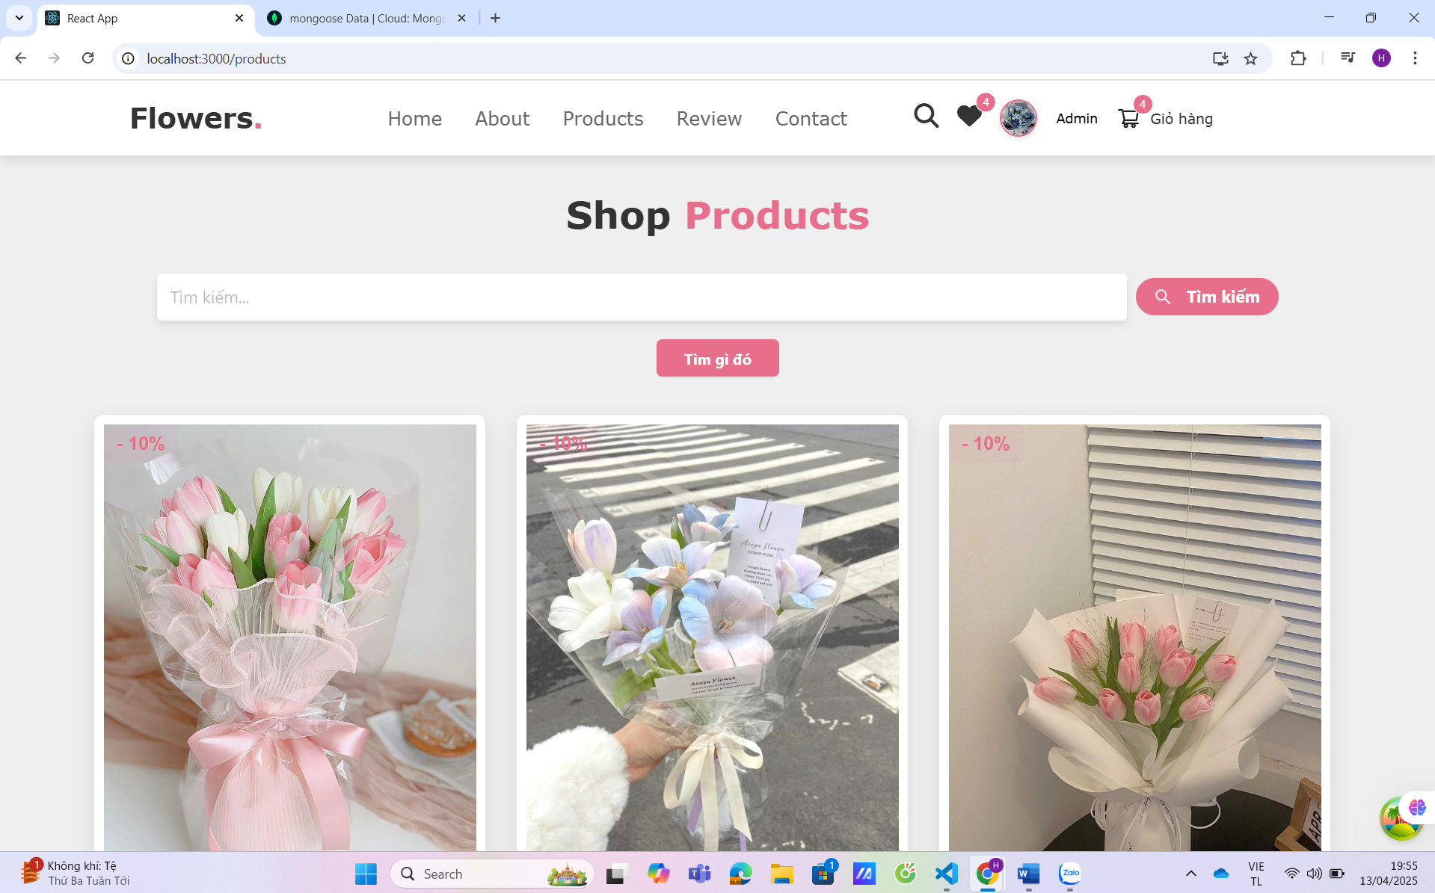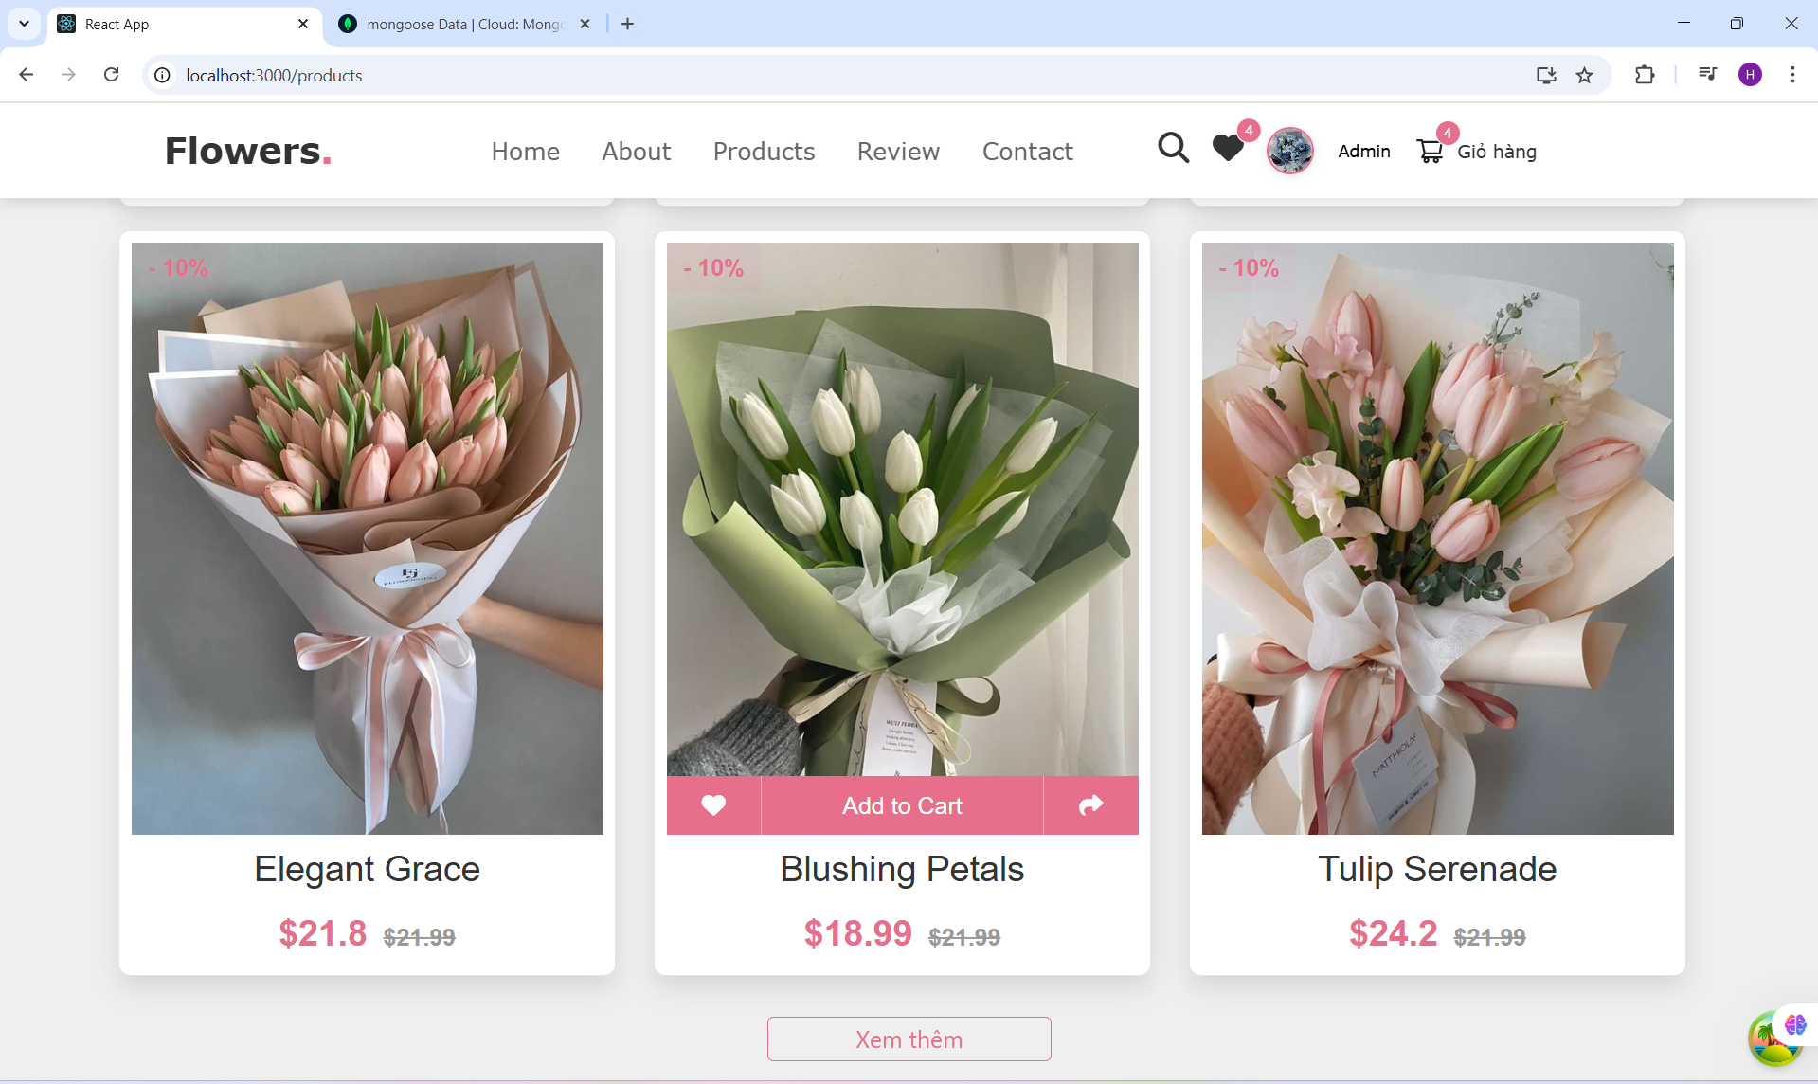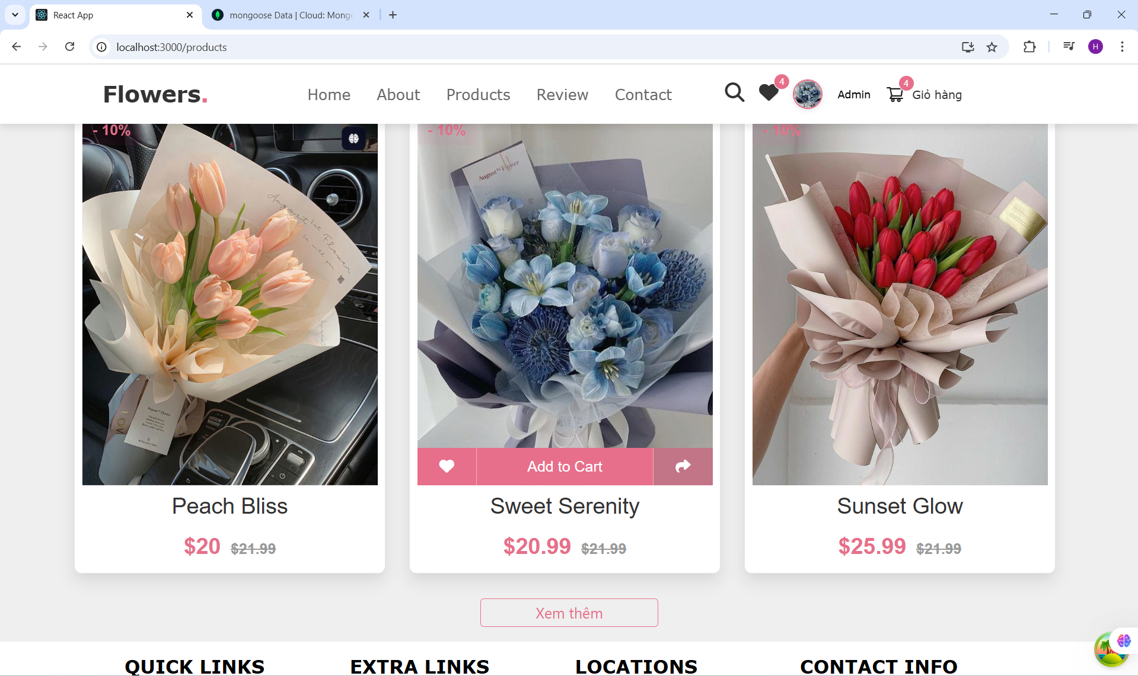
    - Order Page
import React, { useEffect, useState } from "react";
import {
WrapperCountOrder,
WrapperStyleHeader,
WrapperRight,
WrapperSummaryInfo,
WrapperItemOrder,
WrapperLeft,
WrapperListOrder,
WrapperPriceDiscount,
Heading
} from './style';
import { DeleteOutlined, MinusOutlined, PlusOutlined } from "@ant-design/icons";
import { WrapperInputNumber } from "../../components/ProductDetailsComponent/style";
import ButtonComponent from "../../components/ButtonComponent/ButtonComponent";
import { useDispatch, useSelector } from "react-redux";
import { Checkbox } from "antd";
import {
increaseAmount,
decreaseAmount,
removeOrderProduct,
updateAmount,
toggleCheckProduct,
toggleCheckAllProduct
} from "../../redux/slides/orderSlide";
import ModalComponent from "../../components/ModalComponent/ModalComponent";
import { Form } from "antd";
import InputComponent from "../../components/InputComponent/InputComponent";
import { useMutationHook } from "../../hooks/useMutationHook";
import * as UserService from '../../services/UserService';
import * as message from '../../components/Message/Message';
import { updateUser } from "../../redux/slides/userSlide";
import { useNavigate } from "react-router-dom";

const OrderPage = () => {
const order = useSelector((state) => state.order);
const user = useSelector((state) => state.user);
const dispatch = useDispatch();
const [form] = Form.useForm();
const navigate = useNavigate()
const [stateUserDetails, setStateUserDetails] = useState({
name: '',
email: '',
phone: '',
address: '',
city: ''
});

const [isOpenModalUpdateInfo, setIsOpenModalUpdateInfo] = useState(false)
const handleChangeCount = (type, idProduct) => {
if (type === 'increase') {
dispatch(increaseAmount({ idProduct }));
} else {
dispatch(decreaseAmount({ idProduct }));
}
};

const handleRemoveProduct = (idProduct) => {
dispatch(removeOrderProduct({ idProduct }));
};

const handleOnchangeCheckAll = (e) => {
dispatch(toggleCheckAllProduct({ checked: e.target.checked }));
};

const handleInputChange = (value, idProduct) => {
if (value && value >= 1) {
dispatch(updateAmount({ idProduct, amount: value }));
}
};

useEffect(() => {
form.setFieldsValue(stateUserDetails)
}, [form, stateUserDetails])

useEffect(() => {
if (isOpenModalUpdateInfo) {
setStateUserDetails({
city: user?.city,
name: user?.name,
address: user?.address,
phone: user?.phone
})
}
}, [isOpenModalUpdateInfo])
const handleChangeAddress =()=>{
setIsOpenModalUpdateInfo(true)
}
const mutationUpdate = useMutationHook( //Đã check
(data) => {
console.log('data', data)
const { id, token, ...rests } = data;
const res = UserService.updateUser(
id,
{ ...rests }, token,
);
return res
}
);

const totalPrice = order?.orderItems
?.filter(item => item.checked)
?.reduce((total, item) => total + item.price * item.amount, 0);

const allChecked = order?.orderItems?.length > 0 && order?.orderItems.every(item => item.checked);
const someChecked = order?.orderItems?.some(item => item.checked);
const handleAddCard = () => {
console.log('user', user)
if (!user?.phone || !user.address || !user.name || !user.city) {
setIsOpenModalUpdateInfo(true)
} else{
navigate('/payment')
}
}
const handleCancelUpdate = () => {
setStateUserDetails({
name: '',
email: '',
phone: '',
isAdmin: false,
});
form.resetFields();
setIsOpenModalUpdateInfo(false)
}
const {data} = mutationUpdate
console.log('data', data)

const handleUpdateInfoUser = () => {
console.log('stateUserDetails', stateUserDetails)
const { name, address, city, phone } = stateUserDetails
if (name && address && city && phone) {

mutationUpdate.mutate({ id: user?.id, token: user?.access_token, ...stateUserDetails }, {
onSuccess: () => {
dispatch(updateUser({ name, address, city, phone }))
setIsOpenModalUpdateInfo(false)
}
})

}
}

const handleOnChangeDetails = (e) => {
console.log('check', e.target.name, e.target.value)
setStateUserDetails({
...stateUserDetails,
[e.target.name]: e.target.value
})
}

return (
<div style={{ marginTop: "80px", background: '#f5f5fa', width: "100%", minHeight: "100vh" }}>
<div style={{ height: '100%', width: '1270px', margin: '0 auto' }}>
<Heading style={{ margin: "50px", marginBottom: "40px", color: "#e76f8b", fontSize: "40px" }}>
Shopping <span style={{ color: "#333" }}>Cart</span>
</Heading>
<div style={{ display: 'flex', justifyContent: 'center' }}>
<WrapperLeft>
<WrapperStyleHeader>
<span style={{ display: 'inline-block', width: '390px' }}>
<Checkbox
onChange={handleOnchangeCheckAll}
checked={allChecked}
indeterminate={someChecked && !allChecked}
/>
<span> Tất cả ({order?.orderItems?.length} sản phẩm)</span>
</span>
<div style={{ flex: 1, display: 'flex', alignItems: 'center', justifyContent: 'space-between' }}>
<span>Đơn giá</span>
<span>Số lượng</span>
<span>Tổng</span>
<DeleteOutlined style={{ cursor: 'pointer' }} />
</div>
</WrapperStyleHeader>

<WrapperListOrder>
{order?.orderItems?.map((item) => (
<WrapperItemOrder key={item.product}>
<div style={{ width: '390px', display: 'flex', alignItems: 'center', gap: 4 }}>
<Checkbox
checked={item.checked}
onChange={() => dispatch(toggleCheckProduct({ idProduct: item.product }))}
/>
<img src={item?.image} alt="product" style={{ width: '77px', height: "79px", objectFit: 'cover' }} />
<div>{item?.name}</div>
</div>
<div style={{ flex: 1, display: 'flex', alignItems: 'center', justifyContent: 'space-between' }}>
<span>
<span style={{ fontSize: '13px', color: '#242424' }}>
{item?.price?.toLocaleString('en-US', { style: 'currency', currency: 'USD' })}
</span>
<WrapperPriceDiscount>
{item?.amount > 1 ? (item?.price + 10).toLocaleString('en-US', { style: 'currency', currency: 'USD' }) : ''}
</WrapperPriceDiscount>
</span>
<WrapperCountOrder>
<button onClick={() => handleChangeCount('decrease', item.product)}>
<MinusOutlined />
</button>
<WrapperInputNumber
min={1}
value={item?.amount}
size="small"
onChange={(value) => handleInputChange(value, item.product)}
/>
<button onClick={() => handleChangeCount('increase', item.product)}>
<PlusOutlined />
</button>
</WrapperCountOrder>
<span style={{ color: "rgb(255,66,78)", fontSize: '13px', fontWeight: 500 }}>
{(item?.price * item?.amount)?.toLocaleString('en-US', { style: 'currency', currency: 'USD' })}
</span>
<DeleteOutlined style={{ cursor: 'pointer' }} onClick={() => handleRemoveProduct(item.product)} />
</div>
</WrapperItemOrder>
))}
</WrapperListOrder>
</WrapperLeft>

<WrapperRight>
<div style={{ width: '100%' }}>
<WrapperSummaryInfo>
<div>
<span>Địa chỉ: </span>
<span style={{ color: " #e76f8b", fontWeight:"bolder"}}>{`${user?.address} ${user?.city} - ` }</span>
<span onClick={handleChangeAddress} style={{ color: "blue", cursor: 'pointer' }}>Thay đổi</span>
</div>
</WrapperSummaryInfo>
<WrapperSummaryInfo>
<div style={{ display: 'flex', alignItems: 'center', justifyContent: 'space-between' }}>
<span>Subtotal</span>
<span style={{ color: '#000', fontSize: '14px', fontWeight: 'bold' }}>
{totalPrice?.toLocaleString('en-US', { style: 'currency', currency: 'USD' })}
</span>
</div>
<div style={{ display: 'flex', alignItems: 'center', justifyContent: 'space-between' }}>
<span>Discount</span>
<span style={{ color: '#000', fontSize: '14px', fontWeight: 'bold' }}>
{(0).toLocaleString('en-US', { style: 'currency', currency: 'USD' })}
</span>
</div>
<div style={{ display: 'flex', alignItems: 'center', justifyContent: 'space-between' }}>
<span>Total</span>
<span style={{ color: '#ff424e', fontSize: '16px', fontWeight: 'bold' }}>
{totalPrice?.toLocaleString('en-US', { style: 'currency', currency: 'USD' })}
</span>
</div>
</WrapperSummaryInfo>
<div style={{ marginTop: 16 }}>
<ButtonComponent
onClick={() => handleAddCard()}
size="large"
styleButton={{ width: '100%', background: '#e76f8b', color: '#fff' }}
textButton="Thanh toán"
disabled={totalPrice === 0}
/>
</div>
</div>
</WrapperRight>
</div>
</div>
<ModalComponent forceRender title="Cập nhật thông tin giao hàng" open={isOpenModalUpdateInfo} onCancel={handleCancelUpdate} onOk={handleUpdateInfoUser}>

<Form
name="basic"
labelCol={{ span: 4 }}
wrapperCol={{ span: 20 }}
//onFinish={onUpdateUser}
autoComplete="on"
form={form}
>
<Form.Item
label="Name"
name="name"
rules={[{ required: true, message: 'Tên người dùng' }]}
>
<InputComponent value={stateUserDetails.name} onChange={handleOnChangeDetails} name="name" />
</Form.Item>
<Form.Item
label="City"
name="city"
rules={[{ required: true, message: 'Thành phố' }]}
>
<InputComponent value={stateUserDetails.city} onChange={handleOnChangeDetails} name="city" />
</Form.Item>

<Form.Item
label="Phone"
name="phone"
rules={[{ required: true, message: 'Số điện thoại' }]}
>
<InputComponent value={stateUserDetails.phone} onChange={handleOnChangeDetails} name="phone" />
</Form.Item>
<Form.Item
label="Address"
name="address"
rules={[{ required: true, message: 'Số điện thoại' }]}
>
<InputComponent value={stateUserDetails.address} onChange={handleOnChangeDetails} name="address" />
</Form.Item>

</Form>
</ModalComponent>

</div>
);
};

export default OrderPage;

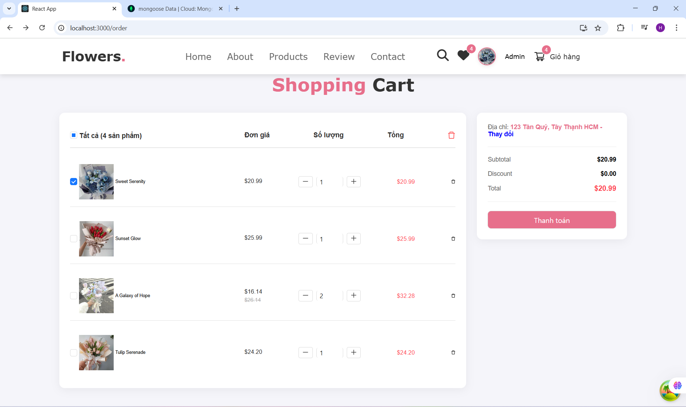
    - Admin Page
import React, { useState } from 'react';
import { Menu } from 'antd';
import { getItem } from '../../untils';
import HeaderComponent from '../../components/HeaderComponent/HeaderComponent'
import { AppstoreOutlined, UserOutlined } from '@ant-design/icons';
import AdminProduct from '../../components/AdminProduct/AdminProduct';
import AdminUser from '../../components/AdminUser/AdminUser';
const AdminPage = () => {
const items = [
getItem("Người dùng", "user", <UserOutlined />),
getItem("Sản phẩm", "product", <AppstoreOutlined />),
];

const [keySelected, setkeySelected] = useState('')

const renderPage = (key) => {
switch (key) {
case 'user':
return (<AdminUser />)
case 'product':
return (<AdminProduct />)
default:
return <></>
}

}
const handleOnClick = ({ key }) => {

setkeySelected(key)
}
console.log('keySelected', keySelected)
return (
<>
<HeaderComponent isHiddenCart isHiddenSearch isHiddenHeart />
<div style={{ display: 'flex', marginTop: "80px" }}>
<Menu
mode="inline"
tr
style={{
width: 256,
boxShadow: '1px 1px 2px #ccc',
height: '90vh'
}}
items={items}
onClick={handleOnClick}
/>
<div style={{ flex: 1, padding:'15px'}}>
{renderPage(keySelected)}
</div>
</div>
</>

)
}

export default AdminPage
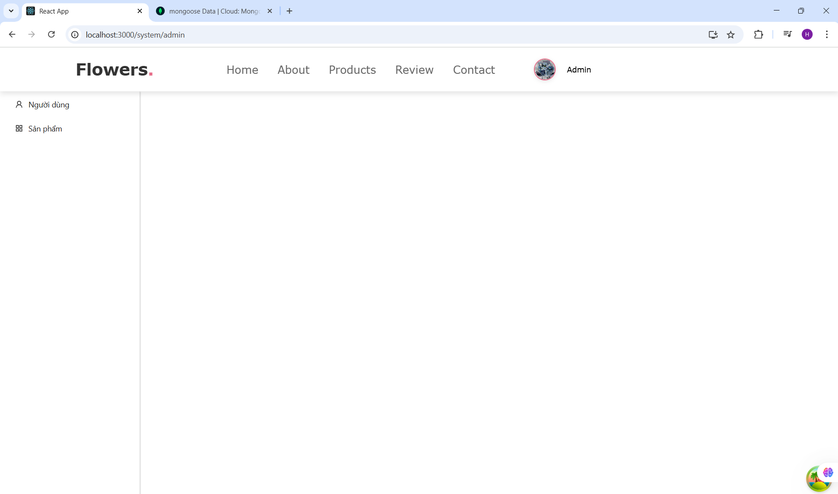
    - NotFound page
import React from 'react';

const NotFoundPage=()=>{
return(
<div>Not Found Page</div>
)
}

export default NotFoundPage
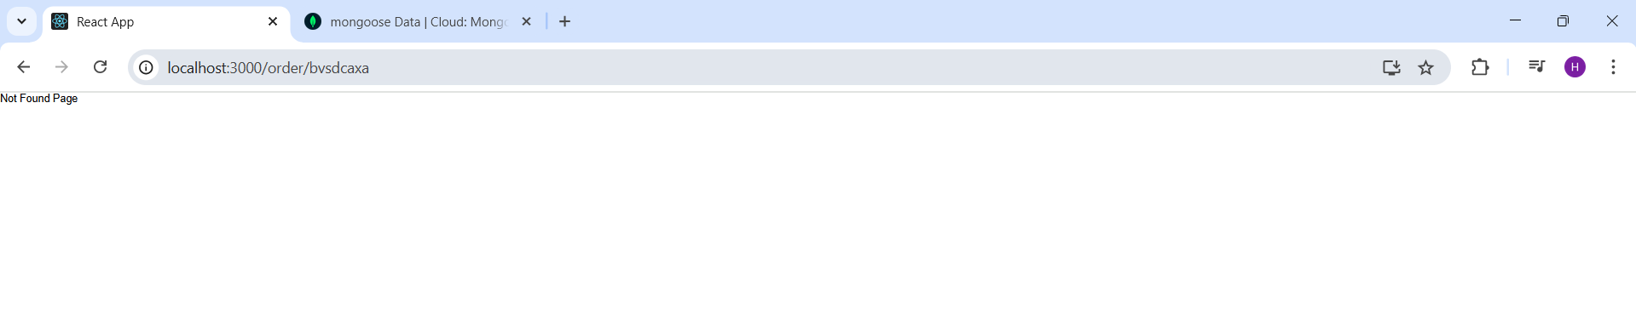
    - ProductDetails Page
import React from 'react'
import ProductDetailsComponent from '../../components/ProductDetailsComponent/ProductDetailsComponent';
import { useParams } from 'react-router-dom';
const ProductDetailsPage = () =>{
const {id} = useParams()

return(
<div style={{background:"#efefef", height: '1000px'}}>
<h5 style={{}}>Trang chủ - Chi tiết sản phẩm</h5>
<ProductDetailsComponent idProduct ={id}/>
</div>

)
}

export default ProductDetailsPage
    - Profile Page
import React, { useEffect, useState } from 'react';
import { useDispatch, useSelector } from 'react-redux';
import ButtonComponent from "../../components/ButtonComponent/ButtonComponent";
import InputForm from "../../components/InputForm/InputForm";
import { WrapperHeader, WrapperContentProfile, WrapperLabel, WrapperInput, WrapperUploadFile } from './style';
import * as UserService from '../../services/UserService';
import { useMutationHook } from '../../hooks/useMutationHook';
import * as message from '../../components/Message/Message';
import { updateUser } from '../../redux/slides/userSlide';
import { Button, Upload } from 'antd';
import { UploadOutlined } from '@ant-design/icons'
import { getBase64 } from '../../untils';

const ProfilePage = () => {
const user = useSelector((state) => state.user);
const [email, setEmail] = useState('');
const [name, setName] = useState('');
const [phone, setPhone] = useState('');
const [address, setAddress] = useState('');
const [avatar, setAvatar] = useState('');

// Lấy thông tin người dùng từ Redux store và cập nhật vào các input field
useEffect(() => {
setEmail(user?.email);
setName(user?.name);
setPhone(user?.phone);
setAddress(user?.address);
setAvatar(user?.avatar);
}, [user]);

const dispatch = useDispatch();

// Sử dụng hook mutation để gọi API cập nhật
const mutation = useMutationHook(
(data) => {
const { id, access_token, ...rests } = data;
return UserService.updateUser(id, rests, access_token); // Thực hiện API gọi cập nhật
}
);

const { data, isLoading, onSuccess, onError } = mutation;

// useEffect xử lý khi mutation thành công hoặc có lỗi
useEffect(() => {
if (mutation.isSuccess) {
message.success("Cập nhật thông tin người dùng thành công!");
handleGetDetailsUser(user?.id, user?.access_token);
} else if (mutation.isError) {
message.error("Cập nhật thất bại!");
console.error("Mutation Error:", JSON.stringify(mutation.error, null, 2)); // Log chi tiết lỗi tại đây
}
}, [mutation.isSuccess, mutation.isError]);

// Hàm gọi API lấy thông tin người dùng
const handleGetDetailsUser = (id, token) => {
return async (dispatch) => {
try {
const res = await UserService.getDetailsUser(id, token);
dispatch(updateUser({ ...res?.data, access_token: token }));
} catch (error) {
console.error('Failed to get user details', error);
message.error('Không thể lấy thông tin người dùng');
}
};
};

// Các hàm handle change cho các trường input
const handleOnchangeEmail = (e) => setEmail(e.target.value);
const handleOnchangeName = (e) => setName(e.target.value);
const handleOnchangePhone = (e) => setPhone(e.target.value);
const handleOnchangeAddress = (e) => setAddress(e.target.value);
const handleOnchangeAvatar = async ({ fileList }) => {
const file = fileList[0]
if (!file.url && !file.preview) {
file.preview = await getBase64(file.originFileObj);
}
setAvatar(file.preview)
}

// Hàm xử lý khi bấm nút cập nhật
const handleUpdate = async () => {
// Kiểm tra nếu có bất kỳ trường nào trống
if (!email || !name || !phone || !address || !avatar) {
message.error("Vui lòng điền đầy đủ thông tin.");
return;
}

// Gửi dữ liệu cập nhật đến API
try {
await mutation.mutateAsync({
id: user?.id,
email,
name,
phone,
address,
avatar,
access_token: user?.access_token
});
} catch (error) {
console.error('Error during update:', error);
message.error('Cập nhật thất bại');
}
};

return (
<div style={{ margin: '100px auto', width: '1270px', height: "500px", fontFamily: "Verdana, Geneva, Tahoma, serif, sans-serif" }}>
<WrapperHeader>Thông tin người dùng</WrapperHeader>

<WrapperContentProfile>
<WrapperInput>
<WrapperLabel htmlFor='email'>Email</WrapperLabel>
<InputForm style={{ width: "300px" }} id="email" value={email} onChange={handleOnchangeEmail} />
</WrapperInput>

<WrapperInput>
<WrapperLabel htmlFor='name'>Name</WrapperLabel>
<InputForm style={{ width: "300px" }} id="name" value={name} onChange={handleOnchangeName} />
</WrapperInput>

<WrapperInput>
<WrapperLabel htmlFor='phone'>Phone</WrapperLabel>
<InputForm style={{ width: "300px" }} id="phone" value={phone} onChange={handleOnchangePhone} />
</WrapperInput>
<WrapperInput>
<WrapperLabel htmlFor='address'>Address</WrapperLabel>

<InputForm style={{ width: "300px" }} id="address" value={address} onChange={handleOnchangeAddress} />
</WrapperInput>

<WrapperInput>
<WrapperLabel htmlFor='avatar'>Avatar</WrapperLabel>
<WrapperUploadFile onChange={handleOnchangeAvatar} maxCount={1}>
<Button icon={<UploadOutlined />}>Select File</Button>
</WrapperUploadFile>
{avatar && (
<img
src={avatar}
style={{
height: '80px',
width: '80px',
borderRadius: '50%',
objectFit: 'cover',
border: '2px solid #e76f8b',
boxShadow: '0 2px 8px rgba(0, 0, 0, 0.1)',
transition: 'transform 0.3s ease-in-out',
}}
alt="avatar"
onMouseEnter={(e) => e.target.style.transform = 'scale(1.05)'}
onMouseLeave={(e) => e.target.style.transform = 'scale(1)'}
/>
)}

</WrapperInput>

<ButtonComponent
onClick={handleUpdate}
size={40}
styleButton={{
height: '30px',
width: 'fit-content',
border: '1px solid #e76f8b',
borderRadius: '4px',
}}
textButton={"Cập nhật"}
styleTextButton={{ color: '#e76f8b', fontSize: '15px', fontWeight: '700' }}
/>
</WrapperContentProfile>
</div>
);
};

export default ProfilePage;

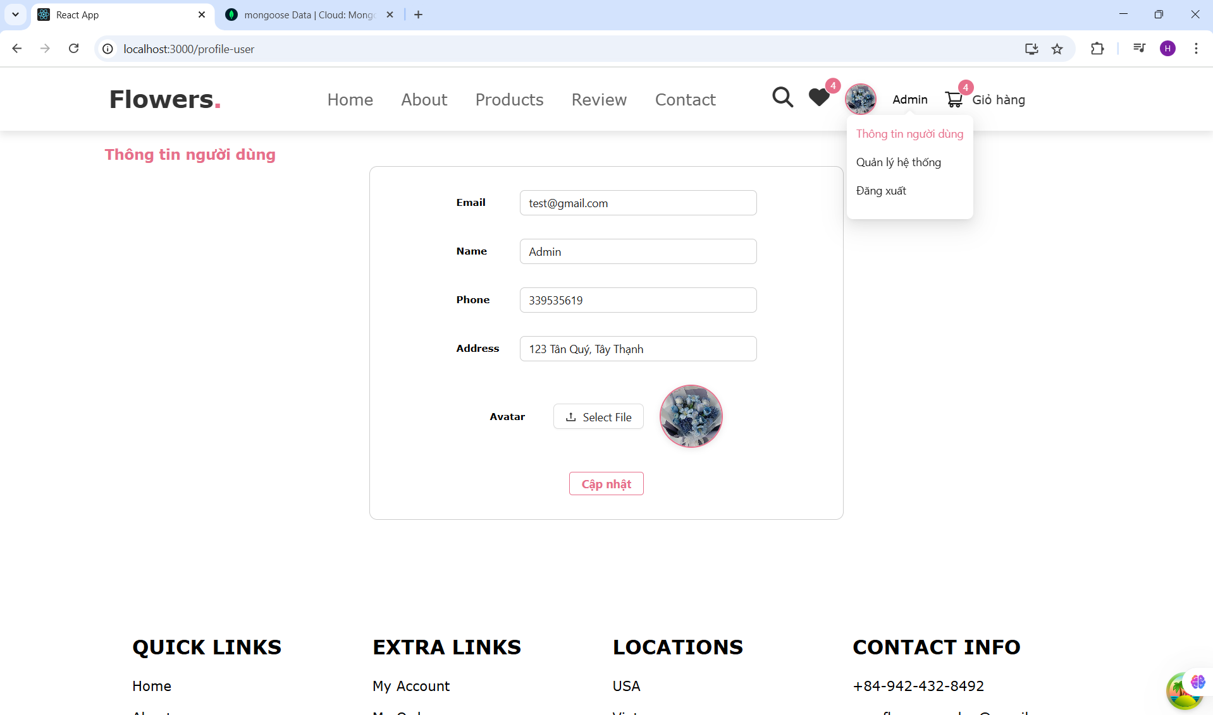
    - Search Page
import React, { useEffect, useState } from "react";
import ButtonInputSearch from "../../components/ButtonInputSearch/ButtonInputSearch";
import { Button } from "antd";
import { useDispatch, useSelector } from "react-redux";
import ProductService from '../../services/ProductService';
import { searchProduct as searchProductAction } from "../../redux/slides/productSlide";
import { useQuery } from "@tanstack/react-query";
import CardComponent from "../../components/CardComponent/CardComponent";

const SearchPage = () => {
const [search, setSearch] = useState('');
const [stateProducts, setStateProducts] = useState([]);
const dispatch = useDispatch();
const searchProduct = useSelector((state) => state?.product?.search);

const fetchProductAll = async () => {
const res = await ProductService.getAllProducts(searchProduct);
return res?.data || [];
};

const { isLoading, data: products, isPreviousData } = useQuery({
queryKey: ['products', searchProduct],
queryFn: fetchProductAll,
retry: 3,
retryDelay: 1000,
keepPreviousData: true
});

console.log('isPreviousData', isPreviousData);

const onSearch = (e) => {
const value = e.target.value;
setSearch(value);
dispatch(searchProductAction(value));
};

useEffect(() => {
if (products?.length > 0) {
setStateProducts(products);
} else {
setStateProducts([]);
}
}, [products]);

// Scroll to top
const handleScrollToTop = () => {
window.scrollTo({ top: 0, behavior: 'smooth' });
};

return (
<div style={{ backgroundColor: "#efefef", minHeight: "100vh", paddingTop: "120px" }}>
<ButtonInputSearch onChange={onSearch} />

<div style={{ display: "flex", justifyContent: "center", marginTop: "20px" }}>
<Button
style={{
backgroundColor: "#e76f8b",
color: "white",
border: "none",
padding: "20px 30px",
fontSize: "16px",
fontWeight: "bold",
}}
>
Tìm gì đó
</Button>
</div>

{/* Grid hiển thị sản phẩm */}
<div
style={{
marginTop: "40px",
padding: "0 100px",
display: "grid",
gridTemplateColumns: "repeat(3, 1fr)",
gap: "20px",
boxSizing: "border-box",
marginBottom: "40px"
}}
>
{isLoading ? (
<p>Đang tải sản phẩm...</p>
) : stateProducts.length === 0 ? (
<p>Không có sản phẩm phù hợp.</p>
) : (
stateProducts.map((product) => (
<CardComponent
key={product._id}
id={product._id}
name={product.name}
image={product.image}
price={product.price}
discount={product.discount}
rating={product.rating}
type={product.type}
countInSttock={product.countInSttock}
description={product.description}
/>
))
)}
</div>

{/* Nút ở cuối trang */}
<div style={{ display: "flex", justifyContent: "center", marginBottom: "100px" }}>
<Button
type="primary"
style={{
backgroundColor: "#e76f8b",
color: "#fff",
padding: "15px 40px",
fontSize: "16px",
fontWeight: "bold",
border: "none",
borderRadius: "8px",
display: "none"
}}
onClick={handleScrollToTop}
>
Quay lại đầu trang
</Button>
</div>
</div>
);
};

export default SearchPage;

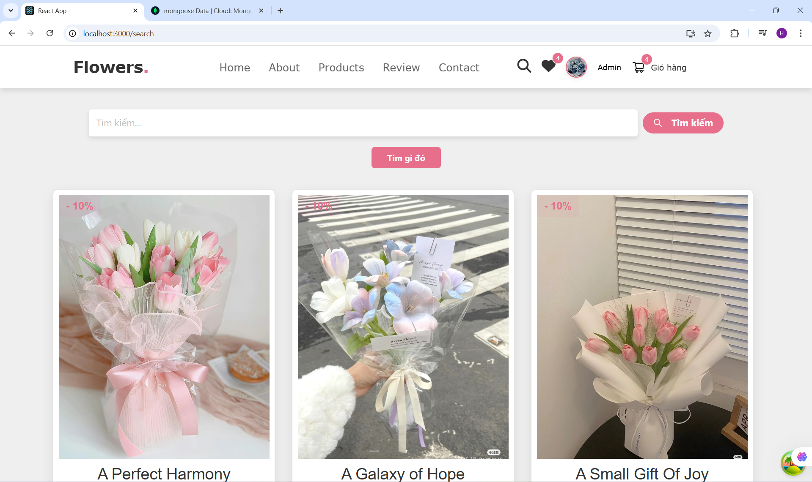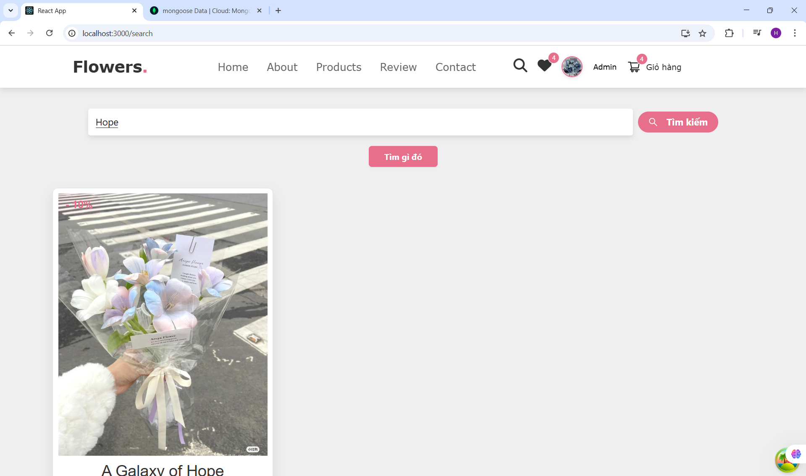
    - Signin page
import React, { useEffect, useState } from 'react';
import { useLocation, useNavigate } from 'react-router-dom';
import { Image, message, Spin } from 'antd';
import { EyeFilled, EyeInvisibleFilled } from '@ant-design/icons';
import * as UserService from '../../services/UserService';
import ButtonComponent from '../../components/ButtonComponent/ButtonComponent';
import InputForm from '../../components/InputForm/InputForm';
import { WrapperContainerLeft, WrapperContainerRight, WrapperTextLight } from './style';
import imageLogo from '../../assets/images/login.jpg';
import { useMutationHook } from '../../hooks/useMutationHook';
import { jwtDecode } from "jwt-decode";
import { useDispatch } from 'react-redux';
import { updateUser } from '../../redux/slides/userSlide';

const SignInPage = () => {
const [email, setEmail] = useState('');
const [password, setPassword] = useState('');
const [isShowPassword, setIsShowPassword] = useState(false);
const [isLoading, setIsLoading] = useState(false);
const navigate = useNavigate();
const dispatch = useDispatch();
const location = useLocation()

const mutation = useMutationHook(UserService.loginUser, {
onMutate: () => {
setIsLoading(true);
},
onSuccess: (data) => {
message.success('Đăng nhập thành công!');
localStorage.setItem('access_token', JSON.stringify(data?.access_token));
navigate('/');

if (data?.access_token && data?.user) {
dispatch(updateUser({
name: data.user.name,
email: data.user.email,
access_token: data.access_token
}));
}
},
onError: (error) => {
message.error(error.message || 'Login failed. Please try again.');
},
onSettled: () => {
setIsLoading(false);
}
});

useEffect(() => {
if (mutation.isSuccess && mutation.data) {
const { data } = mutation;
if(location?.state){
navigate(location?.state)
}else{
navigate('/');
}

localStorage.setItem('access_token', JSON.stringify(data?.access_token));

if (data?.access_token) {
const decoded = jwtDecode(data?.access_token);
if (decoded?.id) {
handleGetDetailsUser(decoded?.id, data?.access_token);
}
}
}
}, [mutation.isSuccess, mutation.data]); // Chỉ gọi lại khi mutation thành công

const handleGetDetailsUser = async (id, token) => {
const res = await UserService.getDetailsUser(id, token);
dispatch(updateUser({ ...res?.data, access_token: token }));
};

const handleSignIn = () => {
if (!email || !password) {
message.warning('Please enter email and password!');
return;
}
mutation.mutate({ email, password });
};

return (
<div style={{ display: 'flex', alignItems: 'center', justifyContent: 'center', background: 'rgba(0,0,0,0.53)', height: '100vh' }}>
<div style={{ width: '800px', height: '445px', borderRadius: '6px', background: '#fff', display: 'flex' }}>
<WrapperContainerLeft>
<h1>Welcome Back!</h1>
<p>Login or Register</p>

<InputForm id="email" placeholder="abc@gmail.com" value={email} onChange={(e) => setEmail(e.target.value)} />

<div style={{ position: 'relative', marginTop: '10px' }}>
<InputForm
id="password"
placeholder="Password"
type={isShowPassword ? 'text' : 'password'}
value={password}
onChange={(e) => setPassword(e.target.value)}
/>
<span
style={{ position: 'absolute', top: '50%', right: '8px', transform: 'translateY(-50%)', cursor: 'pointer' }}
onClick={() => setIsShowPassword(!isShowPassword)}
>
{isShowPassword ? <EyeFilled /> : <EyeInvisibleFilled />}
</span>
</div>

{mutation?.data?.status === "ERROR" && <span style={{ color: "red" }}>{mutation?.data?.message}</span>}

{/* Nút Sign In với Loading */}
<ButtonComponent
onClick={handleSignIn}
disabled={isLoading || !email || !password}
size={40}
styleButton={{
background: '#e76f8b',
height: '48px',
width: '100%',
border: 'none',
borderRadius: '4px',
margin: '26px 0 10px',
display: 'flex',
alignItems: 'center',
justifyContent: 'center'
}}
textButton={
isLoading ? <Spin size="small" style={{ color: '#fff' }} /> : 'Log in'
}
styleTextButton={{ color: '#fff', fontSize: '20px', fontWeight: 'bolder' }}
/>

<p><WrapperTextLight>Forgot Password?</WrapperTextLight></p>
<p style={{ fontSize: '13px' }}>
No Account? <WrapperTextLight onClick={() => navigate('/sign-up')}>Create Account</WrapperTextLight>
</p>
</WrapperContainerLeft>

<WrapperContainerRight>
<Image src={imageLogo} preview={false} alt="Logo Login" height="260px" width="260px" style={{ borderRadius: '50%' }} />
<h4 style={{ color: '#85b247', fontSize: '16px', fontWeight: 'bolder' }}>Welcome to our Flowers Garden</h4>
</WrapperContainerRight>
</div>
</div>
);
};

export default SignInPage;

import styled from "styled-components";

export const WrapperContainerLeft = styled.div`
font-family: Verdana, Geneva, Tahoma, serif, sans-serif;
flex: 1;
padding: 40px 45px 24px;
display: flex;
flex-direction: column;
`

export const WrapperContainerRight = styled.div`
width: 300px;
background: linear-gradient(136deg, rgb(234, 210, 213) -1%, rgb(212,162,161) 85%);
display: flex;
justify-content: center;;
flex-direction: column;
align-items: center;
gap: 4px;
`

export const WrapperTextLight = styled.span`
color: rgb(13,92,182);
font-size: 13px;
cursor: pointer;
`;

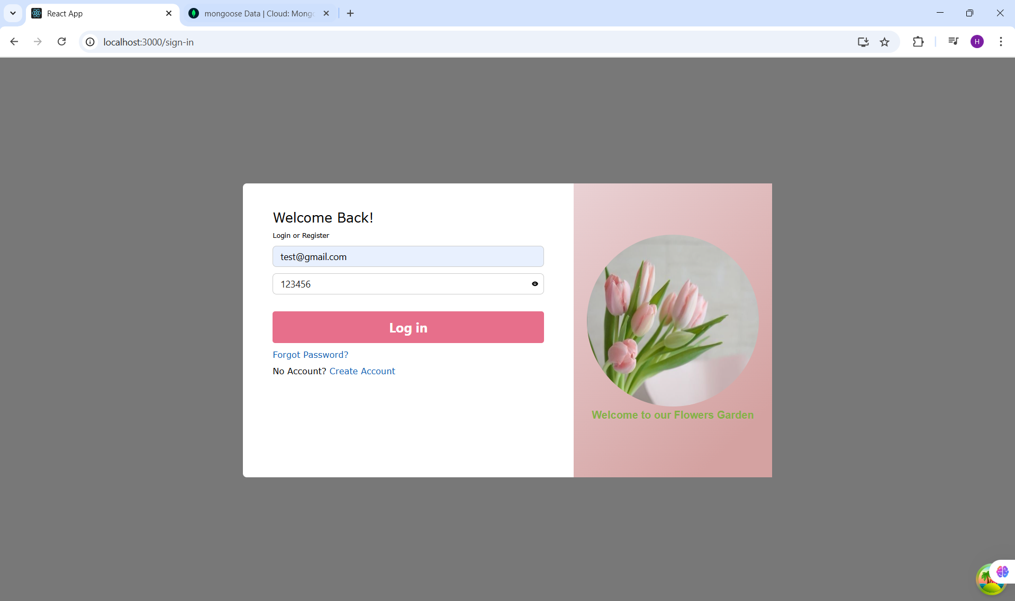
    - SignUp page
import React, { useState } from 'react';
import { Image, Spin } from 'antd';
import { EyeFilled, EyeInvisibleFilled } from '@ant-design/icons';
import { useNavigate } from 'react-router-dom';
import ButtonComponent from '../../components/ButtonComponent/ButtonComponent';
import InputForm from '../../components/InputForm/InputForm';
import { WrapperContainerLeft, WrapperContainerRight, WrapperTextLight } from './style';
import imageLogo from '../../assets/images/login.jpg';
import * as UserService from '../../services/UserService';
import { useMutationHook } from '../../hooks/useMutationHook';
import * as message from "../../components/Message/Message"
const SignUpPage = () => {
const [name, setName] = useState('');
const [email, setEmail] = useState('');
const [password, setPassword] = useState('');
const [confirmPassword, setConfirmPassword] = useState('');
const [isShowPassword, setIsShowPassword] = useState(false);
const [isShowConfirmPassword, setIsShowConfirmPassword] = useState(false);
const [isLoading, setIsLoading] = useState(false);
const [errors, setErrors] = useState({}); // State lưu lỗi

const navigate = useNavigate();

const mutation = useMutationHook(UserService.signupUser, {
onMutate: () => {
setIsLoading(true);
},
onSuccess: (data) => {
if (data.status === "ERROR") {

setErrors({ email: data.message });
} else {

navigate('/sign-in');
}
},
onError: (error) => {
setErrors({ server: error.message || 'Sign up failed. Please try again.' });
},
onSettled: () => {
setIsLoading(false);
},
});

const handleSignUp = () => {
let validationErrors = {};

if (!name) validationErrors.name = 'Full name is required!';
if (!email) validationErrors.email = 'Email is required!';
else if (!/^\w+([.-]?\w+)*@\w+([.-]?\w+)*(\.\w{2,3})+$/.test(email)) {
validationErrors.email = 'Invalid email format!';
}
if (!password) validationErrors.password = 'Password is required!';
if (!confirmPassword) validationErrors.confirmPassword = 'Please confirm your password!';
if (password && confirmPassword && password !== confirmPassword) {
validationErrors.confirmPassword = 'Passwords do not match!';
}

if (Object.keys(validationErrors).length > 0) {
setErrors(validationErrors);
return;
}

setErrors({});
mutation.mutate({ name, email, password, confirmPassword });
};

return (
<div
style={{
display: 'flex',
alignItems: 'center',
justifyContent: 'center',
background: 'rgba(0,0,0,0.53)',
height: '100vh',
}}
>
<div
style={{
width: '800px',
height: '500px',
borderRadius: '6px',
background: '#fff',
display: 'flex',
}}
>
<WrapperContainerLeft>
<h1>Hi Darling</h1>
<p>Login or Register</p>

{/* Input Name */}
<InputForm
style={{ marginBottom: '5px' }}
placeholder="Full Name"
value={name}
onChange={(e) => setName(e.target.value)}
/>
{errors.name && <p style={{ color: 'red', fontSize: '12px' }}>{errors.name}</p>}

{/* Input Email */}
<InputForm
style={{ marginBottom: '5px' }}
placeholder="abc@gmail.com"
value={email}
onChange={(e) => setEmail(e.target.value)}
/>
{errors.email && <p style={{ color: 'red', fontSize: '12px' }}>{errors.email}</p>}

{/* Input Password */}
<div style={{ position: 'relative', marginBottom: '5px' }}>
<InputForm
placeholder="Password"
type={isShowPassword ? 'text' : 'password'}
value={password}
onChange={(e) => setPassword(e.target.value)}
/>
<span
style={{
position: 'absolute',
top: '50%',
right: '8px',
transform: 'translateY(-50%)',
cursor: 'pointer',
}}
onClick={() => setIsShowPassword(!isShowPassword)}
>
{isShowPassword ? <EyeFilled /> : <EyeInvisibleFilled />}
</span>
</div>
{errors.password && <p style={{ color: 'red', fontSize: '12px' }}>{errors.password}</p>}

{/* Input Confirm Password */}
<div style={{ position: 'relative', marginBottom: '5px' }}>
<InputForm
placeholder="Confirm Password"
type={isShowConfirmPassword ? 'text' : 'password'}
value={confirmPassword}
onChange={(e) => setConfirmPassword(e.target.value)}
/>
<span
style={{
position: 'absolute',
top: '50%',
right: '8px',
transform: 'translateY(-50%)',
cursor: 'pointer',
}}
onClick={() => setIsShowConfirmPassword(!isShowConfirmPassword)}
>
{isShowConfirmPassword ? <EyeFilled /> : <EyeInvisibleFilled />}
</span>
</div>
{errors.confirmPassword && <p style={{ color: 'red', fontSize: '12px' }}>{errors.confirmPassword}</p>}

{/* Hiển thị lỗi server */}
{errors.server && <p style={{ color: 'red', fontSize: '12px', marginTop: '10px' }}>{errors.server}</p>}

{/* Button Sign Up */}
<ButtonComponent
disabled={isLoading}
onClick={handleSignUp}
size={40}
styleButton={{
background: '#e76f8b',
height: '48px',
width: '100%',
border: 'none',
borderRadius: '4px',
margin: '26px 0 10px',
}}
textButton={isLoading ? <Spin size="small" style={{ color: '#fff' }} /> : 'Sign up'}
styleTextButton={{ color: '#fff', fontSize: '20px', fontWeight: 'bolder' }}
/>

{/* Chuyển sang trang đăng nhập */}
<p style={{ fontSize: '13px' }}>
You have an account?{' '}
<WrapperTextLight onClick={() => navigate('/sign-in')}>Log in</WrapperTextLight>
</p>
</WrapperContainerLeft>

<WrapperContainerRight>
<Image
src={imageLogo}
preview={false}
alt="Logo Login"
height="260px"
width="260px"
style={{ borderRadius: '50%' }}
/>
<h4 style={{ color: '#85b247', fontSize: '16px', fontWeight: 'bolder' }}>
Welcome to our Flowers Garden
</h4>
</WrapperContainerRight>
</div>
</div>
);
};

export default SignUpPage;

import styled from "styled-components";

export const WrapperContainerLeft = styled.div`
font-family: Verdana, Geneva, Tahoma, serif, sans-serif;
flex: 1;
padding: 40px 45px 24px;
display: flex;
flex-direction: column;
`

export const WrapperContainerRight = styled.div`
width: 300px;
background: linear-gradient(136deg, rgb(234, 210, 213) -1%, rgb(212,162,161) 85%);
display: flex;
justify-content: center;;
flex-direction: column;
align-items: center;
gap: 4px;
`

export const WrapperTextLight = styled.span`
color: rgb(13,92,182);
font-size: 13px;
cursor: pointer;
`;

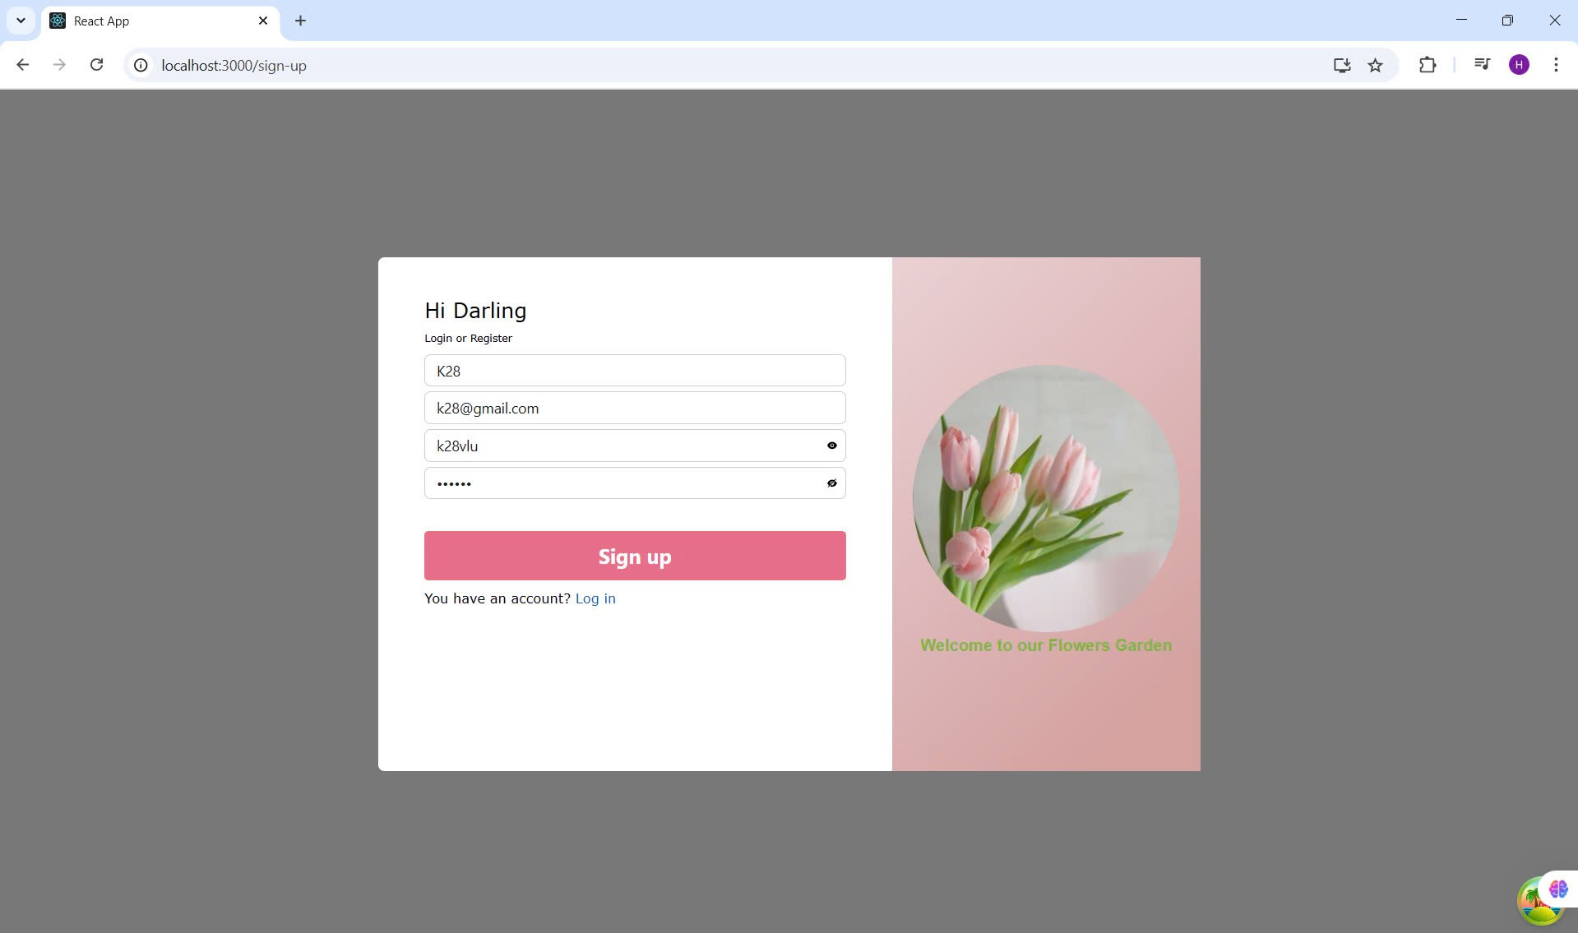

  - Các cấu hình khác để render và liên kết với Backend
// src/slides/orderSlide.js
import { createSlice } from '@reduxjs/toolkit';

const initialState = {
orderItems: [],
wishlistItems: [],
ShippingAddress: {},
paymentMethod: '',
itemsPrice: 0,
shippingPrice: 0,
taxPrice: 0,
totalPrice: 0,
user: '',
isPaid: false,
paiAt: '',
isDelivered: false,
deliveredAt: '',
};

export const orderSlice = createSlice({
name: 'order',
initialState,
reducers: {
// addOrderProduct: (state, action) => {
// const { orderItems } = action.payload;
// const itemOrder = state.orderItems.find((item) => item.product === orderItems.product);
// if (itemOrder) {
// itemOrder.amount += orderItems.amount;
// } else {
// state.orderItems.push(orderItems);
// }
// },
addOrderProduct: (state, action) => {
const { orderItems } = action.payload;
const itemOrder = state.orderItems.find((item) => item.product === orderItems.product);
if (itemOrder) {
itemOrder.amount += orderItems.amount;
} else {
state.orderItems.push({ ...orderItems, checked: false }); // thêm checked
}
},
toggleCheckProduct: (state, action) => {
const { idProduct } = action.payload;
const item = state.orderItems.find((item) => item.product === idProduct);
if (item) {
item.checked = !item.checked;
}
},
toggleCheckAllProduct: (state, action) => {
const { checked } = action.payload;
state.orderItems.forEach(item => {
item.checked = checked;
});
},
increaseAmount: (state, action) => {
const { idProduct } = action.payload;
const item = state.orderItems.find((item) => item.product === idProduct);
if (item) {
item.amount += 1;
}
},
decreaseAmount: (state, action) => {
const { idProduct } = action.payload;
const item = state.orderItems.find((item) => item.product === idProduct);
if (item && item.amount > 1) {
item.amount -= 1;
}
},
removeOrderProduct: (state, action) => {
const { idProduct } = action.payload;
state.orderItems = state.orderItems.filter(item => item.product !== idProduct);
},
updateAmount: (state, action) => {
const { idProduct, amount } = action.payload;
const item = state.orderItems.find((item) => item.product === idProduct);
if (item && amount >= 1) {
item.amount = amount;
}
},
addToWishlist: (state, action) => {
const item = action.payload;
const existItem = state.wishlistItems.find(i => i.product === item.product);
if (!existItem) {
state.wishlistItems.push(item);
}
},
removeFromWishlist: (state, action) => {
const idProduct = action.payload;
state.wishlistItems = state.wishlistItems.filter(item => item.product !== idProduct);
},
toggleWishlist: (state, action) => {
const idProduct = action.payload;
const index = state.wishlistItems.findIndex(item => item.product === idProduct);
if (index !== -1) {
state.wishlistItems.splice(index, 1); // remove
} else {
// cần thêm logic lấy sản phẩm nếu muốn tự thêm (nếu chưa có)
}
},

}
});

export const {
addOrderProduct,
increaseAmount,
decreaseAmount,
removeOrderProduct,
updateAmount,
toggleCheckProduct,
toggleCheckAllProduct,
removeFromWishlist,
toggleWishlist,
addToWishlist
} = orderSlice.actions;

export default orderSlice.reducer;

import { createSlice } from '@reduxjs/toolkit'

const initialState = {
search: '',
}

export const productSlice = createSlice({
name: 'product',
initialState,
reducers: {
searchProduct: (state, action) => {
state.search = action.payload;
},
},
})

// Action creators are generated for each case reducer function
export const { searchProduct } = productSlice.actions

export default productSlice.reducer
import { createSlice } from '@reduxjs/toolkit';

const initialState = {
name: '',
email: '',
access_token: '',
address: '',
phone: '',
avatar: '',
id: '',
isAdmin: false,
city:''
};

const userSlice = createSlice({
name: 'user',
initialState,
reducers: {
updateUser: (state, action) => {
const { name = '', email = '', access_token = '', phone = '', avatar = '', address = '', _id = '', isAdmin, city='' } = action.payload;
state.name = name || '';
state.email = email || '';
state.phone = phone || '';
state.address = address || '';
state.avatar = avatar || '';
state.id = _id;
state.access_token = access_token || '';
state.isAdmin = isAdmin;
state.city=city;
},

resetUser: (state) => {
state.name = '';
state.email = '';
state.access_token = '';
state.address = '';
state.avatar = '';
state.id = '';
state.phone = '';
state.isAdmin = false;
state.city = ''
},
},
});

export const { updateUser, resetUser } = userSlice.actions;
export default userSlice.reducer;

import { configureStore } from '@reduxjs/toolkit';
import productReducer from './slides/productSlide';
import userReducer from './slides/userSlide';
import orderReducer from './slides/orderSlide';

// Load order state từ localStorage
const loadOrderState = () => {
try {
const serializedState = localStorage.getItem('orderState');
return serializedState ? JSON.parse(serializedState) : undefined;
} catch (err) {
console.error('Lỗi khi load order từ localStorage:', err);
return undefined;
}
};

// Save order state vào localStorage
const saveOrderState = (state) => {
try {
const serializedState = JSON.stringify(state.order);
localStorage.setItem('orderState', serializedState);
} catch (err) {
console.error('Lỗi khi save order vào localStorage:', err);
}
};

// Gọi load để lấy initial order state
const preloadedState = {
order: loadOrderState(),
};

export const store = configureStore({
reducer: {
product: productReducer,
user: userReducer,
order: orderReducer,
},
preloadedState, // <-- sử dụng giá trị đã load
});

// Lưu order state mỗi khi thay đổi
store.subscribe(() => {
saveOrderState(store.getState());
});

- Cấu hình đường dẫn
import HomePage from "../pages/HomePage/HomePage";
import OrderPage from "../pages/OrderPage/OrderPage";
import ProductsPage from "../pages/ProductsPage/ProductsPage";
import SearchPage from "../pages/SearchPage/SearchPage";
import NotFoundPage from "../pages/NotFoundPage/NotFoundPage";
import SignInPage from "../pages/SignInPage/SignInPage";
import SignUpPage from "../pages/SignUpPage/SignUpPage";
import ProductDetailsPage from "../pages/ProductDetailsPage/ProductDetailsPage";
import ProfilePage from "../pages/Profile/ProfilePage";
import AdminPage from "../pages/AdminPage/AdminPage";
import FavoritePage from "../pages/FavoritePage/FavoritePage";
import PaymentPage from "../pages/PaymentPage/PaymentPage";
import OrderSuccess from "../pages/OrderSuccess/OrderSuccess"
export const routes = [
{
path: '/',
element: HomePage,
isShowHeader: true,

},
{
path: '/order',
element: OrderPage,
isShowHeader: true,

},
{
path: '/payment',
element: PaymentPage,
isShowHeader: true,

},
{
path: '/orderSuccess',
element: OrderSuccess,
isShowHeader: true,

},
{
path: '/favorite',
element: FavoritePage,
isShowHeader: true,

},
{
path: '/products',
element: ProductsPage,
isShowHeader: true
},
{
path: '/search',
element: SearchPage,
isShowHeader: true
},
{
path: '/sign-in',
element: SignInPage,
isShowHeader: false
},
{
path: '/sign-up',
element: SignUpPage,
isShowHeader: false
},
{
path: '/product-details/:id',
element: ProductDetailsPage,
isShowHeader: true
},
{
path: '/profile-user',
element: ProfilePage,
isShowHeader: true
},

{
path: '/system/admin',
element: AdminPage,
isShowHeader: false,
isPrivate: true

},
{
path: '*',
element: NotFoundPage
},
];

- OrderService của front end
import { axiosJWT } from "./UserService";

export const createOrder = async (access_token, data) => {
if (!access_token) {
throw new Error("Thiếu token xác thực");
}

const res = await axiosJWT.post(
`${process.env.REACT_APP_API_URL_BACKEND}/order/create`,
data,
{
headers: {
Authorization: `Bearer ${access_token}`,
},
}
);
return res.data;
};

- ProductService của front end
import axios from "axios";
import { axiosJWT } from "./UserService";
import { data } from "react-router-dom";
import Cookies from 'js-cookie';

export const getAllProducts = async (search, limit, page) => {
let res = {}
if (search && search.length > 0) {

res = await axios.get(
`${process.env.REACT_APP_API_URL_BACKEND}/product/getAll-product?limit=${limit}&page=${page}&filter=name:${encodeURIComponent(search)}`
);
} else {
res = await axios.get(
`${process.env.REACT_APP_API_URL_BACKEND}/product/getAll-product?limit=${limit}&page=${page}`
);
//res = await axios.get(`${process.env.REACT_APP_API_URL_BACKEND}/product/getAll-product?limit=${limit}`);
}

return res.data;

};

export const getAllProducts_2 = async ({ search = '', limit = 6, page = 0 }) => {
let res = {};

let url = `${process.env.REACT_APP_API_URL_BACKEND}/product/getAll-product?limit=${limit}&page=${page}`;
if (search && search.length > 0) {
url += `&filter=name:${encodeURIComponent(search)}`;
}

res = await axios.get(url);
return res.data;
};

export const createProduct = async (data) => {

const res = await axios.post(`${process.env.REACT_APP_API_URL_BACKEND}/product/create`, data);
return res.data;

};

export const getDetailsProduct = async (id) => {

const res = await axios.get(`${process.env.REACT_APP_API_URL_BACKEND}/product/get-details/${id}`);
console.log('res.data', res.data)
return res.data

};

export const updateProduct = async (id, data) => {
const token = Cookies.get('access_token'); // Lấy access token từ cookie
if (!token) {
throw new Error("Token xác thực bị thiếu");
}

try {
const response = await axios.put(
`${process.env.REACT_APP_API_URL_BACKEND}/product/update/${id}`, data,
{
headers: {
'Authorization': `Bearer ${token}`,
}
}
);
return response.data;
} catch (error) {
throw new Error(error.response?.data?.message || 'Cập nhật thất bại');
}
};

export const deleteProduct = async (id) => {
const token = Cookies.get('access_token'); // Lấy access token từ cookie
if (!token) {
throw new Error("Token xác thực bị thiếu");
}
const res = await axios.delete(`${process.env.REACT_APP_API_URL_BACKEND}/product/delete-product/${id}`, {
headers: {
'Authorization': `Bearer ${token}`,
}
});
console.log('res.data', res.data)
return res.data

};

const ProductService = {
getAllProducts,
getDetailsProduct,
createProduct,
updateProduct,
deleteProduct,
getAllProducts_2
};

export default ProductService;

- UserService của front end
import axios from "axios";
import Cookies from 'js-cookie';

export const axiosJWT = axios.create({
baseURL: process.env.REACT_APP_API_URL_BACKEND,
headers: {
"Content-Type": "application/json",
},
});

axiosJWT.interceptors.request.use(async (config) => {
const token = Cookies.get('access_token'); // Lấy token từ cookie
if (token) {
config.headers['Authorization'] = `Bearer ${token}`; // Thêm token vào header
} else {
console.error("Authentication token is missing");
}
return config;
}, (error) => {
return Promise.reject(error);
});

export const loginUser = async (data) => {
try {
const res = await axios.post(
`${process.env.REACT_APP_API_URL_BACKEND}/user/sign-in`,
data,
{ headers: { "Content-Type": "application/json" } }
);

// Lưu access_token vào cookie với thời gian hết hạn là 1 ngày
Cookies.set('access_token', res.data.access_token, { expires: 1 });
// Lưu refresh_token vào cookie với cờ HttpOnly (không thể truy cập từ JS)
Cookies.set('refresh_token', res.data.refresh_token, { expires: 1, httpOnly: true });

return res.data;
} catch (error) {
throw error.response?.data || new Error("Login failed");
}
};

export const signupUser = async (data) => {
try {
const res = await axios.post(
`${process.env.REACT_APP_API_URL_BACKEND}/user/sign-up`,
data,
{ headers: { "Content-Type": "application/json" } }
);
return res.data;
} catch (error) {
throw error.response?.data || new Error("Sign up failed");
}
};

export const getDetailsUser = async (id) => {
const token = Cookies.get('access_token'); // Lấy token từ cookie
if (!token) {
throw new Error("Cần có token truy cập");
}
try {
const res = await axiosJWT.get(
`/user/get-details/${id}`,
{ headers: { Authorization: `Bearer ${token}` } }
);
return res.data;
} catch (error) {
if (error.response) {
// Xử lý lỗi từ máy chủ (ví dụ 401, 500)
if (error.response.status === 401 && error.response.data.message.includes("Invalid or expired token")) {
// Nếu token hết hạn, gọi refresh token
const refreshedToken = await refreshToken();
return getDetailsUser(id); // Thử lại với token mới
}
throw new Error(`Lỗi từ máy chủ: ${error.response.data.message || 'Có lỗi xảy ra'}`);
} else {
throw new Error("Không có phản hồi từ máy chủ. Vui lòng thử lại sau.");
}
}
};

export const getAllUsers = async(access_token) => {
const token = Cookies.get('access_token');
if (!token) {
throw new Error("Cần có token truy cập");
}
const res = await axiosJWT.get(
`/user/getAll`,
{ headers: { Authorization: `Bearer ${token}` } }
);
return res.data;

};

export const refreshToken = async () => {
try {
const refresh_token = Cookies.get('refresh_token'); // Lấy refresh token từ cookie
if (!refresh_token) {
throw new Error("Refresh token is missing");
}

const res = await axios.post(
`${process.env.REACT_APP_API_URL_BACKEND}/user/refresh-token`,
{ refresh_token }, // Gửi refresh token để lấy access token mới
{ withCredentials: true } // Đảm bảo gửi cookie nếu có
);

if (res.data?.access_token) {
// Lưu lại access token mới vào cookie
Cookies.set('access_token', res.data.access_token, { expires: 1 });
return res.data.access_token; // Trả về access_token mới
} else {
throw new Error("Không nhận được access_token từ máy chủ");
}
} catch (error) {
throw error.response?.data || new Error("Lỗi khi làm mới token");
}
};

export const logoutUser = async () => {
try {
const res = await axios.post(`${process.env.REACT_APP_API_URL_BACKEND}/user/log-out`);
// Xóa token sau khi đăng xuất khỏi cookie
Cookies.remove('access_token');
Cookies.remove('refresh_token');
return res.data;
} catch (error) {
throw error.response?.data || new Error("Logout failed");
}
};

export const updateUser = async (userId, userData) => {
const token = Cookies.get('access_token'); // Lấy access token từ cookie
if (!token) {
throw new Error("Token xác thực bị thiếu");
}

try {
const response = await axios.put(
`${process.env.REACT_APP_API_URL_BACKEND}/user/update-user/${userId}`,
userData,
{
headers: {
'Authorization': `Bearer ${token}`, // Gửi access_token trong header
}
}
);
return response.data;
} catch (error) {
throw new Error(error.response?.data?.message || 'Cập nhật thất bại');
}
};

export const deleteUser = async (id) => {
const token = Cookies.get('access_token'); // Lấy access token từ cookie
if (!token) {
throw new Error("Token xác thực bị thiếu");
}
const res = await axios.delete(`${process.env.REACT_APP_API_URL_BACKEND}/user/delete-user/${id}`, {
headers: {
'Authorization': `Bearer ${token}`,
}
});
console.log('res.data', res.data)
return res.data

};

- App.js
import React, { useEffect } from 'react';
import { BrowserRouter as Router, Routes, Route } from 'react-router-dom';
import DefaultComponent from './components/DefaultComponent/DefaultComponent';
import { routes } from './routes';
import * as UserService from './services/UserService';
import { jwtDecode } from 'jwt-decode';
import { useDispatch, useSelector } from 'react-redux';
import { updateUser } from './redux/slides/userSlide';

function App() {
const dispatch = useDispatch();
const user = useSelector((state)=> state.user);

useEffect(() => {
const { storageData, decoded } = handleDecoded();
if (decoded?.id && storageData) {
handleGetDetailsUser(decoded?.id, storageData);
}
}, []); // Chỉ chạy khi component mount

// Interceptor để tự động thêm token vào header Authorization: Bearer <token>
UserService.axiosJWT.interceptors.request.use((config) => {
const { decoded } = handleDecoded();

if (decoded?.id) {
const token = localStorage.getItem('access_token'); // Lấy token từ localStorage
if (token) {
config.headers['Authorization'] = `Bearer ${token}`; // Thêm token vào header Authorization
} else {
console.error('Authentication token is missing');
}
}

return config;
}, (err) => {
return Promise.reject(err);
});

const handleGetDetailsUser = async (id, token) => {
console.log('Access Token:', token); // Kiểm tra token trước khi gửi yêu cầu
try {
const res = await UserService.getDetailsUser(id, token);
console.log('User Details:', res); // Kiểm tra kết quả từ API
dispatch(updateUser({ ...res?.data, access_token: token }));
} catch (error) {
console.error('Error fetching user details:', error); // Xử lý lỗi
}
};

const handleDecoded = () => {
let storageData = localStorage.getItem('access_token'); // Lấy token từ localStorage
let decoded = {};
if (storageData) {
try {
decoded = jwtDecode(storageData); // Giải mã token
} catch (error) {
console.error('Error decoding token:', error);
}
}
return { decoded, storageData };
};
return (
<Router>
<Routes>
{routes.map(({ path, element: Page, isShowHeader, isPrivate }) => {
// Kiểm tra quyền truy cập vào route nếu có yêu cầu isPrivate
const ischeckAuth = !isPrivate || user.isAdmin;

// Nếu route là private và người dùng không phải admin, chuyển hướng về trang chủ
if (isPrivate && !user.isAdmin) {
return <Route key={path} path={path} element={<navigate to="/" />} />;
}

return (
<Route
key={path}
path={path}
element={
isShowHeader ? (
<DefaultComponent>
<Page />
</DefaultComponent>
) : (
<Page />
)
}
/>
);
})}
</Routes>
</Router>
);

}

export default App;

- Index.js
import React from 'react';
import ReactDOM from 'react-dom/client';
import './index.css';
import App from './App';
import reportWebVitals from './reportWebVitals';
import { store } from './redux/store';
import { Provider } from 'react-redux';
import { QueryClient, QueryClientProvider } from '@tanstack/react-query';
import { ReactQueryDevtools } from '@tanstack/react-query-devtools';

const queryClient = new QueryClient();

const root = ReactDOM.createRoot(document.getElementById('root'));
root.render(
<QueryClientProvider client={queryClient}>
<Provider store={store}>
<App />
</Provider>
<ReactQueryDevtools initialIsOpen={false} />
</QueryClientProvider>
);

reportWebVitals();

